Chapter 1
Operating System
Operating System
A program that acts as an intermediary between a user of a computer and the computer hardware
Goals of an Operating System
1. Run user programs
- How: The OS loads your program into memory, gives it CPU time, and makes sure it can use input/output devices.
- Example: When you play a song in VLC Media Player, the OS loads it, gives CPU and RAM, and lets it use speakers to play sound.
2. Make problem-solving easier
- How: The OS provides built-in services like file management, copy/paste, networking, and device drivers.
- Example: You don’t need to know how a hard disk works physically – the OS just lets you “save” and “open” files with simple commands.
3. Convenience
- How: The OS gives you user-friendly interfaces like GUI (Graphical User Interface) with windows, icons, menus, or CLI (Command Line Interface) for text commands.
- Example: Instead of typing long commands to print, you just click “Print” in Word, and the OS handles the printer.

4. Efficiency
- How: The OS manages resources smartly through scheduling, memory management, and multitasking so that no hardware sits idle unnecessarily.
- Example: While you’re listening to music, downloading a file, and typing a document, the OS divides CPU time and memory so all three run smoothly.
Computer System Structure
1. Hardware
- The physical parts of the computer.
- Provides the basic resources needed for computing.
- Examples: CPU (processor), memory (RAM), and I/O devices (keyboard, mouse, monitor, printer, etc.).
2. Operating System (OS)
- The manager that controls and coordinates how the hardware is used.
- Make sure hardware is shared fairly between different applications and users.
3. Application programs
- Application programs are software that directly helps the user perform tasks. They are not a part of the operating system itself, but they run on top of it and use its services, like file handling, memory, and networking.
- Example: Word processors (MS Word, Google Docs → for typing documents), Web browsers (Chrome, Firefox → for using the internet, Games (Free Fire, PUBG)
4. Users
- The people or systems that use the computer.
- It could be humans, machines (like robots), or even other computers connected in a network.
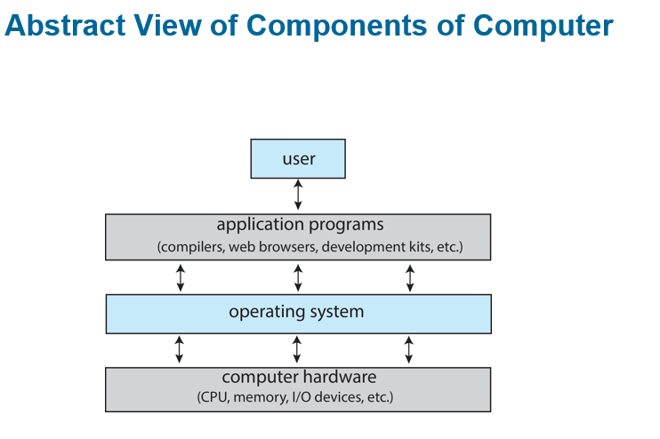
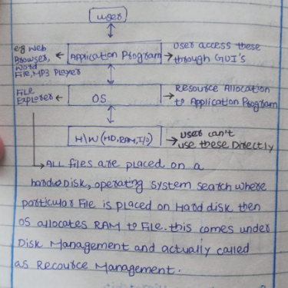
What Operating Systems Do
The role of an Operating System (OS) can look different depending on the situation:
1. From a User’s View
- Normal users just want the computer to be easy to use, fast, and convenient.
- They usually don’t care how the computer is using its internal resources.
2. Shared Computers (Mainframes, Minicomputers)
- But shared computers such as mainframe or minicomputer must keep all users happy
3. OS as a Resource Manager
- The OS is like a resource allocator (manager).
- It makes sure hardware (CPU, memory, devices) is used efficiently.
- Also, it is a control program that manages the execution of user programs.
4. Dedicated Systems (Workstations, PCs)
- Each user usually has their own computer resources.
- But sometimes, they also share resources from servers (like printers, cloud storage, or networks).
5. Mobile Devices (Smartphones, Tablets)
- These are resource-limited (less powerful than PCs).
- The OS is designed to:
  - Save battery life
  - Be very easy to use
- Interfaces often include touch screens, gestures, and voice recognition.
Embedded Computers (Little or No User Interface)
- Some computers are built inside devices (not like normal PCs).
- They usually have no screen, keyboard, or direct user interface.
- They are programmed to do specific tasks automatically.
- They work in the background without the user needing to control them.
- Example: Washing machine – runs wash cycles automatically once you set it.
Defining Operating Systems
Many Roles of OS
- The term Operating System (OS) covers many different roles because computers are used in so many ways.
Different Uses
OSes are found everywhere:
- Small devices like toasters, TVs, game machines.
- Chips inside electronics.
- Big systems like spacecraft and industrial machines.
Origin of OS
- At first, computers were made for fixed tasks (like military use).
- Later, computers became general purpose (for many users and tasks).
- This created the need for an OS to manage resources (CPU, memory, devices) and control programs.
Operating System Definition
No Single Definition
There is no universally agreed definition of what exactly an Operating System (OS) is.
Practical View
- A simple way to think of it:
“Everything a company gives you, when you buy an OS.”
- But this can be very different for each OS (Windows, Linux, Android, etc.)
OS main Parts
Kernel (Core Part)
The kernel is the most important part of an operating system. It is like the core or brain of the OS. The kernel is always present in the computer’s memory while the system is running, unlike other programs that may start and stop. Its main job is to control and manage the hardware, such as the CPU, memory, and input/output devices. In simple words, the kernel acts as a bridge between the hardware and the rest of the software, making sure everything works smoothly together.
System Program
System programs are programs that come with the Operating System to help manage the computer and make it easier for users to use.
Example: Text editors (Notepad, vi), Compilers and assemblers (to translate code)

Application programs
Application programs are software that directly helps the user perform tasks. They are not a part of the operating system itself, but they run on top of it and use its services, like file handling, memory, and networking.
Example: Word processors (MS Word, Google Docs → for typing documents), Web browsers (Chrome, Firefox → for using the internet, Games (Free Fire, PUBG)
Computer-System Operation
- CPU and Devices Work Together
- A computer has one or more CPUs (the “brain” of the computer) and device controllers (like those for the keyboard, mouse, printer, or hard drive).
- All of these connect using a common bus, which is like a shared highway for data.
- Shared Memory
- The CPU and devices use this bus to access the same memory. Think of memory as a big storage room that everyone can use.
- Concurrent Execution
- The CPUs and devices can work at the same time (concurrently).
- But since they share the memory, sometimes they compete for memory access. Only one can use a part of memory at a time, so they take turns very fast.
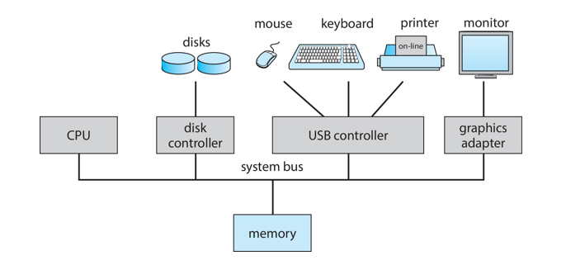
I/O devices and CPU Concurrency Concept
Concurrency
Concurrency means that two or more tasks can happen during the same time. It doesn’t mean they must run at the exact same second, but their work overlaps.
CPU and I/O Devices Working Together
The CPU is the brain of the computer that runs instructions and calculations. On the other hand, I/O devices (like the keyboard, disk, printer, or network card) handle input and output. Both the CPU and I/O devices can work at the same time. For example, while the CPU is busy running a program, an I/O device can be transferring data in the background.
How Concurrency Happens
Here’s how it usually works:
- The CPU starts a task and then requests input/output (for example, reading data from the disk).
- Instead of sitting idle and waiting, the CPU continues doing other work.
- Meanwhile, the I/O device is still completing its task in the background.
- Once the I/O is finished, the CPU takes the data and uses it.
In this way, the CPU and I/O devices overlap their work, which is called concurrent execution.
Illusion of Multitasking and CPU Time Slotting
The illusion of multitasking happens because a single CPU can only execute one instruction at a time. However, the operating system makes it look like multiple programs are running simultaneously. This is where CPU time slotting, or time slicing, comes in.
Time slicing divides the CPU’s time into small segments called time slices, and each process gets a turn to use the CPU for a short period. When the time slice is over, the CPU quickly switches to the next process. This switching happens so fast that the user perceives all programs as running at the same time, even though the CPU is actually handling them one by one.
In short, CPU time slotting is the mechanism, and the illusion of multitasking is what the user experiences. Without time slicing, the CPU would run one process to completion before moving to the next, and the illusion would disappear.
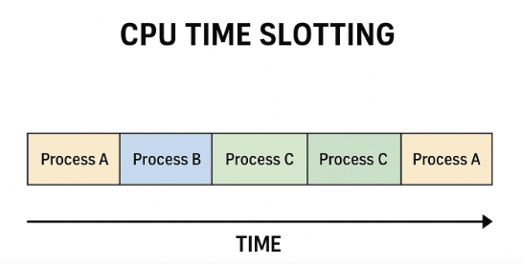
Note: - Every Program Load in RAM before execution
Device Controller and Device Driver
Device Controller
A device controller is a small hardware part (chip or circuit) inside the computer. It works like a middleman between the computer system and a hardware device (such as a keyboard, mouse, hard disk, or printer). The operating system sends instructions to the device controller, and the controller then passes those instructions to the actual device. In simple words, the device controller directly controls how the device works and manages its physical operations.
Device Driver
A device driver is a software component that acts as an intermediary between the operating system (OS) and the hardware device. It works like a translator, so the OS doesn’t need to worry about the technical details of the device. Instead, the driver provides a simple way for the OS to give instructions.
Note
- The OS does not directly talk to the device controller.
- The Device Driver (software) first takes the OS instructions and translates them into commands the Device Controller (hardware) can understand.
- The Device Controller then passes those commands to the actual device and manages how it works physically.
Printer Example
- You press Print on your computer.
- The printer driver (software) takes your document and turns it into special commands that the printer understands.
- These commands are sent to the device controller (hardware chip inside the printer or computer).
- The controller then handles the physical work — moving the paper, spraying the ink, and producing the printout.
Flow
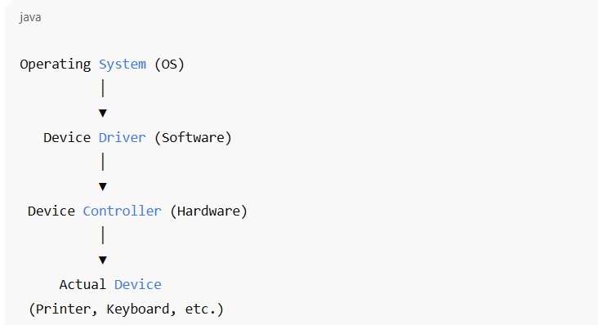

Computer-System Operation
1. CPU and devices can work at the same time → The computer’s brain (CPU) and devices (keyboard, printer, etc.) don’t have to wait for each other; they can do their jobs together.
2. Each device has its own controller → A controller is a small hardware part that manages only one type of device (like disk controller, printer controller).
3. Controller has a local buffer → A small temporary memory inside the controller, used to hold data for a short time.
4. Controller has a device driver → A software helper that lets the operating system talk to the device easily.
5. CPU moves data using buffers → Data goes between the CPU/main memory and the controller’s buffer, not directly to the device.
5. I/O happens through the buffer → Devices send or receive data only from their controller’s buffer.
6. Controller interrupts CPU when done → After finishing a task (like printing a page), the controller sends a signal (interrupt) to tell the CPU “I’m done.”
Interrupt and Trap
Interrupt
An interrupt is a signal generated mainly by I/O devices to inform the CPU that they need attention — either because the device has finished its work (like data transfer complete) or because an error has occurred (like printer out of paper or disk error).

Common functions of Interrupt
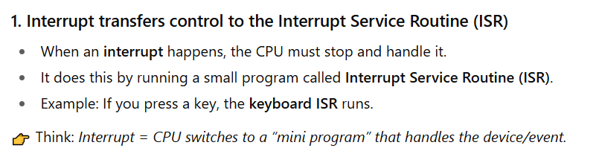
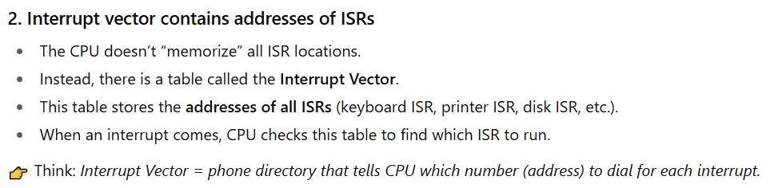
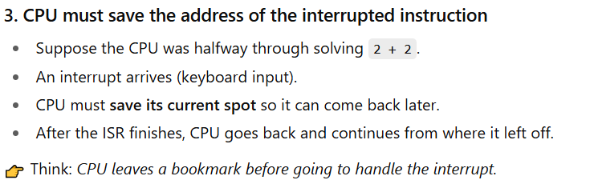
Trap
A trap is a special kind of software-generated interrupt. Unlike normal hardware interrupts (which come from devices like the keyboard or printer), a trap is triggered by the CPU itself while running a program.
Why does a Trap happen?
Traps usually happen for two reasons:

- Errors (Exceptions):
- Example: Division by zero, invalid memory access, or overflow.
- The CPU raises a trap to alert the OS that something went wrong.
- System Calls (Intentional):
- A program can purposely use a trap to request a service from the OS.
- Example: A program wants to read from a file → it uses a trap to ask the OS for help.
How it Works
- Program runs and a condition occurs (error or system call).
- The CPU generates a trap signal.
- Control is transferred to the Trap Handler (special routine in the OS).
- The OS handles the request or error.
- Program either continues (if possible) or is stopped (if it crashes).
In short:
Interrupt = from outside (hardware like keyboard).
Trap = from inside (software error or request).

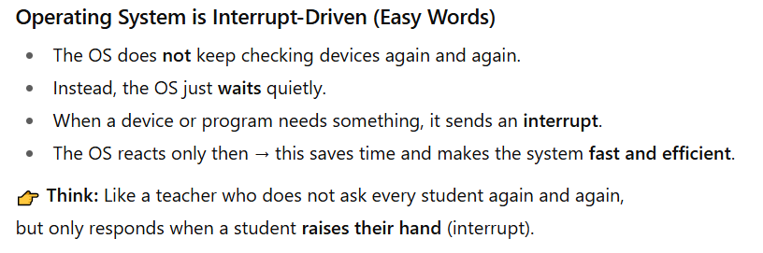
Interrupt Timeline
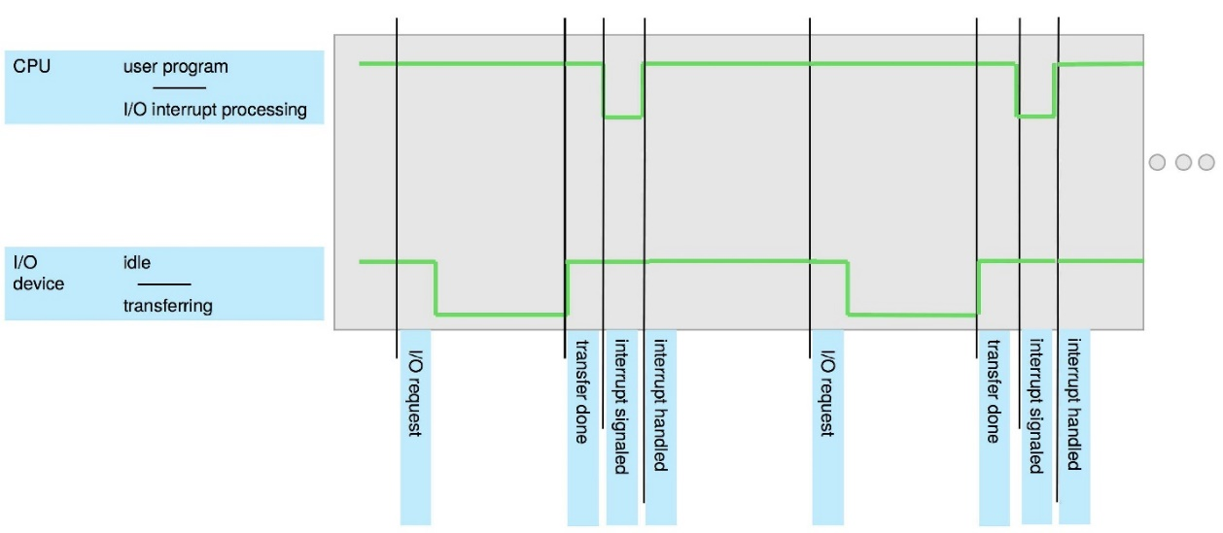
Interrupt Handling
1. Save CPU’s Current Work
When an interrupt occurs, the operating system first saves the CPU’s current state (registers and program counter). This allows the CPU to return to exactly where it left off after the interrupt is handled.
2. Identify the Interrupt Type
Next, the OS checks the type of interrupt to find out who is requesting service — for example, the keyboard, printer, disk, or even a software error.

3. Run the Correct ISR
Once the source is identified, the OS runs the correct Interrupt Service Routine (ISR). Each device or event has its own ISR, which contains the instructions to handle that specific request.
Two methods for handling I/O
Synchronous I/O (Wait for completion)
- When an I/O (input/output) operation starts, the program pauses.
- The program continues only after the I/O is finished.
- Example: If you ask a printer to print, your program will wait until printing is done before moving on.

Asynchronous I/O (Don’t wait)
- When an I/O operation starts, the program does not wait.
- The program continues running while I/O happens in the background.
- Example: If you ask a printer to print, your program keeps working on other tasks while the printer is still printing.
Continue…
Method 1: Control returns after I/O completion (Synchronous I/O)
- The program waits until I/O is finished.
- CPU can sit idle (doing nothing) until an interrupt comes.
- Sometimes the CPU keeps checking repeatedly (busy waiting), wasting time.
- Only one I/O request can happen at a time → no parallel I/O.
- Example: You click “Download” and your computer just freezes until the file finishes downloading.
Method 2: Asynchronous I/O (Don’t Wait for I/O)
- Here, the program does not wait after starting I/O.
- The program can keep running other work immediately.
- If later the program needs the I/O result, it asks the OS to check whether it’s ready.
- The OS keeps a device-status table, which stores info like:
  - Which device is (type)
  - Where it is (address)
  - What is it doing (busy or ready)
- The OS updates this table whenever an interrupt occurs.
- Example: You click “Download” and while the file is downloading, you can still use your computer to type or browse.
Computer Startup
- When you turn on (power-up) or restart (reboot) the computer, a small program called the Bootstrap Program runs first.
- This program is stored in ROM/EPROM (a chip inside the computer). Because it’s permanent, it’s also called firmware.
- The bootstrap program’s job is to prepare the computer:
- It checks and sets up the hardware (CPU, memory, devices).
- Then it loads the operating system (OS) kernel into memory.
- Finally, it starts the OS so the computer becomes ready to use.
Storage Structure
Main Memory (RAM)
- The CPU can directly use main memory.
- It is fast and allows random access (CPU can jump to any location quickly).
- It is usually volatile → data is lost when the power is off.
- Normally it is DRAM (Dynamic RAM).
Secondary Storage
- Works as an extension of main memory.
- Stores much larger amounts of data than RAM.
- It is non-volatile → data stays even after the power is off.
- Examples: Hard disk, SSD, USB drive.
Hard Disk Drives (HDD)
- Made of metal or glass plates coated with magnetic material.
- The surface of the disk is divided into tracks (big circles) and then into sectors (small parts of a track).
- A disk controller manages how the computer and the disk talk to each other.
- HDD is non-volatile, meaning data stays even when power is off.
Non-Volatile Memory (NVM) Devices (like SSDs, Flash drives)
- Faster than hard disks.
- Data is also non-volatile (doesn’t disappear when power is off).
- Made with different technologies (flash memory, SSDs, etc.).
- Becoming more popular because they are getting cheaper, bigger in size, and faster.
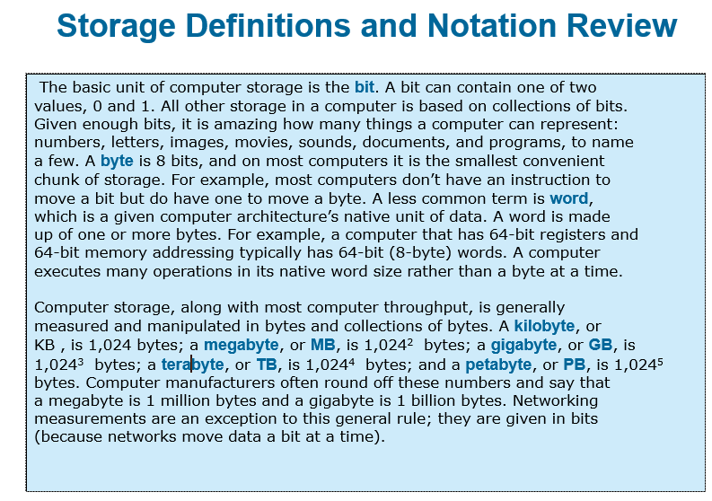
Storage Systems Organized in a Hierarchy
Computer storage is arranged in levels (hierarchy) based on:
- Speed → Faster storage is usually smaller.
- Cost → Faster storage is more expensive.
- Volatility → Some storage (like RAM) loses data when power is off, while others (like hard disks) keep data.
Cache
- Caching = making a copy of data into faster storage for quick access.
- Example: Main memory (RAM) works as a cache for secondary storage (hard disk/SSD).
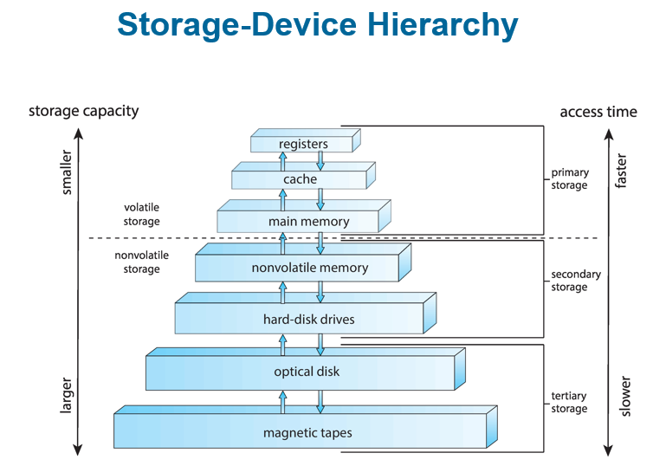

How a Modern Computer Works
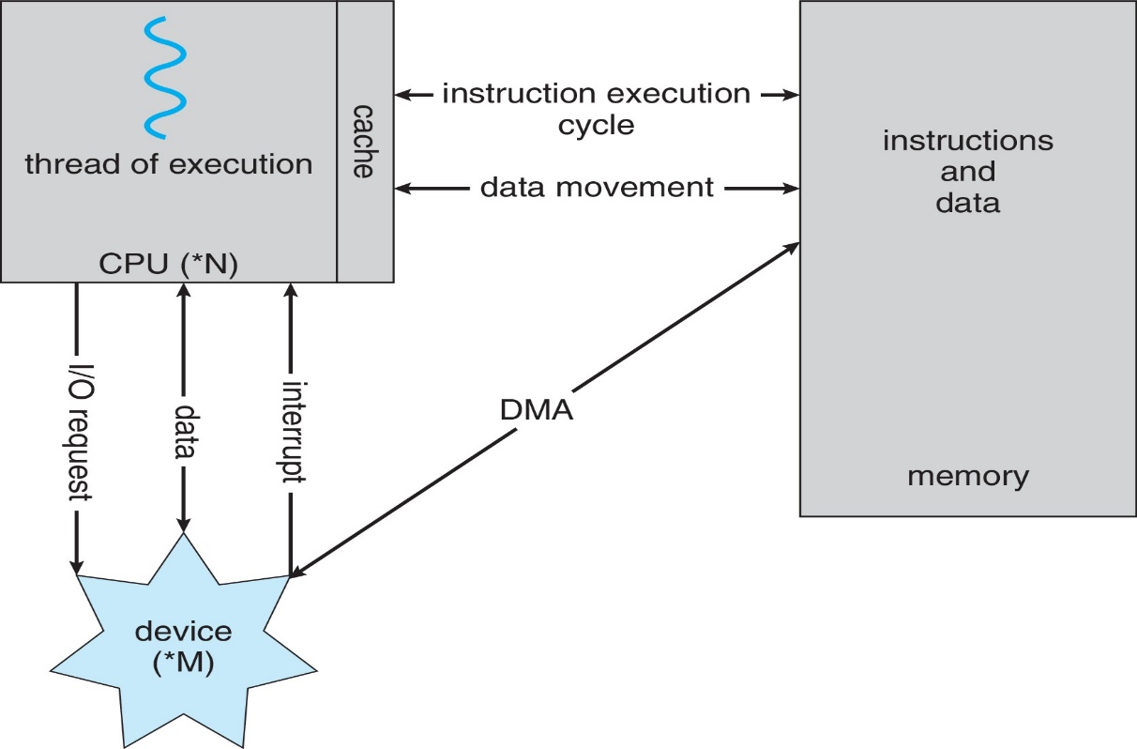
Diagram Illustration
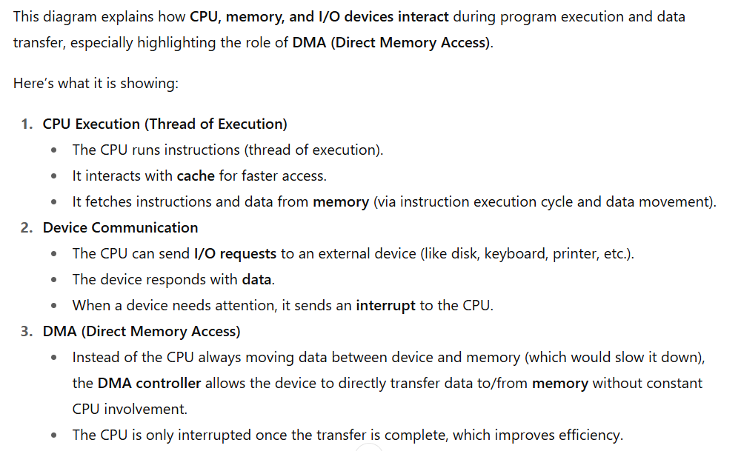

Direct Memory Access (DMA) Structure
- Used for fast devices (like disk drives, graphics cards, etc.) that can send/receive data very quickly.
- The device controller (like a helper) moves a whole block of data directly from the device to main memory, without asking the CPU to move every single piece.
- Instead of disturbing the CPU for every byte, the CPU only gets one signal (interrupt) when the whole block of data is done.
Analogy:
It’s like instead of a delivery guy ringing your bell for every single item, he delivers the entire package at once and rings the bell only once.
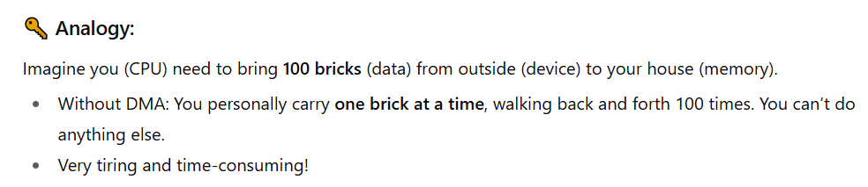
Operating-System Operations
- Bootstrap program
- A very small program stored in ROM.
- Its job: turn on the computer, check hardware, and load the operating system kernel into memory.
- Kernel loads
- The kernel (core part of the OS) is placed into memory.
- Now the OS can start working.

- System daemons (background services)
- These are small helper programs that run in the background (like managing printing, networking, etc.).
- They are outside the kernel but essential.
- Interrupts (kernel is interrupt-driven)
The kernel responds to interrupts (signals that something happened).
Two types:
- Hardware interrupt: comes from devices (like keyboard press, disk ready, network packet arrived).
- Software interrupt: comes from programs.
  - Could be an error (like division by zero).
  - Or a request for OS help (called a system call).
- Other problems the OS must handle
- Program stuck in an infinite loop.
- A program trying to modify another program or even the OS itself (dangerous).
Multiprogramming (Batch System)
In a simple system, a single program cannot keep both the CPU and I/O devices busy all the time. For example, when one program is waiting for input/output, the CPU would sit idle. Multiprogramming solves this by keeping many jobs in memory at the same time. The operating system uses job scheduling to choose which job to run. If one job has to wait for input/output, the OS quickly switches to another job. In this way, the CPU is never left idle because it always has some work to do.

Multitasking (Time-Sharing)
Multitasking is a more advanced form of multiprogramming. Here, the CPU switches between programs very quickly — so fast that it looks like all the programs are running at the same time. This makes the computer interactive, meaning when you type something, the system responds almost instantly. For a smooth experience, the response time should be less than one second. In multitasking, each user has at least one program (process) in memory. If many jobs are ready, the operating system uses CPU scheduling to decide which one should run. When memory is not enough, the OS uses swapping (moving processes in and out of memory). Virtual memory also helps by allowing programs to run even if they don’t completely fit into the real physical memory.

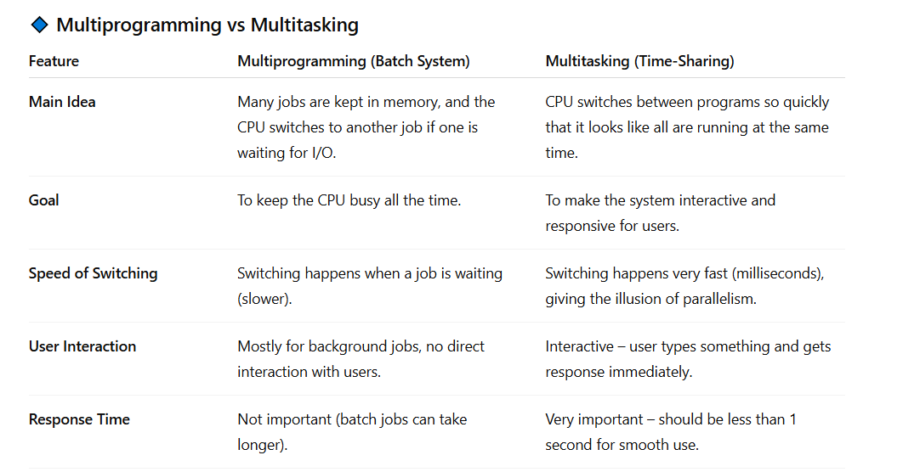
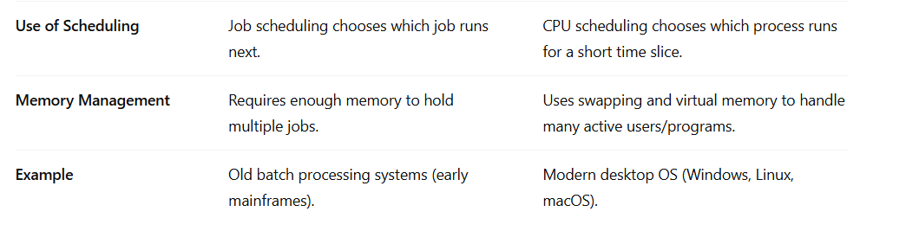
Dual-Mode Operation
1. Two modes of CPU operation
- User mode → normal programs run here (games, apps, etc.).
- Kernel mode → operating system runs here (has full control of hardware).
2. Mode bit
- A special bit in hardware tells whether the CPU is in user mode or kernel mode.
- If mode bit = user → program cannot do dangerous things.
- If mode bit = kernel → OS has full power.
3. Why?
To protect the system:
- Accidentally or intentionally crash the operating system.
- Directly control hardware (like disk, memory, CPU instructions) and mess things up.
4. How is mode changed?
A user program cannot change mode directly (for safety).
Only the OS can do it.

Example:
- When a program makes a system call (like asking OS to read a file), the CPU automatically switches to kernel mode.
- After finishing, the OS switches back to user mode.
5. Privileged instructions
- Some special instructions (like controlling I/O, changing mode bit) are marked as privileged.
- These can only run in kernel mode.
- If a user program tries to run them, the CPU will stop it (trap/exception).
Transition from User to Kernel Mode
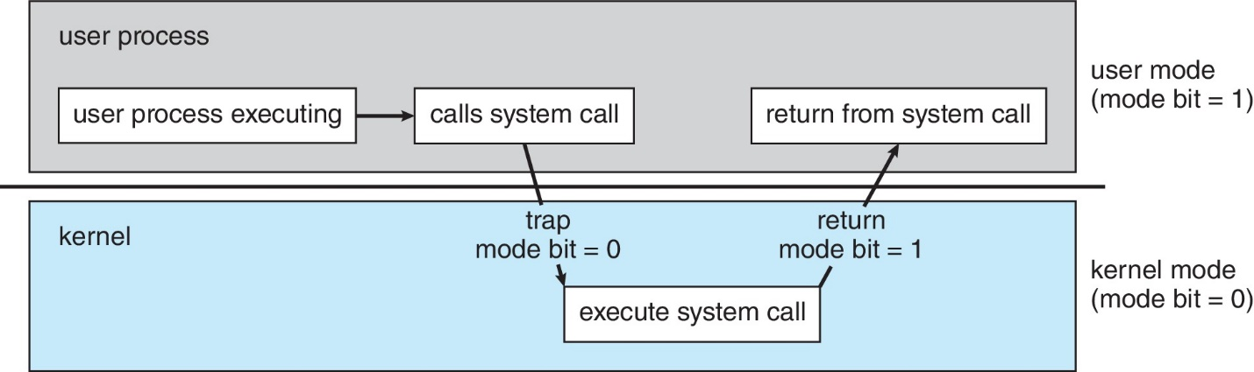
Link Between System Calls and Dual-Mode
Programs run in user mode where they cannot directly access hardware or perform dangerous operations.
When a program needs something special (like reading a file, printing, or allocating memory), it makes a system call.
The system call triggers a switch from user mode to kernel mode.
In kernel mode, the OS performs the requested task because only the OS has full hardware access.
After finishing, the CPU switches back to user mode, and the program continues.
In short:
- System call = the “door” to enter kernel mode.
- Dual mode = ensures only the OS (in kernel mode) can do privileged tasks.
Timer in Operating System
The timer in an operating system is used to make sure that no single program runs forever and wastes CPU time. The operating system sets a counter that decreases with every clock tick. When this counter reaches zero, the CPU creates an interrupt that stops the program and gives control back to the OS. Only the operating system can set this timer because it is a privileged job. The timer is always set before giving control to a process, so the OS can take the CPU back when the time ends or stop the process if it misbehaves. This helps prevent CPU hogging and keeps the system safe and responsive.
Process Management
What is a Process?
A process is simply a program that is running. A program stored on disk is passive entity (inactive), but when it has been assigned RAM and starts executing, it becomes an active process. It is the basic unit of work inside the computer system.
Resources Needed by a Process
To finish its task, a process needs some resources:
- The CPU to run instructions
- Memory to store data
- Input/Output devices like keyboard, screen, or printer
- Files
- Some initial data to start with
When a Process Ends
Once the process finishes, the operating system takes back all the resources it was using so they can be used again by other processes.
Single-Threaded and Multi-Threaded Processes
Single Thread of Execution
In traditional systems, each process contains only a single thread of execution, meaning it can execute only one instruction sequence at a time. The process has one program counter that keeps track of the next instruction to be executed.
Multiple Threads of Execution
Modern operating systems allow a single process to have multiple threads of execution, also known as multithreading. In this case, a process can have multiple program counters, with each thread maintaining its own counter and execution path. This enables different parts of a program to run concurrently, improving performance and responsiveness. For example, one thread might handle user input while another performs background calculations.

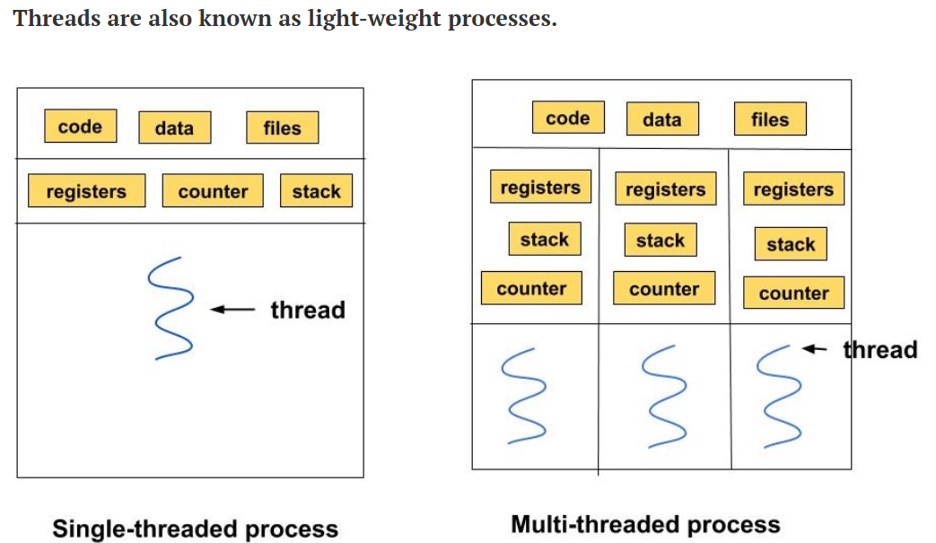
Many Processes in the System
Usually, many processes are running together in a system. Some belong to the user (like apps), and some belong to the operating system its
Concurrency
The CPU is shared among these processes using multiplexing. This means the CPU switches quickly between processes or threads, giving the feeling that they are running at the same time.
Process Management Activities
The operating system (OS) takes care of many jobs related to processes, such as:
1. Creating and Deleting Processes
The OS can create new processes (both user programs and system programs) and also end/delete processes when they are finished.

2. Suspending and Resuming Processes
The OS can pause (suspend) a process for some time and later start it again (resume) when needed.
3. Process Synchronization
When many processes run at the same time, sometimes they need to use the same resource (like a file, printer, or memory). If they don’t take turns properly, they might interfere with each other or create wrong results.
The OS provides rules so that processes wait for each other and work in the correct order without clashing.
4. Process Communication
Processes may need to exchange data or messages with each other. The OS provides safe methods for this communication.
5. Deadlock Handling
Sometimes, processes get stuck waiting for each other’s resources (called deadlock). The OS has methods to detect, prevent, or solve such deadlocks.
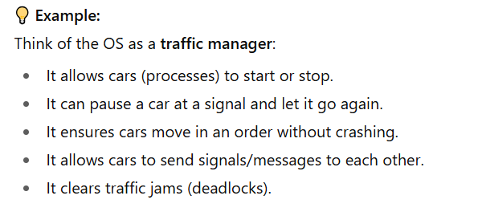
Memory Management
What is Memory Management?
When a program is running, its instructions and the data it needs must be in the computer’s memory (RAM).
Memory management is the job of the operating system that decides:
- What goes into memory,
- When it goes in, and
- When it should be removed.
The goal is to use the CPU efficiently and give fast responses to users.
Activities of Memory Management
- Keeping Track of Memory
The OS keeps a record of which parts of memory are in use and which parts are free, as well as which process is using them.
- Deciding Movement of Processes/Data
The OS decides which processes (or their parts) and which data should be moved into memory and which can be taken out (for example, moved to hard disk temporarily).
- Allocating and Deallocating Memory
The OS gives memory space to processes when they need it (allocation) and takes it back when they are done (deallocation).
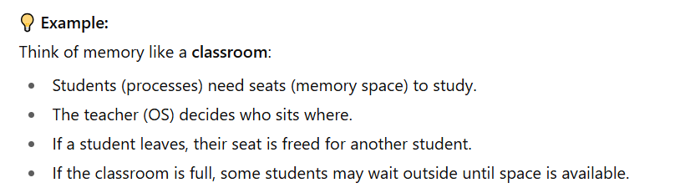
File-System Management
What OS Does for Storage
The operating system (OS) gives users a simple and uniform way to handle data, no matter what type of storage device is used (hard disk, SSD, CD, tape, etc.).
It hides the physical details and shows everything as files.
- Each device (disk drive, tape drive, etc.) has different properties like:
  - Speed (how fast data can be read/written),
  - Capacity (how much data it can store),
  - Data-transfer rate (how quickly data moves),
  - Access method (sequential = one by one, random = direct jump).
Files and Directories
- Files are usually grouped into directories (folders) to stay organized.
- Access control is used to decide who can open, edit, or delete files.
Activities of the OS in File-System Management
The OS is responsible for:
- Creating and Deleting files and directories.
- Giving commands (primitives) to read, write, or modify files and directories.
- Mapping files onto the secondary storage (deciding where on the disk they are stored).
- Making backups of files onto safe storage (non-volatile media like another disk, cloud, or tape) so data isn’t lost.
Mass Storage Management
What is Mass Storage?
- Mass storage usually means disks (like HDDs or SSDs).
- It is used for data that doesn’t fit in main memory (RAM) or data that needs to be stored for a long time (e.g., files, software, backups).
- Managing storage properly is very important because the speed of the whole computer depends a lot on how well the disk system is managed.
Activities of the OS in Mass Storage Management
1. Mounting and Unmounting
Mounting
- Mounting means making a storage device (like a hard disk, SSD, or USB) ready to use by the operating system.
- After mounting, you can see the files and use the device.
Example:
When you plug in a USB drive, your OS mounts it so you can open it in “My Computer” or “This PC.”
Unmounting
- Unmounting means safely removing or disconnecting the storage device from the OS.
- This ensures that all data is saved properly and nothing is lost or corrupted.
Example:
When you click “Safely Remove USB”, you are unmounting the drive before pulling it out.
2. Free-Space Management
- The OS keeps track of which parts of the disk are free and which are already used.
3. Storage Allocation
- The OS decides where on the disk to store each file or piece of data.
4. Disk Scheduling
- When many requests come at once, the OS decides the order in which disk operations are done to make things faster.
5. Partitioning
- Dividing one physical disk into separate sections (partitions) that act like independent disks.
6. Protection
- The OS protects files and data on the disk so that unauthorized access is not allowed.
Caching
What is Caching?
Caching means keeping a temporary copy of data in a faster storage place so it can be used quickly.
It happens at many levels in a computer:
- Hardware (CPU cache, disk cache),
- Operating system,
- Software (like web browsers storing pages).
How Caching Works
- When the computer needs some data, it first checks the cache (the fast storage).
- If the data is found in the cache → it is used directly (this is very fast).
- If the data is not in the cache → it is brought from the slower storage into the cache, and then used.
Important Points
- The cache is smaller than the main storage, so it cannot hold everything.
- Managing the cache is important: the system must decide which data to keep and which data to remove when the cache gets full.
- This is called a replacement policy (e.g., removing the least recently used data).
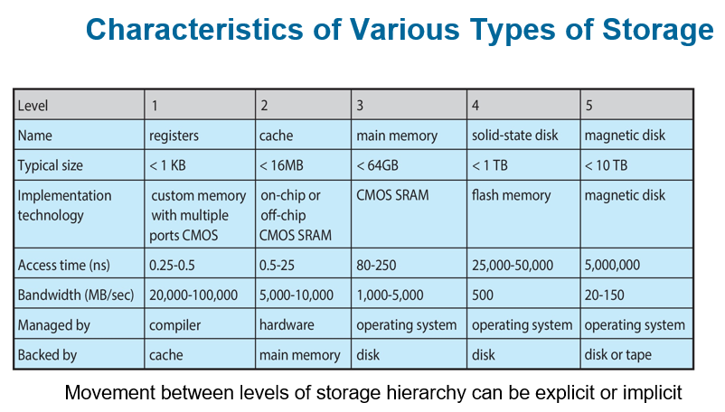
Migration of Data
From Disk to Register
Data moves step by step in the storage hierarchy:
- Disk → Main Memory → Cache → Register (CPU’s fastest storage).
When data “A” is used, it may exist in different places at the same time.
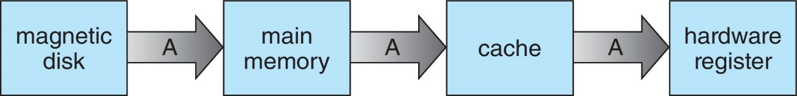
In Multitasking Systems
When many programs are running, the system must make sure it always uses the latest (most recent) value of the data, no matter where it is stored (disk, memory, or cache).
In Multiprocessor Systems
If the computer has many CPUs, each CPU has its own cache.
The system must ensure cache coherency → all CPUs should see the same updated value of data “A” in their caches.
In Distributed Systems
Things are even more complex because data can exist on different computers connected in a network.
Several copies of the same data may exist, and the system must keep them consistent (all showing the correct, updated value).
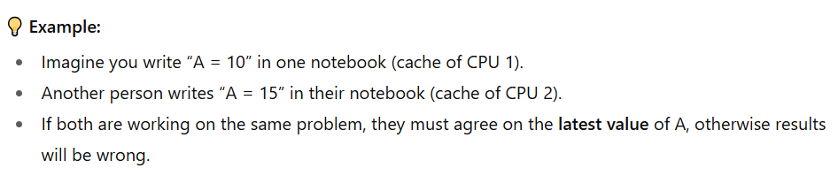
I/O Subsystem
Purpose
One job of the Operating System (OS) is to hide the details of hardware devices (like printer, keyboard, mouse, disk) from the user, so users can use them easily without worrying about how they actually work.
What the I/O Subsystem Does
- Memory Management for I/O
  - Buffering → temporarily storing data while it is being moved (like a waiting area).
  - Caching → keeping a copy of frequently used data in faster storage for quick access.
  - Spooling: Spooling means lining up tasks in a queue so devices can handle them one by one, while the user or computer can keep working on other things.
- General Device-Driver Interface
The OS provides a common way for programs to talk to hardware devices.
- Device Drivers
For each specific device (like a printer or graphics card), the OS uses a driver, which is special software that knows how to control that device.

Protection and Security in OS
Protection
- Protection means controlling who can use which resources in the computer.
- Example: Some users can open a file, but others cannot.
Security
- Security means defending the system from attacks (inside or outside).
- Attacks can be things like viruses, worms, hacking, stealing data, or blocking services.
How the OS manages this
- User Identification (User ID):
- Every user has a unique ID (like a username with a number).
- This ID is linked to all the user’s files and processes.
- Group Identification (Group ID):
- Users can be put into groups (like "students", "teachers", "admins").
- Permissions can be given to the whole group instead of individual users.
- Access Control:
- The OS checks user IDs and group IDs to decide who can read, write, or run a file or program.
- Privilege Escalation:
- Sometimes, a user temporarily gets more power (more rights) to do special tasks.
- Example: "Run as administrator" in Windows.
Task: Distributed Systems
A distributed system is a collection of many computers that are connected to each other through a network. These computers may be different in type or design, but they still work together as a single system. They share tasks and resources to complete work more efficiently. The connection between them is usually done through a network, and the most common way they communicate is by using the TCP/IP protocol, which is also used on the internet.
Types of Networks
- LAN (Local Area Network):
Small area, like inside your home, school, or office.
- WAN (Wide Area Network):
Covers a very large area, like the internet.
- MAN (Metropolitan Area Network):
Covers a city or town.
- PAN (Personal Area Network):
Very small, around one person (like Bluetooth between your phone and earbuds).
How it Works
- A Network Operating System helps these computers work together.
- Computers exchange information by sending messages over the network.
- To the users, the whole distributed system can feel like one single computer, even though many machines are working behind the scenes.
Computer-System Architecture
- Most computers have one main processor (general-purpose processor).
- But many systems also use special-purpose processors (like graphics cards, sound processors, etc.).
- These days, multiprocessor systems (computers with more than one processor) are becoming more common and important.
- Multiprocessor systems are also called parallel systems or tightly-coupled systems.
Advantages of Multiprocessor Systems
- Increased Throughput: More processors can do more work at the same time → faster performance.
- Economy of Scale: Cheaper than having many separate computers, because they share memory, power, and devices.
- Increased Reliability: If one processor fails, the others can still keep the system running (fault tolerance).
Types of Multiprocessing
- Asymmetric Multiprocessing (AMP):
- Each processor has a specific job.
- Example: One processor controls the system, while others do assigned tasks.
- Symmetric Multiprocessing (SMP):
- All processors are equal.
- Each can do any task and share the workload.
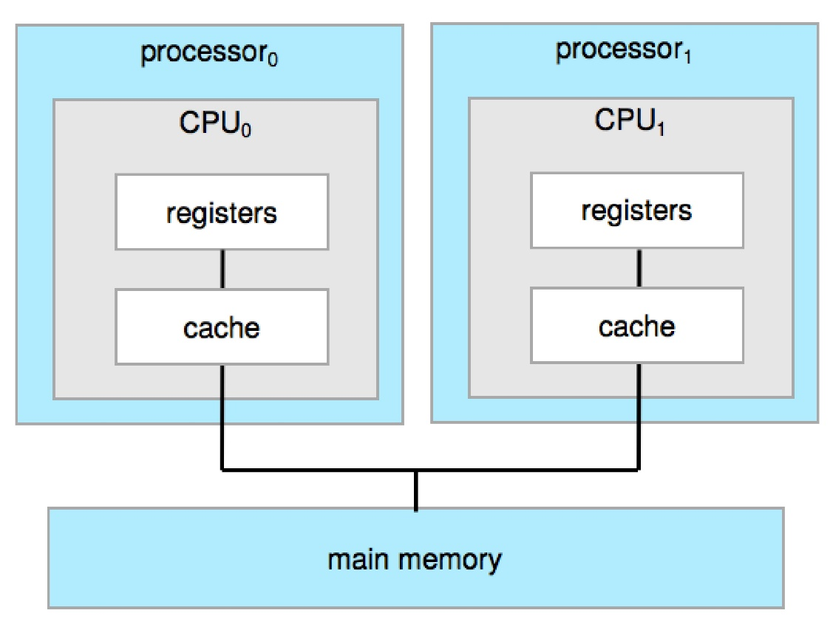
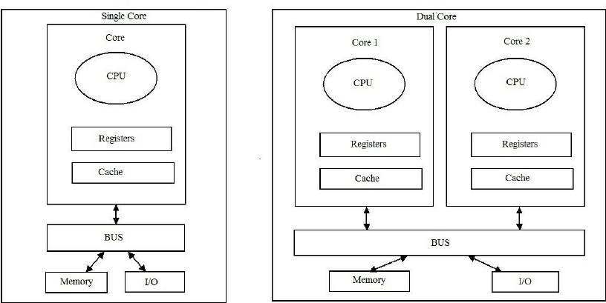

Continue…
So,
- Single core = concurrency (taking turns).
- Multi-core = parallelism (at the same time).
Chapter 2
Operating-System Services
Operating System Services
An Operating System (OS) provides an environment where programs can run and offers different services that make the computer easier to use.
1. User Interface (UI)
Almost every operating system has a user interface that allows people to interact with the computer. This interface can appear in different forms:
- Command-Line Interface (CLI): users type commands.
- Graphical User Interface (GUI): users interact through windows, icons, and menus.
- Touch-Screen Interface: users control the system using fingers or gestures.
- Batch System: A method where jobs/programs are submitted together and executed automatically in groups with little or no user interaction.
2. Program Execution
The operating system helps in running programs. It loads a program into memory, starts its execution, and manages it until the program ends. A program can finish either:
- Normally, when the task is completed, or
- Abnormally, if some error occurs.
3. I/O Operations
Many programs require input and output (I/O) operations. This could mean reading and writing files or interacting with devices like the keyboard, printer, or monitor. The operating system manages these I/O tasks safely and efficiently so that programs can work properly.
4. File System Manipulation
Files are very important for storing information. The operating system provides services to manage them. With the help of the OS, programs can:
- Create, delete, read, and write files.
- Create and remove directories (folders).
- Search for specific files.
- List file information such as size, type, and date.
- Manage permissions to control who can read, write, or execute a file
Operating System Services (Cont.)
Apart from user interface, program execution, I/O operations, and file management, the operating system also provides other important services.
5. Communications
The operating system allows processes (running programs) to share information with each other. This communication can happen:
- On the same computer, between two or more processes.
- Between different computers connected through a network.
Communication is done in two main ways:
- Shared Memory: Processes use the same memory space to exchange data.
- Message Passing: Information is sent in the form of packets, which the OS manages and delivers.
6. Error Detection
The OS must always be watchful for errors to keep the system stable and safe. Errors can happen in:
- CPU or memory hardware (like hardware faults).
- Input/Output devices (like printer or disk failures).
- User programs (like dividing by zero or invalid instructions).
When an error occurs, the OS takes proper action to fix the problem or stop it from affecting other parts of the system.
To help users and programmers, the OS also provides debugging tools, which make it easier to find and correct mistakes in programs.
Operating System Services (Continued)
Besides helping users run programs and handle files, the operating system also provides services that ensure the system itself works efficiently and resources are shared properly.
7. Resource Allocation
When many users or programs are running at the same time, the operating system must divide resources fairly.
- Resources include the CPU, main memory, file storage, and I/O devices.
- The OS decides how much of each resource will be given to each job or user so that all can work smoothly without conflict.
8. Logging (Accounting)
The OS also keeps records of resource usage.
- It tracks how much CPU time, memory, or storage a user or program consumes.
- These logs can be used for billing users in commercial systems, or just for statistics to monitor performance and improve the system.
- Billing Example: In cloud services, if a user runs a program that uses the CPU for 5 hours and stores 10 GB of data, the OS logs this usage, and the provider generates a bill based on it.
- Statistics Example: If logs show that CPU usage is very high between 9 AM and 12 PM, admins can add more CPUs or memory to improve performance during peak hours.
9. Protection and Security
In a multi-user or networked system, it is very important to keep information safe and prevent unwanted access.
Protection ensures that processes do not interfere with each other and that every access to system resources is properly controlled.
On the other hand, security focuses on protecting the system from outsiders. This includes methods such as user authentication through passwords or biometric logins, preventing unauthorized access to files, memory, and devices, and defending external devices like network ports or USB drives from harmful or invalid attempts. Together, protection and security make the system reliable, safe, and fair for all users.

A View of Operating System Services
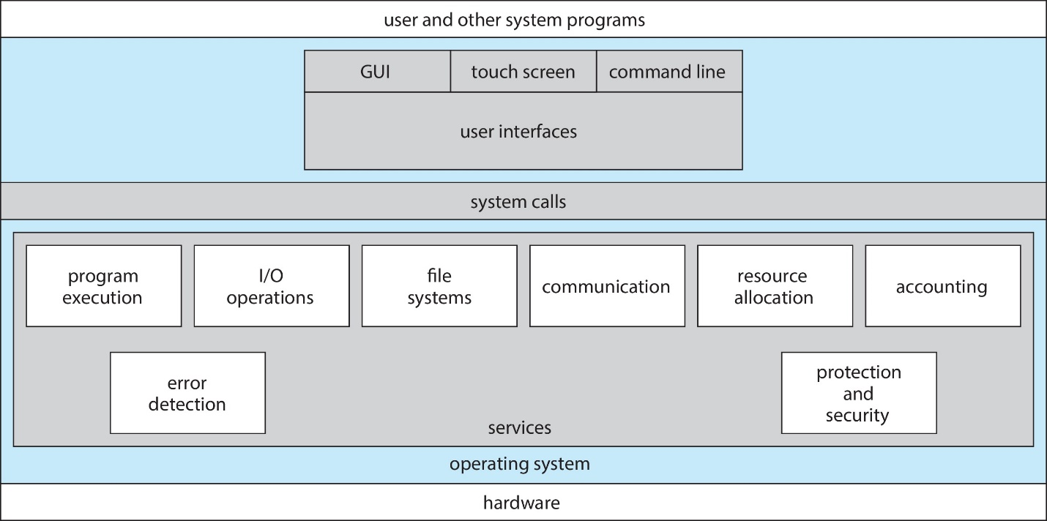
Command Line Interpreter (CLI)
A Command Line Interpreter (CLI) lets users control the computer by typing commands. It can be part of the operating system or a separate program. Different versions are called shells (like Bash in Linux or Command Prompt in Windows).
When you type a built-in command like cd, the shell itself does the work — no other program is opened.
When you type an external command like python or git, the shell sees the word you typed, looks for that program on your computer, and runs that program.

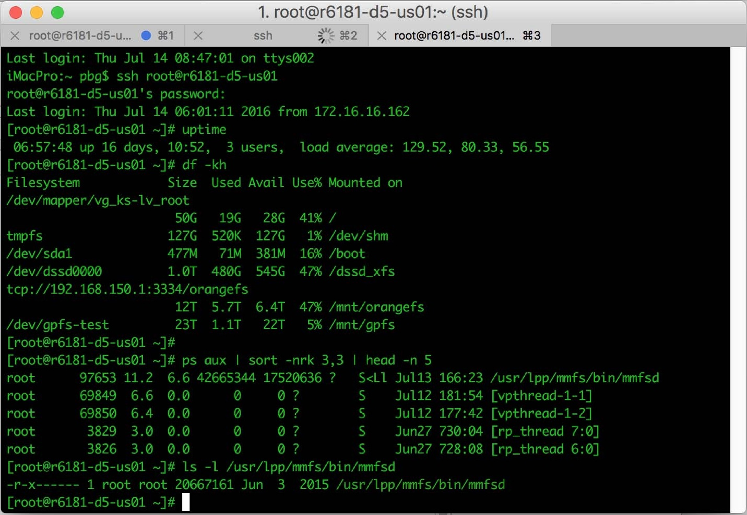
User Operating System Interface – GUI
A Graphical User Interface (GUI) makes the operating system more user-friendly by allowing people to interact with the computer through visuals instead of only typing commands. In a GUI, users work with a desktop-like environment using a mouse, keyboard, and monitor. Files, programs, and actions are shown as icons, and clicking or right-clicking on them can open folders, show options, provide information, or run programs.
The idea of GUI started at Xerox PARC and is now used in almost all modern systems. Most operating systems provide both GUI and CLI, so users can choose either.
For example:
- Windows mainly uses GUI but also has Command Prompt.
- macOS has the Aqua GUI with a UNIX base.
- Linux/Unix are command-line based but also offer GUIs like KDE and GNOME

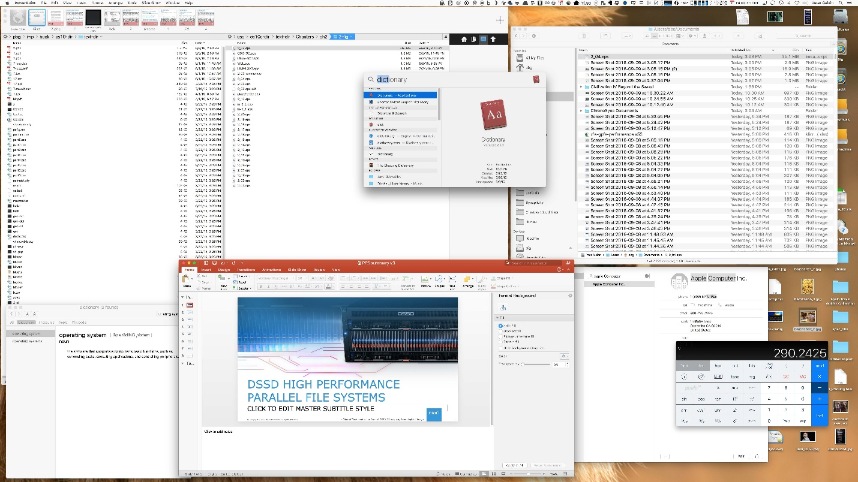
Touchscreen Interfaces
Touchscreen devices need special interfaces because using a mouse is either not possible or not convenient. In these systems, actions and selections are done through gestures such as tapping, swiping, or pinching on the screen. For typing, a virtual keyboard appears on the screen instead of a physical one. Many touchscreen interfaces also support voice commands, making it even easier for users to interact with the system without needing extra devices

System Calls
System calls act as a bridge between a program and the operating system (OS), allowing the program to use the services provided by the OS, such as reading files, creating processes, or managing hardware. They are usually written in high-level programming languages like C or C++. However, most programs do not directly use system calls; instead, they access them through an easier interface known as an application.
Link Between System Calls and APIs
- System calls are the direct way for programs to talk to the operating system (like asking it to read a file or print something).
- APIs are a simpler layer on top of system calls that programmers use.
So basically:
When you use an API function in your program (like printf() in C or readFile() in JavaScript), that function secretly uses system calls inside to talk to the operating system and get the job done.
Example of System Calls
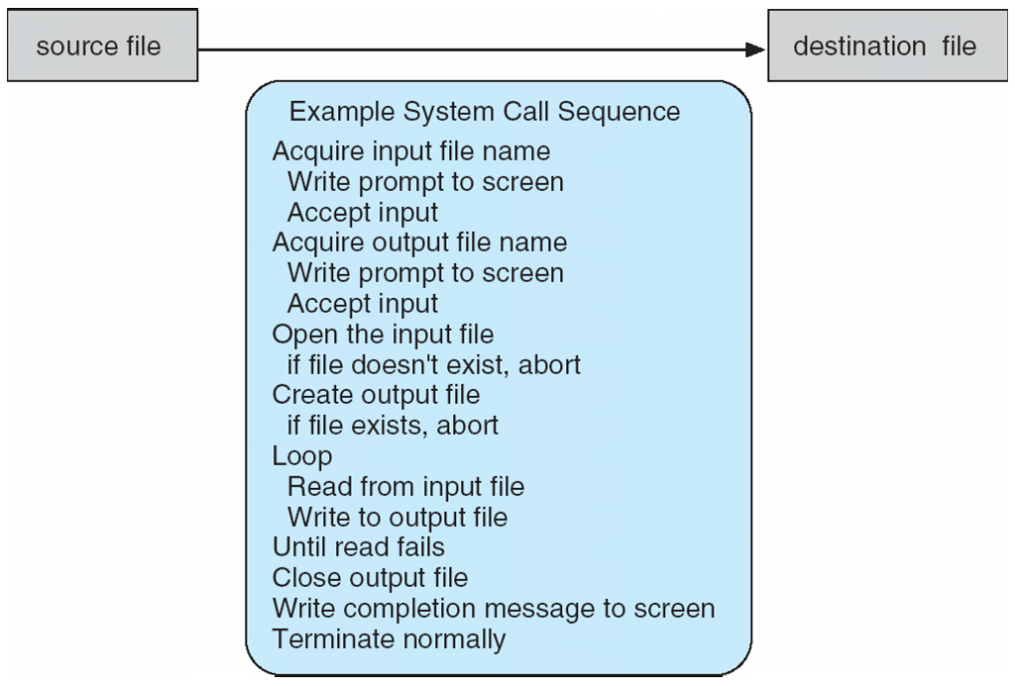
Application Programming Interface (API)
An API (Application Programming Interface) is a set of rules and protocols that allows one software application to communicate and interact with another. It defines how different software components should exchange information, making it easier for them to send requests and receive responses in a well-structured way.
Example
For example, in data access, APIs enables applications to retrieve or send data to other systems — like a weather app using an API to get the latest weather updates from an online server.
Commonly Used APIs
There is also Web APIs (or HTTP APIs) that use web protocols such as HTTP to transfer data, usually in formats like JSON or XML. Common examples of web APIs include REST APIs and GraphQL APIs, which are widely used for web and mobile app development.
System Call Implementation
Each system call has a unique number assigned to it. The operating system keeps a table that matches these numbers to the correct system call functions. When a program makes a system call, the system call interface looks up this number in the table, runs the correct function inside the OS kernel, and then sends back the result or status to the program.
API – System Call – OS Relationship
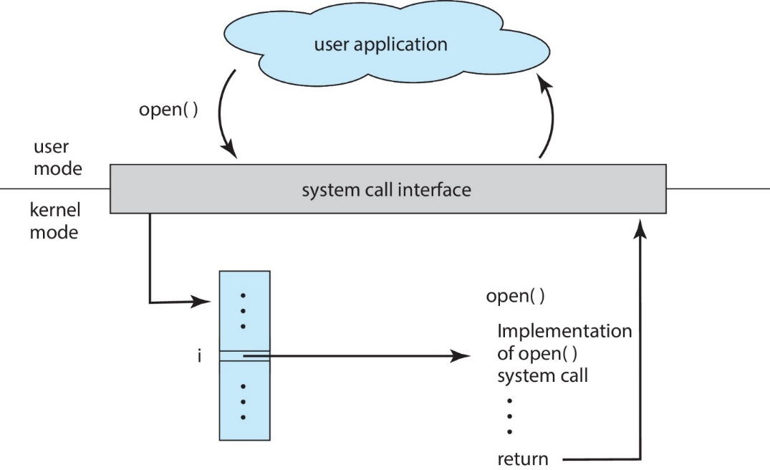
Figure Explanation
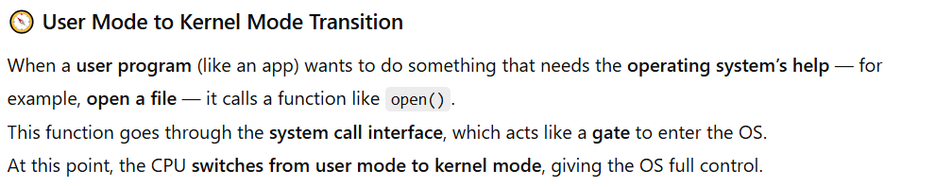
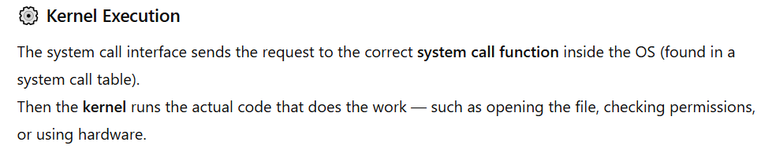
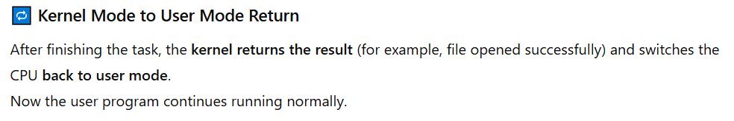
System Services
System programs make it easier to create and run programs.
They help users work with the computer in a simple and comfortable way.
System services include:
- File manipulation: Creating, deleting, reading, writing, or changing files.
- Status information: Showing system details like memory use, time, or device status (sometimes saved in a file).
- Programming language support: Providing compilers, assemblers, and debuggers for writing programs.
- Program loading and execution: Loading programs into memory and running them.
- Communications: Allowing different systems or users to send and receive data.
- Background services: Programs that run automatically to handle tasks like updates or printing.
- Application programs: Software that helps users do specific tasks (e.g., word processing, games).
System Services (Continued)
System services make it easy to develop and run programs.
Some are just simple tools that connect directly to system calls,
while others are more advanced and do complex tasks.
File Management
- Used to create, delete, copy, rename, print, list, or manage files and folders.
- Helps users organize and control their data.
Status Information
- Some programs show system info like date, time, memory, disk space, and number of users.
- Others give detailed reports such as performance logs or debugging info.
- Usually, this information is displayed on the screen or printed.
- Some systems have a registry that stores and retrieves configuration (settings) information.
System Services (Continued)
File Modification
- Use text editors to create or change files.
- Use special commands to search for specific content in files or to modify text automatically.
Programming Language Support
- The system provides tools like compilers, assemblers, debuggers, and interpreters to help programmers write and test programs.
Program Loading and Execution
- Programs such as loaders and linkers are used to put programs into memory and run them.
- Debugging systems help find and fix errors in both high-level and machine-level programs.
Communications
- Allow processes, users, or computers to connect and share information.
Examples include:
Sending messages between users
- Browsing websites
- Sending emails
- Logging in remotely
- Transferring files between computers
Linkers and Loaders
1. Object Files
When we write code and compile it, it turns into an object file.
This file can be placed anywhere in memory when it runs — that’s why it’s called a relocatable object file.

2. Linker
The linker’s job is to combine all object files into one single executable file (the final runnable program).
It also adds libraries (like built-in code your program needs).
3. Loader
The loader takes that executable file from the hard drive and loads it into the main memory (RAM) so it can actually run.
4. Relocation
This is the step where the final memory addresses are given to all parts of the program,
and the code is adjusted to use those new addresses properly.
5. Dynamic Linking
Modern systems don’t copy whole libraries into every program.
Instead, they use Dynamic Link Libraries (DLLs) — these are loaded only when needed and can be shared among programs that use the same library (saves space and time!).
Example
Let’s say you have 3 programs that all use the same math functions.
With static linking, each program would have its own copy of the math code — wasting space.
With dynamic linking, the math library is stored once, and all 3 programs share it while running.
6. Standard Formats
Both object files and executable files follow standard formats,
so the operating system knows exactly how to load and start them.

The Role of the Linker and Loader
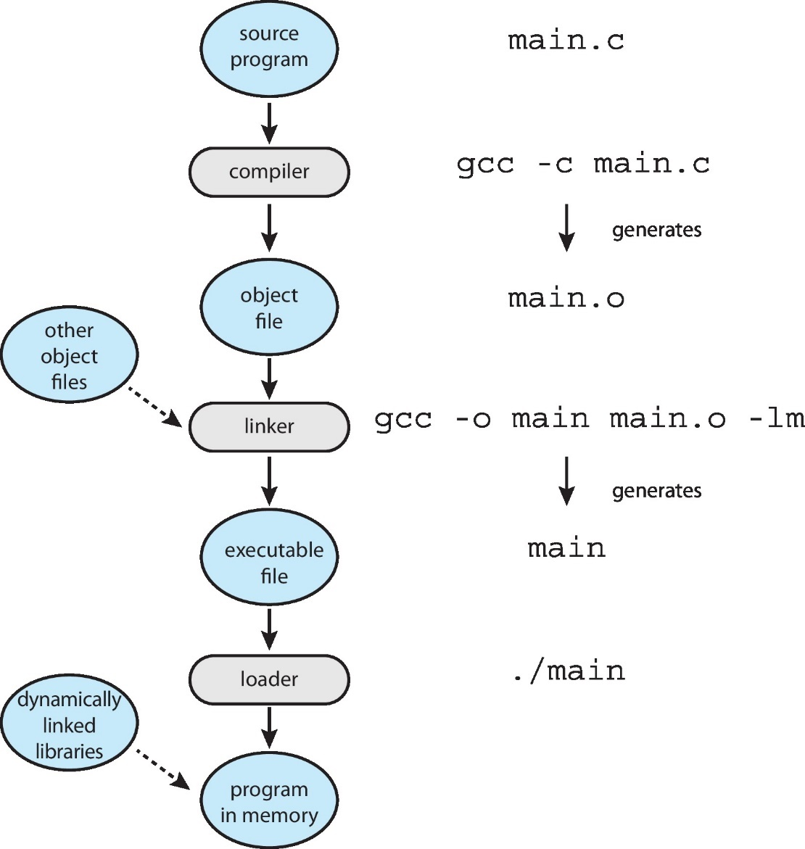
Operating System Structure
General Purpose Operating System
A general-purpose operating system (like Windows, Linux, or macOS) is a very large and complex program.
Because it does many different jobs — managing files, memory, devices, and users — it needs to be organized properly.
1. Simple Structure (Example: MS-DOS)
- MS-DOS is an example of a simple OS structure.
- It doesn’t have clear separation between its parts — everything is connected.
- This makes it small and fast but also harder to maintain or secure.
Think of it like a small house where kitchen, bedroom, and bathroom are all in one room — easy to build but messy to manage.
2. More Complex Structure (Example: UNIX)
- UNIX is more organized than MS-DOS.
- It separates different parts of the OS (like file system, process management, and input/output).
- This makes it more reliable and easier to fix or update.
3. Layered – an abstraction
4. Microkernel – Mach
Monolithic Structure
1. What It Means
The monolithic structure is the simplest type of operating system structure.
It means everything is combined together — all parts of the operating system work inside one big program (a single large file).
So, instead of separating tasks (like memory management, file handling, etc.),
all the functions are put together in one place.
2. How It Works
- All the OS functions (like file system, device drivers, and process control) are built into one single program.
- This program runs in one memory area (called a single address space).
- It is a static binary file, meaning it doesn’t change or load separate parts later — everything is included from the start.
3. Example – Original UNIX
The original UNIX operating system used this monolithic design.
It had two main parts:
- Kernel – the main part that controls hardware and system operations.
- System Programs – tools and commands that help users interact with the system.
Over time, UNIX developers added more interfaces and device drivers to the kernel, making it larger and more capable.
UNIX Operating System Structure
1. Limited by Hardware
The original UNIX system was created when computers were simple and had limited power.
Because of that, the structure of UNIX was also simple and not very organized.
2. Two Main Parts of UNIX
The UNIX operating system is divided into two main parts:
- System Programs
→ These are the tools and commands that help users interact with the operating system.
(For example: file editors, compilers, and utilities like ls or cp.)
- Kernel
→ This is the core part of the operating system.
It directly communicates with the hardware and controls everything that happens inside the computer.
3. What the Kernel Does
The kernel includes everything that works below the system-call interface (the bridge between user programs and the OS)
and above the hardware (like CPU, memory, and devices).
It performs important functions like:
- Managing files and directories (File System)
- Handling CPU scheduling (deciding which program runs next)
- Managing memory (keeping track of which program uses which memory)
- Controlling input/output (I/O) devices
All these functions are grouped into one single level — that’s why UNIX is considered a monolithic structure.
Monolithic Kernels – Advantages and Drawbacks
Drawbacks
1. Hard to Modify or Maintain
Since all parts of the kernel are combined in one big program,
making changes (like adding a new feature or fixing a bug) is very difficult.
A small change in one part can affect the whole system or cause errors.
2. Less Secure and Stable
Because everything runs in the same memory space,
if one part of the kernel (for example, a device driver) crashes or has a bug,
it can crash the entire operating system.
This makes the system less stable and more risky.
Drawbacks
1. Fast and Efficient
One big advantage of the monolithic kernel is speed.
Because all parts of the kernel are tightly connected and run in the same memory space,
there is very little delay when programs use system calls (like accessing files or devices).
Also, communication between different parts of the kernel is very fast.
2. Easy Communication Inside the Kernel
Since everything is connected closely inside one big program,
the different parts of the kernel can communicate directly with each other.
This makes system calls (like accessing files or devices) quick and smooth.
3. Still Used Today
Even though monolithic kernels have some drawbacks,
their speed and efficiency make them very useful.
That’s why modern operating systems like UNIX, Linux, and even Windows
still use monolithic-style kernel designs (sometimes with improvements).

Traditional UNIX System Structure
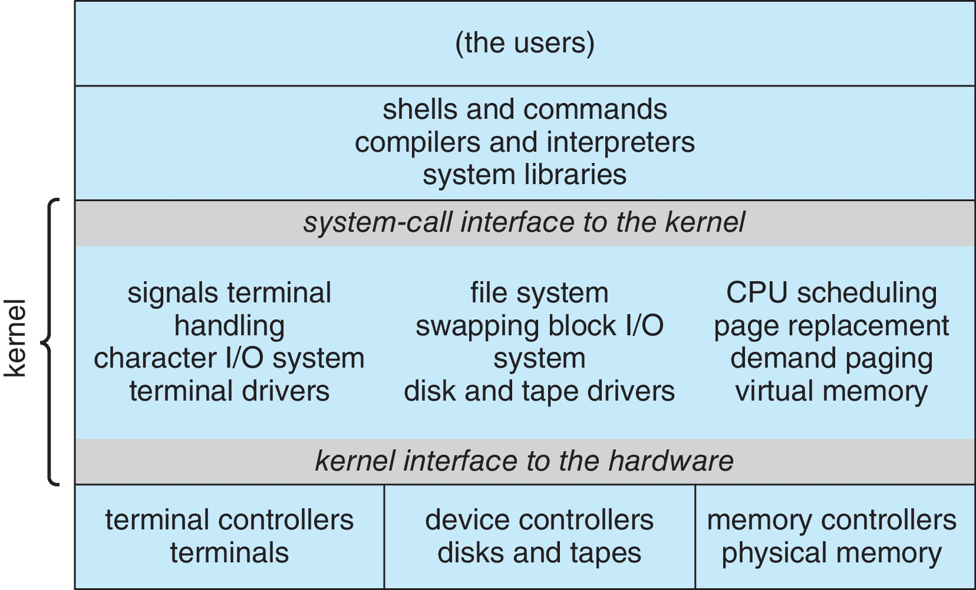
Chapter 3
Processes
Process
An operating system runs many different programs at the same time. Each running program is called a process.
A process means a program in execution — it’s not just stored in memory but actually being carried out by the CPU.
The process runs in a step-by-step (sequential) order. It does not execute instructions in parallel; instead, one instruction runs after another within the same process.
Parts of a Process
Every process is made up of several important parts that help it work properly:
1. Program Code (Text Section)
This is the actual code or instructions written by the programmer. The CPU reads these instructions and performs them.
2. Current Activity
This includes the Program Counter (PC) and Processor Registers.
The Program Counter keeps track of which instruction is currently being executed, and the registers store temporary values that the CPU needs right now.
3. Stack
The stack stores temporary data, such as:
- Function parameters (values passed to functions)
- Return addresses (where to go after a function finishes)
- Local variables (variables used inside functions)
4. Data Section
This part stores global variables, which can be used by any part of the program.
5. Heap
The heap is used for dynamic allocation, memory that is requested during program execution (for example, when using malloc () in C or new in Java).
Process Concept (Cont.)
A program by itself is just a passive entity, meaning it is simply a file stored on the disk (like an .exe or .bat file). It doesn’t do anything on its own.
But when this program is loaded into memory and starts running, it becomes a process. At this point, it becomes active — it uses the CPU, memory, and other system resources.
How a Program Becomes a Process
When you start a program, for example by:
- Double-clicking its icon (using GUI), or
- Typing its name in the command line,
The operating system loads the program’s code into memory and begins its execution. This is the moment when a program turns into a process.
One Program – Many Processes
It’s possible for one single program to create many processes.
For example, if several users open the same text editor or web browser at the same time, each user is running their own process of that same program.
So, even though the program file is one, the system handles multiple active copies (processes) of it running independently.
Example
Let’s take the example of Google Chrome:
When you open Chrome, each tab you open runs as a separate process.
So, if you open 5 tabs, the operating system actually creates 5 different Chrome processes (plus one main process for the browser).
Each process runs separately so that if one-tab crashes, the others can still work properly.
Process in Memory
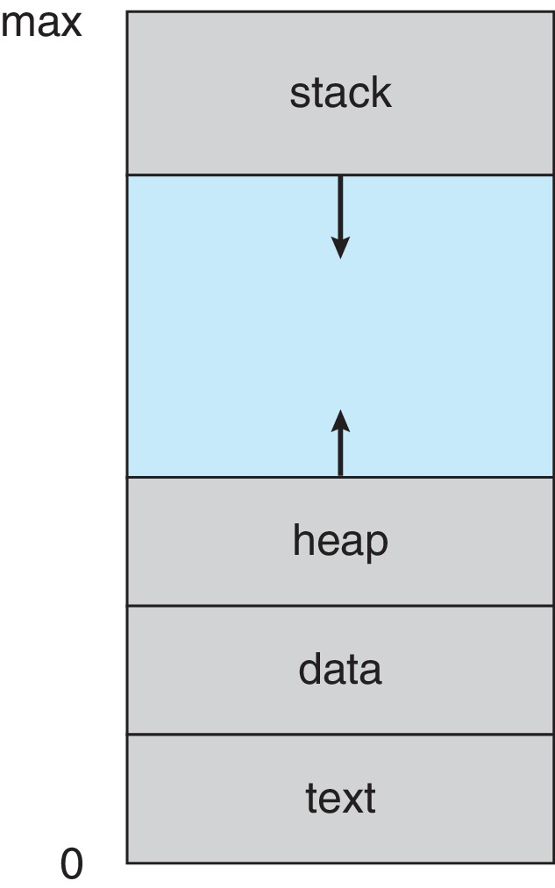

Free Space: The gap between heap and stack is unused memory. Both can grow into this space, but if they collide, your program crashes.
All others text; data, heap and stack have been discussed at the start of the chapter.
Memory Layout of a C Program
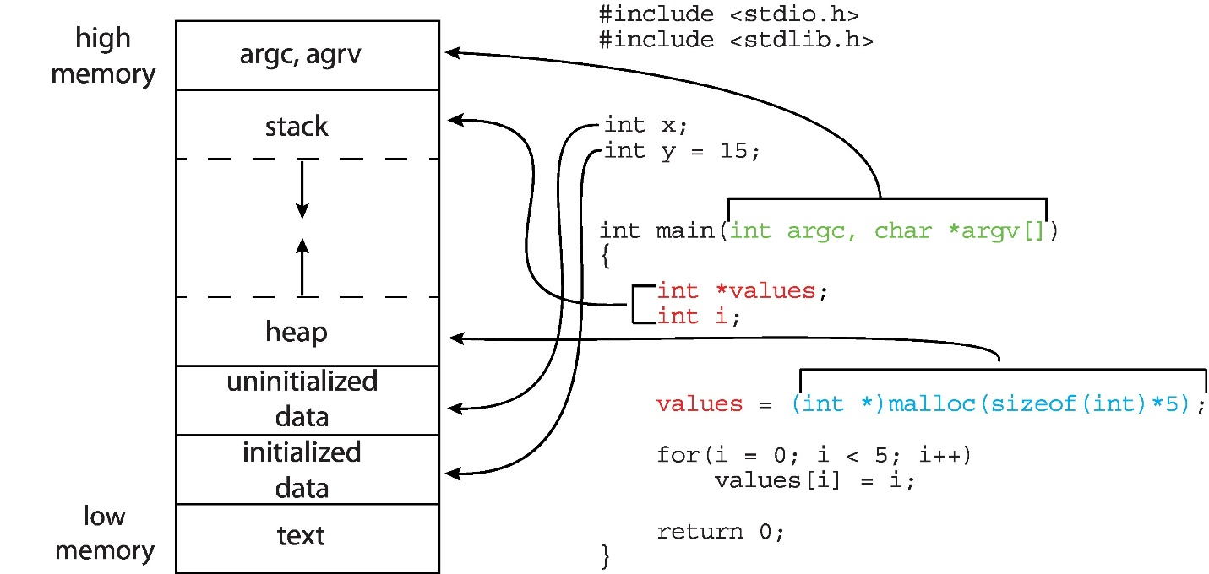
Process State
When a process runs, it keeps changing from one state to another depending on what it is doing.
There are five main states of a process:
1. New
The process is just being created.
It has not started running yet — the operating system is setting up the required resources.
Example: When you click on the icon of MS Word, the system starts creating the process — this is the new state.
2. Running
The process is currently using the CPU and executing its instructions.
Example: When MS Word is open and you are typing a document, it is in the Running state.

3. Waiting
The process is paused, waiting for some event to happen before it can continue.
It might be waiting for input, like data from the keyboard, mouse, or a file to load.
Example: When you press “Print” in MS Word and it waits for the printer to be ready, the process is in the Waiting state.
Example: User Input
When a program shows a message like “Enter your name:” and waits for you to type, it is in the Waiting state.
It’s waiting for keyboard input.
4. Ready
The process is prepared to run and waiting for the CPU to become free.
It’s not running right now but can start anytime the CPU is available.
Example: If many programs are open, MS Word might be Ready while the CPU is running Chrome. When Chrome’s turn ends, Word can run.
5. Terminated
The process has finished execution and is now ended.
All its resources (like memory) are released by the system.
Example: When you close MS Word after saving your document, the process moves to the Terminated state.

Diagram of Process State
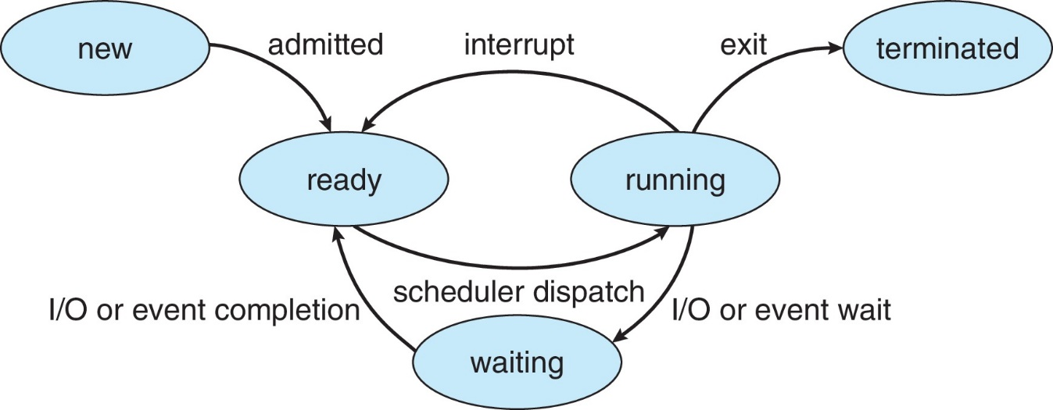
Explanation of figure along with example
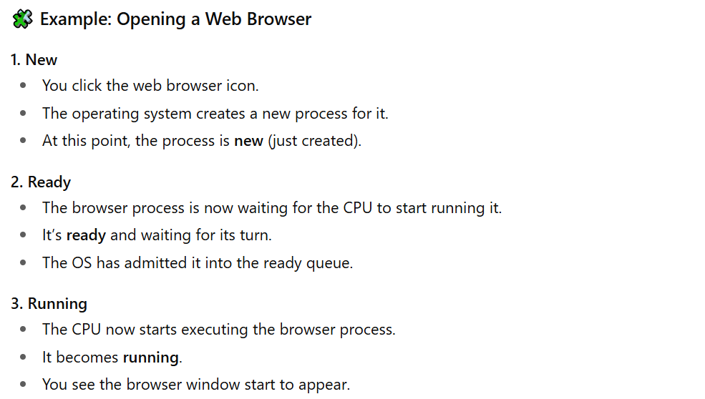
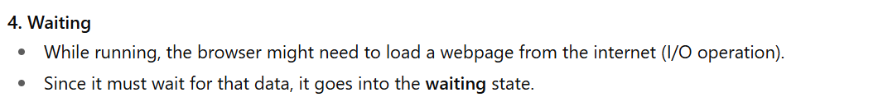

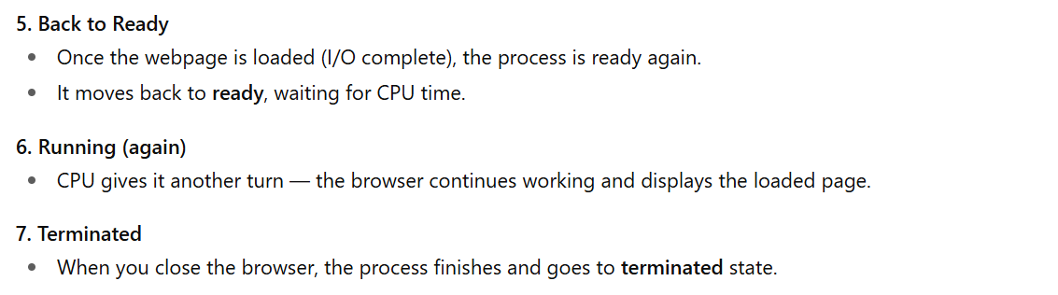
Task: Difference Between Ready Queue and Wait Queue
Ready Queue
The Ready Queue contains all the processes that are ready to run but are waiting for the CPU to become free. These processes are already loaded into memory and can start executing as soon as the CPU gives them a turn. They are not waiting for any input or output operation — just for CPU time.
Example: If you have opened Word and Chrome at the same time, while Chrome is using the CPU, Word stays in the Ready Queue waiting for its turn.
Wait Queue
On the other hand, the Wait Queue (also called the Blocked Queue) holds processes that are waiting for some event or I/O operation to finish before they can continue. These processes cannot execute even if the CPU is available because they are waiting for input or output devices like the keyboard, disk, or printer.
Example: If you press “Print” in Word and it waits for the printer to be ready, the Word process moves to the Wait Queue until the printing is complete.
Imp: After the event occurs, the process moves from the Waiting Queue to the Ready Queue.
Process Control Block (PCB)
Each running or waiting process in the system has a Process Control Block (PCB) — a small data structure where the OS keeps all information about that process (like its ID, register values, memory info, and current state).
Information Stored in PCB:
- Process State: Current state (running, ready, waiting, etc.)
- Program Counter: Address of the next instruction to execute
- CPU Registers: Contents of all registers used by the process
- CPU Scheduling Info: Priority, scheduling queue pointers
- Memory Management Info: Memory allocated to the process (page tables, segment tables, etc.)
- Accounting Info: CPU usage, elapsed time, time limits, etc.
- I/O Status Info: Devices allocated, list of open files
Together, this is called the Context of the process.
Where the Process Control Block (PCB) Exists in Memory
Overview
The Process Control Block (PCB) is a crucial data structure used by the operating system to manage and control processes. Its location in memory is carefully chosen to ensure both security and efficient process management.
Kernel Space (OS Memory)
Protected Memory Area
The Process Control Block (PCB) is stored in the kernel space, which is a protected section of memory reserved for the operating system. This area is inaccessible to user processes, ensuring that critical process management data remains secure and cannot be accidentally or maliciously altered.
Reason for Kernel Control
Since the PCB contains vital information such as process states, CPU registers, memory allocation details, and I/O status, it must remain under the complete control of the kernel.
Importance of Kernel Storage
Storing PCB in kernel space helps maintain the security, integrity, and stability of the operating system, as only the kernel has the authority to modify or access it.

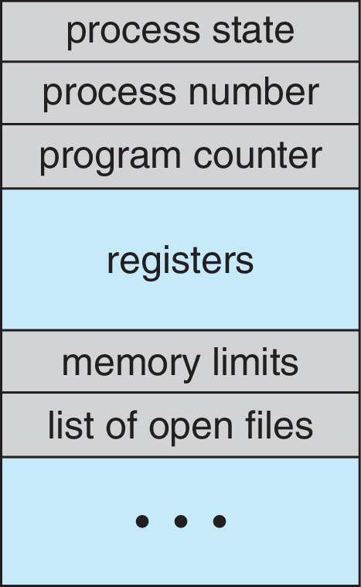

Dynamic Allocation in the Operating System
Creation of a New Process
When a new process is created, for example using a system call like fork () in UNIX-based systems, the operating system dynamically allocates memory for its PCB within the kernel space. Each process receives its own PCB to store all necessary information for execution and scheduling.
Data Structures Used
The operating system organizes and manages multiple PCBs using data structures such as linked lists, queues, or tables.
Example Queues
For instance, the ready queue may hold PCBs of processes waiting for CPU time, while waiting queues manage processes waiting for I/O operations.
Purpose of Structured Management
This structured management allows the OS to efficiently track, schedule, and control all active processes in the system.
Thread
A thread is the smallest unit of execution within a process.
Single Thread of Execution
In traditional systems, each process contains only a single thread of execution, meaning it can execute only one instruction sequence at a time. The process has one program counter that keeps track of the next instruction to be executed.

Multiple Threads of Execution
Modern operating systems allow a single process to have multiple threads of execution, also known as multithreading. In this case, a process can have multiple program counters, with each thread maintaining its own counter and execution path. This enables different parts of a program to run concurrently, improving performance and responsiveness. For example, one thread might handle user input while another performs background calculations.
Shared Resources
All threads within the same process share common resources, such as the code section, data section, and open files. However, each thread has its own registers, stack, and program counter. This allows threads to execute independently while still cooperating within the same process environment.
Thread Information in PCB
Because multiple threads exist within a process, the Process Control Block (PCB) must be expanded to include thread-related information. This includes details such as thread identifiers, thread states, and individual program counters for each thread. The operating system uses this information to manage, schedule, and coordinate multiple threads efficiently.


Process Scheduler
Process scheduler is responsible for deciding which process should run next on the CPU core. Its main goal is to maximize CPU usage by keeping the processor as busy as possible and by quickly switching between processes when needed.
To manage this, the scheduler keeps different queues of processes:
- Ready Queue: Contains all processes that are in main memory and are ready to run, waiting for their turn to use the CPU.
- Wait Queue: Contains all processes that are waiting for some event, such as input/output (I/O) operations, to complete before they can continue.
Processes move between these queues as they run, wait, or become ready again.

I/O Bound and CPU bound Processes
1. I/O-Bound Processes
An I/O-bound process spends most of its time performing input/output operations, such as reading from a disk, writing to a file, or waiting for user input. These processes spend relatively little time on computations. For example, a word processor that waits for the user to type or a file download program is primarily I/O-bound because it spends most of its time waiting for data transfer.
2. CPU-Bound Processes
A CPU-bound process spends most of its time performing computations and generates fewer I/O requests. These processes require more CPU time for calculations rather than waiting for I/O events. For example, a scientific simulation or a video rendering program is CPU-bound because it mainly performs intensive computations with minimal interaction with input/output devices.
3. Importance in Scheduling
Classifying processes as I/O-bound or CPU-bound helps the operating system schedule tasks efficiently, balancing CPU utilization and I/O activity to maximize overall system performance.
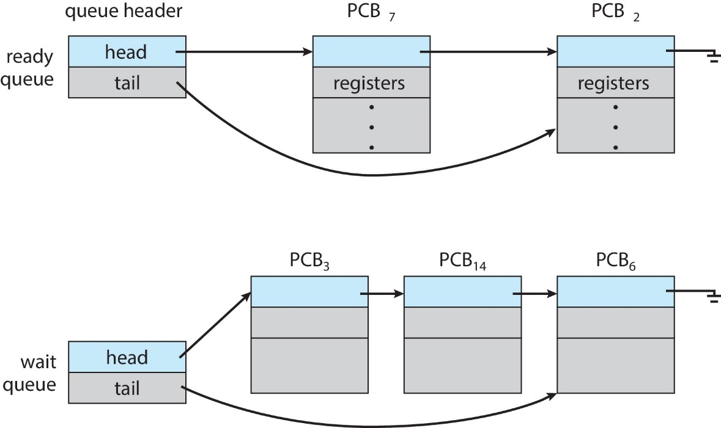
Figure Explanation
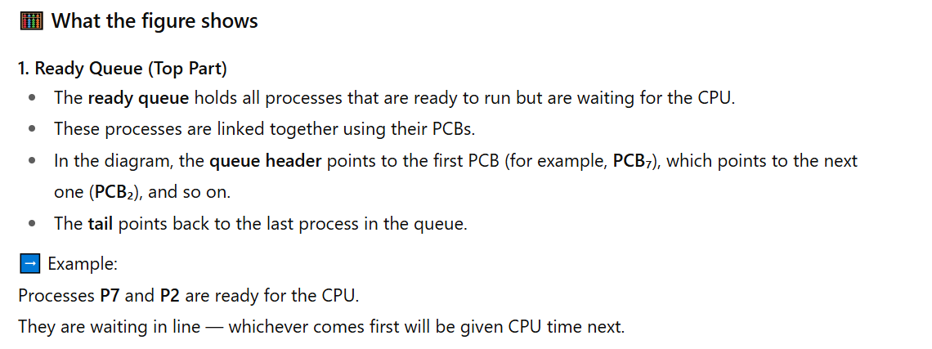
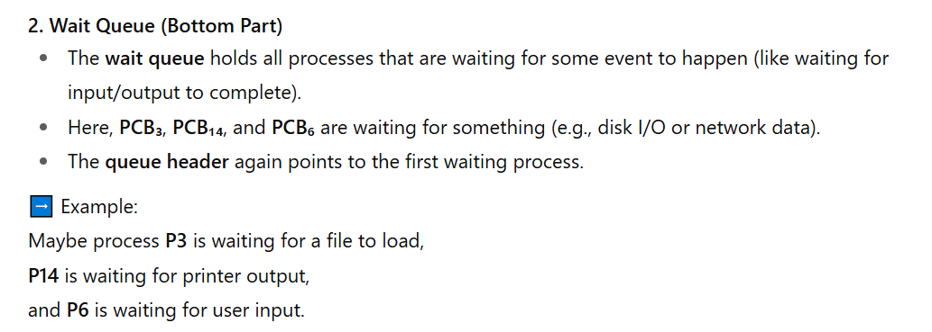
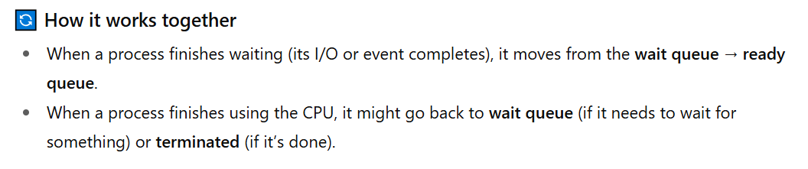Representation of Process Scheduling
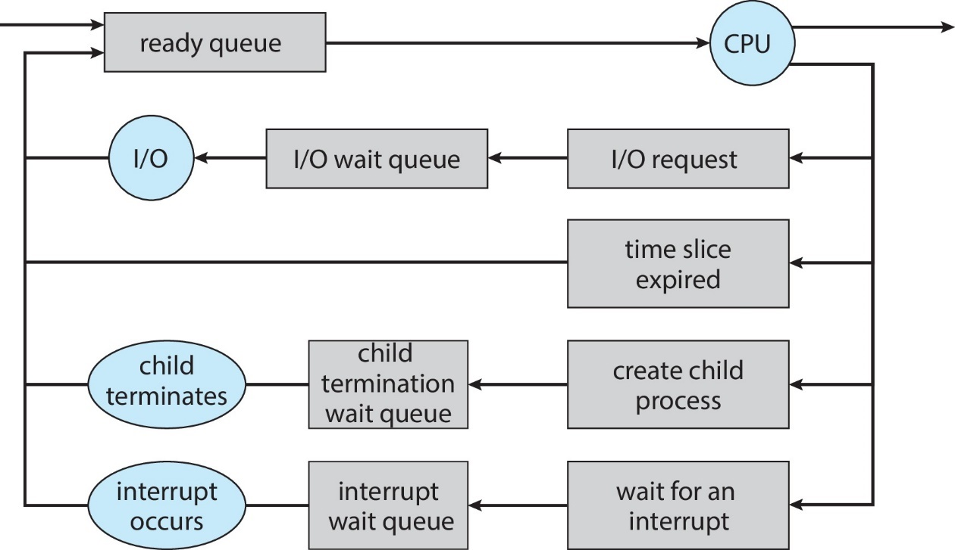
Context Switch
A context switch is the process by which the CPU changes from executing one process (or thread) to another.
When this happens, the operating system must:
- Save the current state of the old process (like register values, program counter, etc.) into its PCB (Process Control Block).
- Load the saved state of the new process from its PCB so that it can continue running from where it left off.

Important Points
- The context of a process = all the information about its current state (stored in the PCB).
- Context-switch time is pure overhead because the CPU does no useful work, only saves and restores process states.
- The more complex the OS or PCB, the longer the switch takes. Because a more complex OS or PCB contains more data to save and restore during a context switch — such as extra registers, memory info, and process details — so the CPU needs more time to handle all that information, making the switch slower.
- The hardware also affects switching time.
Some CPUs have multiple sets of registers, allowing faster switching (because several process states can be kept ready at once).
CPU Switch from Process to Process
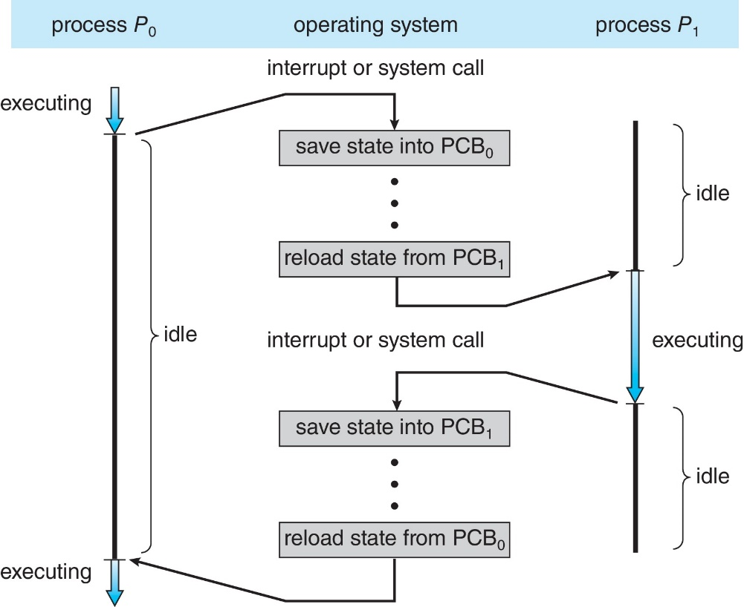

Foreground and Background Process
Foreground Process:
The app or process that is currently on the screen and the user is interacting with.
Example: When you are chatting on WhatsApp, that app is the foreground process.
Background Process:
The app or process that is not visible on the screen but is still running to do some task.
Example: When you play music and then open another app, the music app keeps running in the background.
Multitasking in Mobile Systems
Multitasking means a mobile device can run more than one app or process at the same time. It lets users do different things together — for example, listening to music while using another app.
Multitasking in iOS
In iOS, especially in older versions, only one app could run actively at a time, while others were paused in the background. Because of the small screen and simple design, iOS allows only one foreground app (the one on the screen) to run fully. Other background apps stay in memory but can do only limited work — like playing music, getting notifications, or tracking location. This helps save battery power and keeps the system smooth.
Multitasking in Android
In Android, both foreground and background apps can run at the same time with fewer limits. Android uses a special part called a Service to handle background work like music playback, downloads, or data syncing. A Service keeps running even if the app is closed and uses very little memory because it has no user interface. This makes Android better for true multitasking.
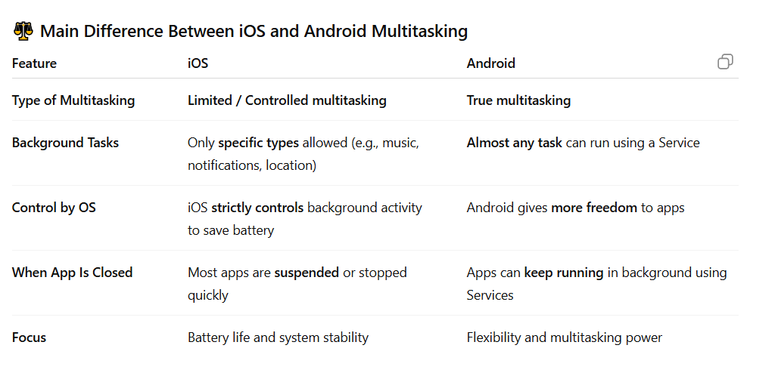
Process Creation
Process creation means starting or creating a new process in the operating system.
A process is basically a program in execution, and the OS is responsible for creating, managing, and ending processes.
When a parent process creates one or more child processes, and those children create more processes, it forms a tree of processes.
Each process is given a unique number called a Process ID (PID) so the operating system can identify and manage it easily.
In terms of resource sharing, there are three possibilities:
- The parent and child share all resources,
- The child shares only some of the parent’s resources, or
- The parent and child share no resources at all.
For execution, the parent and child can either run at the same time (concurrently) or the parent can wait until the child’s process finishes running.
Process Creation (Cont....)
When a new process (child) is made from an existing one (parent), this is called process creation.
1. Address Space
When a child’s process is created it needs its own address space — which is the part of memory where it runs.
This can happen in two ways:
“The child process is a duplicate of the parent”
This means that when the child process is created, it gets an exact copy of everything the parent process had in memory —
the same program code, same variables, same data, and same state.
So right after creation, both processes look the same, but they are independent — changing something in one does not affect the other.
Example:
If the parent process has a variable x = 10,
the child will also start with x = 10.
If the child changes x to 20, the parent’s x stays 10
“The Child Loads a New Program”
After being created, the child process can replace its copied program with a different one using exec ().
This means the child throws away the parent’s code and loads a new program into its memory to run something else.
Example:
The parent might be the command shell, and the child process it creates might load and run another program like ls or gcc.
So, even though the child started as a copy of the shell, it soon replaces its memory with the new program.
2. UNIX Example
In UNIX or Linux, this process happens in three steps using system calls:
- Fork () → creates a new child process that is a copy of the parent.
- Exec () → used by the child to run a new program (it replaces the copied program with a new one).
- Wait () → used by the parent to wait until the child process finishes running.
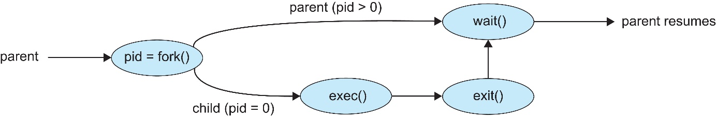
Explanation of figure
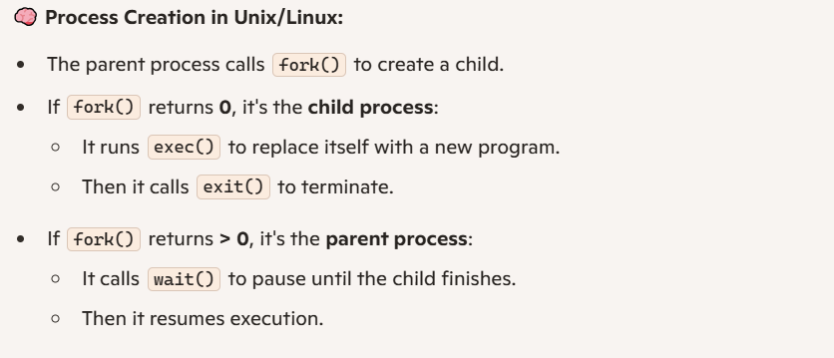
A Tree of Processes in Linux
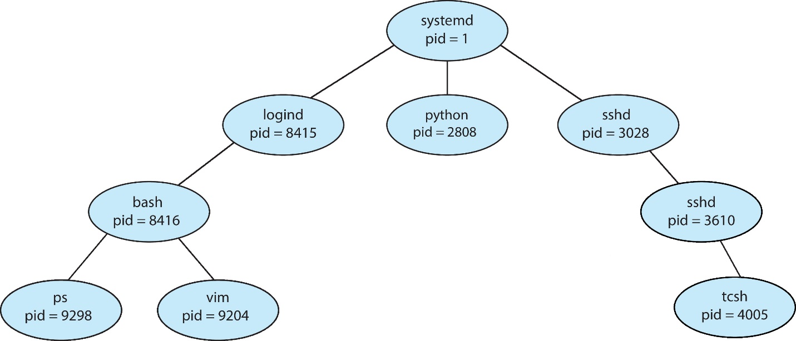
Process Termination
When a process finishes running its last statement, it tells the operating system to end it using the exit () system call.
When a process finishes, it can return a small piece of information (called exit status or return code) to its parent process.
This helps the parent know how the child process ended — for example, whether it finished successfully or had an error.
After that, the operating system frees (deletes) all the resources that were being used by that process (like memory or files).
Termination of a Child Process by Parent
Sometimes, the parent process can also stop (kill) its child process using the abort () system call.
This can happen for a few reasons:
- The child used more resources than it was allowed to.
- The task is no longer needed.
- The parent process is ending, and the system does not allow the child to continue running without its parent.
Note
- Exit () is used by the child process to finish and send a status code.
- Wait () is used by the parent process to receive that status code.
Process Termination (Continue…)
In some operating systems, a child process cannot keep running if its parent process has ended.
So, when a parent process ends, all its child processes must also be stopped.
This is called cascading termination — which means not only the children but also grandchildren and further generations are all terminated.
This termination is done automatically by the operating system.
Parent Waiting for Child
A parent process can wait for its child process to finish using the wait() system call.
This call gives back two things:
- Status information (how the child ended)
- The process ID (pid) of the child that has finished
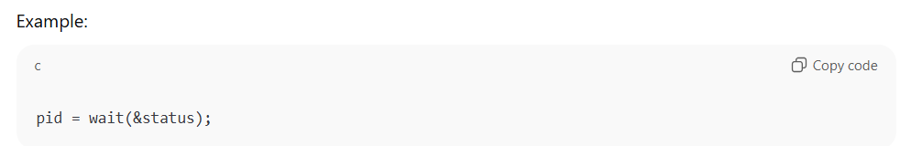

Zombie Process
If the child process finishes, but the parent does not call wait (),
then the child becomes a zombie process — it has finished running, but its exit information still exists in memory.
Orphan Process
If the parent process ends before calling wait (),
then the child process becomes an orphan — it keeps running, but it no longer has a parent process.
Android Process Importance Hierarchy
In Android, sometimes the system needs to close some apps or processes to free up memory or other resources.
To decide which processes to keep and which to remove first, Android gives importance levels to every process — from most important to least important.
1. Foreground Process:
The app or process that is currently on the screen and the user is interacting with.
Example: When you are chatting on WhatsApp, that app is the foreground process.
2. Visible Process
This process is visible to the user but not in focus — for example, an activity showing a dialog on top of another app.
It’s important but not as much as the foreground one.
Example 2: YouTube App
You’re watching a video, and the “Share” dialog opens on top of the video.
- The Share dialog is foreground.
- The video player behind it is still visible but not active → visible process.
3. Service Process
These are background services doing something useful — like playing music or downloading a file.
They are kept running if possible.
Example: Spotify playing music or a file download happening in the background.
4. Background Process:
The app or process that is not visible on the screen but is still running to do some tasks.
Example: When you play music and then open another app, the music app keeps running in the background.
5. Empty Process
These are inactive apps kept in memory just to start faster next time.
They are the least important and killed first when the system needs memory.
Example: You closed Calculator, but Android keeps it in memory for quick reopening.


Multiprocess Architecture – Chrome Browser
In the past, most web browsers used to run as a single process.
This means that everything — all the tabs, plugins, and the main browser window — worked together inside one big process.
The problem was:
If one website or tab crashed, the entire browser could hang or stop working.
Chrome’s Multiprocess Design
Google Chrome fixed this problem by using a multiprocess architecture.
It divides work into separate processes, each handling a different part of the browser.
There are mainly three types of processes:
1. Browser Process
The browser process handles the main user interface (UI) of the browser.
It manages everything you see and use — such as tabs, the address bar, and navigation buttons.
This process is also responsible for disk access and network communication, like downloading files, saving data, or connecting to the internet.
In short, it controls the overall working of the browser and manages communication between other processes.
2. Renderer Process
The renderer process is responsible for displaying web pages.
It takes care of rendering (drawing) HTML, CSS, and JavaScript to show the website’s content properly on the screen.
Chrome creates a new renderer process for each website or tab, so that if one website crashes, the others stay safe.
Each renderer runs inside a sandbox, which is a secure area that blocks direct access to the computer’s disk or network.
This improves security and protects the system from malicious or harmful websites.
3. Plug-in Process
The plug-in process handles plug-ins, which are small helper programs that add extra features to the browser — such as Flash Player (for playing animations and videos) or a PDF viewer (for opening PDF files directly in the browser).
Each plug-in runs in its own separate process, so if one plug-in crashes or stops working, it doesn’t affect the whole browser.
For example, if the PDF viewer plug-in crashes while you are reading a PDF, the rest of Chrome — your other tabs and websites — will keep working normally.
This design makes Chrome more stable and reliable, even when some plug-ins fail.
What is a Sandbox?
A sandbox is a security feature that keeps each process isolated.
It ensures that a web page or plugin cannot harm the computer or steal data, even if it misbehaves.


Intercrosses Communication (IPC)
In a computer system, processes can either work independently or cooperate with each other. Cooperating processes are those that can affect or be affected by other processes. This often involves sharing data or working together on tasks.
There are several reasons why processes might cooperate:
- Information Sharing: Processes can share data and results with each other.
- Computation Speedup: Tasks can be divided among multiple processes to complete work faster.
- Modularity: Large tasks can be broken into smaller, manageable processes.
- Convenience: Cooperation can make programming and system design easier.
To enable cooperation, processes need a way to communicate with each other. This is called Intercrosses Communication (IPC). IPC allows processes to exchange information and coordinate their actions.
There are two main models of IPC:
1. Shared Memory
2. Message Passing
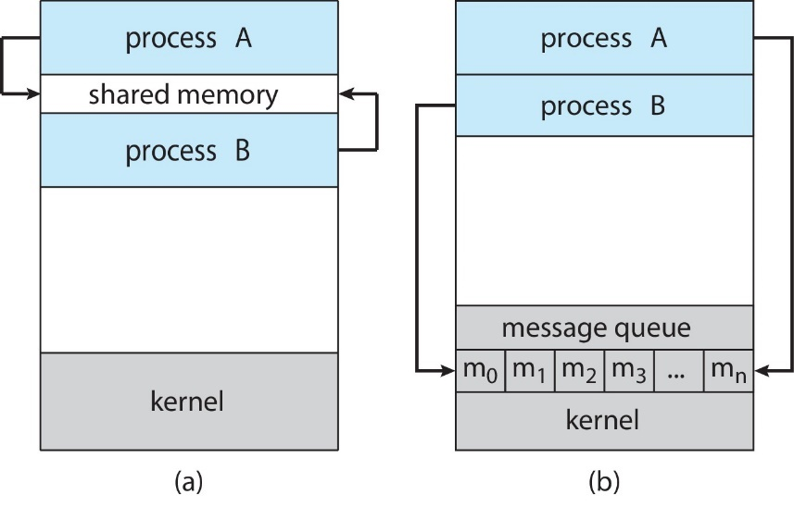
Figure Explanation
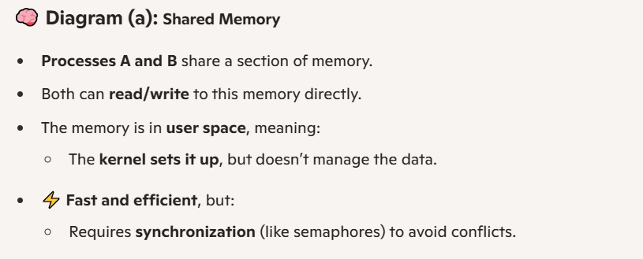
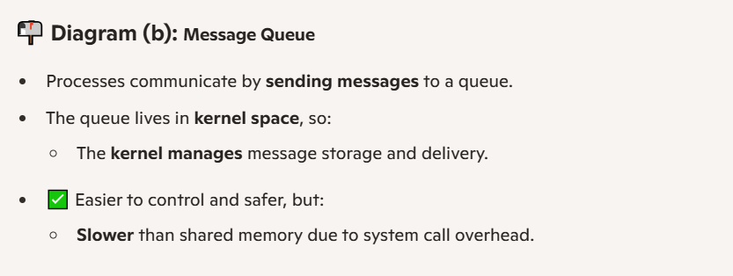

Shared Memory in Inter-Process Communication
What is Shared Memory?
Shared memory is a way for processes to communicate by sharing a region of memory. One process creates a shared memory area in its address space, and other processes that want to communicate must attach that memory segment to their own address space. This allows them to read from and write to the same memory.
Shared Memory Communication
What is Shared Memory?
Shared memory is a part of memory that is shared among processes that want to communicate with each other.
Who Controls It?
The communication is controlled by the user processes themselves, not by the operating system.
Major Issue:
The main challenge is to provide a way for processes to synchronize (because conflicts between processes can happen) their actions so that they don’t interfere with each other while accessing the shared memory.
Example: Producer–Consumer Problem
A common example of shared memory use is the producer–consumer problem. Here, one process (the producer) creates or generates data, and another process (the consumer) uses or consumes that data.
- For instance, a compiler produces assembly code, which is then consumed by an assembler.
- Another example is a web server and a client: the server produces web content like HTML files and images, while the client consumes it by displaying it in a web browser.
Shared memory allows these cooperating processes to work efficiently by sharing data directly in memory rather than sending it through slower communication methods.
Producer–Consumer Problem
The Producer–Consumer problem is a common example of cooperating processes, where one process produces data and another process consumes it.
How it Works:
- Producer process: Creates or produces information.
- Consumer process: Uses or consumes the information produced by the producer.
Two Variations:
1. Unbounded Buffer
- The buffer has no size limit.
- The producer never waits because it can always put data into the buffer.
- The consumer waits only if there is no data available to consume.
2. Bounded Buffer
- The buffer has a fixed size.
- The producer must wait if all buffers are full.
- The consumer waits if there is no data in the buffer to consume.

IPC – Message Passing
Processes communicate by sending and receiving messages. This model does not require shared memory and is useful for processes on different systems.
Example:
Imagine Process X wants to tell Process Y that a file is ready:
- Process X sends a message: "File ready"
- Process Y receives the message and starts processing the file.
Here, the information is passed explicitly through messages rather than shared memories.
Basic Operations:
- send(message): A process sends a message to another process.
- receive(message): A process receives a message from another process.
Key Points of Message Passing
- Messages can be small or large depending on what needs to be sent.
- Processes can talk and coordinate without sharing memory.
- It is very useful when processes are on different computers connected through a network.
Communication Between Processes
If two processes, P and Q, want to communicate, they need to:
- Create a communication link between them.
- Send and receive messages through that link.

Implementation Issues
When setting up message passing, some questions need to be considered:
- How is the link created?
- Can a link connect more than two processes?
- How many links can exist between each pair of processes?
- What is the capacity of the link? (how much data it can hold)
- Is the message size fixed or variable?
- Is the link one-way (unidirectional) or two-way (bi-directional)?
Q: Why in message passing the processes don’t share same address space?
1. Isolation of processes
- Each process has its own private memory (address space).
- This prevents one process from accidentally or maliciously modifying another process’s memory.
- It keeps the system stable and secure.
2. Communication via messages, not memory
- Instead of sharing memory, processes send and receive messages.
- Messages can include data, requests, or signals.
- The operating system handles moving the message from the sender’s memory to the receiver’s memory.
3. Useful for distributed systems
- Processes may be on different machines or systems.
- Since they don’t share memory physically, message passing works across different computers.

4. Overhead trade-off
- Not sharing memory can make communication slower than shared memory.
- But it provides safety, modularity, and the ability to work over networks.
Implementation of Communication Link
1. Physical Implementation
The communication link can be based on:
- Shared memory: Processes communicate through a common memory area.
- Hardware bus: A physical connection that carries messages between processes.
- Network: Communication between processes on different computers.
2. Logical Implementation
The link can also be defined by how it works logically:
- Direct or Indirect: Messages go straight to the receiver (direct) or through an intermediary (indirect).
- Synchronous or Asynchronous: Sender waits for receiver (synchronous) or continues immediately (asynchronous).
- Automatic or Explicit buffering: Messages are stored automatically in a buffer or managed explicitly by processes.
Direct Communication
In direct communication, processes must clearly specify the other process they want to communicate with. For example, a process can use send (P, message) to send a message to process P, or receive (Q, message) to receive a message from process Q.
Properties of a Direct Communication Link
- Automatic link creation: The communication link between the two processes is established automatically.
- One-to-one association: Each link is associated with exactly one pair of communicating processes.
- Single link per pair: Between each pair of processes, there is only one link.
- Direction: The link can be one-way (unidirectional), but it is usually two-way (bi-directional) so that both processes can send and receive messages.
Indirect Communication
In indirect communication, messages are sent and received through mailboxes (also called ports) rather than directly between processes. Each mailbox has a unique ID, and processes can communicate only if they share the same mailbox.
Properties of an Indirect Communication Link
- Link creation: A communication link is established only when processes share a common mailbox.
- Multiple associations: A mailbox (link) can be shared by many processes.
- Multiple links: Each pair of processes may share several communication links through different mailboxes.
- Direction: The link can be one-way (unidirectional) or two-way (bi-directional).
- Communication rules: A process can use multiple mailboxes to communicate with another process, but two processes can communicate only if they share at least one mailbox.
Indirect Communication (Cont.)
Operations on Mailboxes
In indirect communication, processes interact using mailboxes (ports). The main operations are:
1. Create a mailbox: Make a new mailbox that processes can use.
2. Send and receive messages:
- Send (A, message) → Send a message to mailbox A.
- Receive (A, message) → Receive a message from mailbox A.
3. Delete the mailbox: Remove a mailbox when it is no longer needed.
How Mailboxes Work
A mailbox can be thought of as an object or container:
- Processes can place messages into it.
- Processes can take messages out of it.
- Each mailbox has a unique ID, so processes know which mailbox to us
Indirect Communication (Continued)
Mailbox Sharing Problem
Suppose processes P1, P2, and P3 share the same mailbox A.
- P1 sends a message.
- P2 and P3 can receive from the same mailbox.
Question: Who actually gets the message?
Solutions
- Two process limits: Allow a mailbox link to be shared by at most two processes.
- One receiver at a time: Allow only one process to perform a receive operation at any moment.
- System chooses receiver: Let the system pick a receiver randomly and notify the sender which process received the message.
Synchronization in Message Passing
1. Blocking (Synchronous)
- Blocking send: The sender waits until the receiver gets the message.
- Blocking receive: The receiver waits until a message arrives.
2. Non-blocking (Asynchronous)
- Non-blocking sends: The sender sends the message and keeps going.
- Non-blocking receive: The receiver tries to get a message and gets either a message or nothing if no one is there.
3. Special Case – Rendezvous
- If both sender and receiver wait, it’s called a rendezvous – they meet and exchange the message at the same time.
Difference between Blocking and Rendezvous
- First (Blocking/Synchronous): Only one side waits—either the sender waits for the receiver, or the receiver waits for a message.
- Rendezvous (special case): Both sender and receiver wait until they meet and exchange the message.
So, rendezvous is a specific type of blocking where both sides are synchronized at the same time.
Buffering in Message Passing
What is Buffering?
Buffering means keeping a queue of messages attached to the communication link so messages can wait until they are delivered.
Types of Buffering:
1. Zero Capacity
- No messages can be stored in the link.
- The sender must wait until the receiver is ready.
- This is the same as a rendezvous.
Example

2. Bounded Capacity
- The link can hold a limited number of messages (no messages).
- The sender waits if the link to be full.
Example


3. Unbounded Capacity
- The link can hold unlimited messages.
- The sender never waits.
Example

Communications in Client-Server Systems
- Sockets
- Remote Procedure Calls
Sockets
- A socket is simply an endpoint — a point where two computers connect and communicate with each other.
- It is made by combining two things:
IP address + Port number
(The IP address tells which computer, and the port tells which program or service on that computer.)
- Example:
161.25.19.8:1625
means port 1625 on the computer with IP 161.25.19.8.
- Communication always happens between two sockets — one on each computer.
- Ports below 1024 are special and reserved for common or standard services (like web servers, email, etc.).
- The IP address 127.0.0.1 is called loopback.
It refers to your own computer, used when you want to test programs on your own system without connecting to a network.
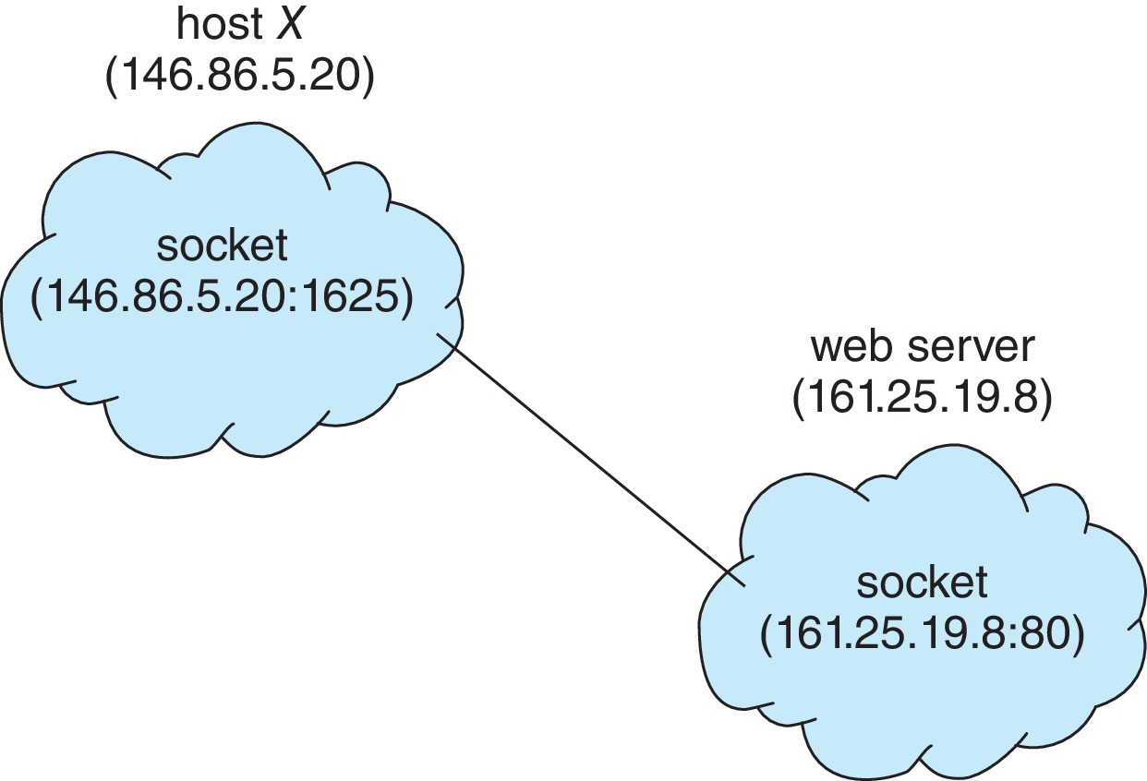
Remote Procedure Calls (RPC)
A Remote Procedure Call (RPC) allows a program on one computer to run a function or procedure on another computer — just like calling a normal function.
It hides (or abstracts) the network part, so the programmer doesn’t need to worry about how data travels between computers.
How Remote Procedure Call (RPC) Works
Ports help the computer know which program or service the message should go to — just like a door number in a big building.
What are Stubs?
Stubs are like messengers that help the client and server talk to each other.
- Client Stub (on the client side):
- Looks like a normal function to the user.
- But instead of running the function itself, it sends a message to the server asking it to run the function.
- Server Stub (on the server side):
- Receives the message from the client.
- Unpacks the data (this is called unmarshalling).
- Then it runs the actual function on the server computer.
Simple Steps:
- The client calls a function (like add (5, 7)).
- The client stub packs the function name and values (5 and 7) and sends them to the server.
- The server stub receives this, unpacks it, and runs the real add () function on the server.
- The server stub sends the result (12) back to the client stub.
- The client gets the answer — as if the function ran on its own computer.
Marshalling: Marshalling means packing data before sending it from one computer to another.
Extra Note (For Windows Users):
- In Windows, you don’t have to write stub code by hand.
- It is automatically created using a special file called MIDL (Microsoft Interface Definition Language) this file explains how the client and server should talk to each other.

Execution of RPC
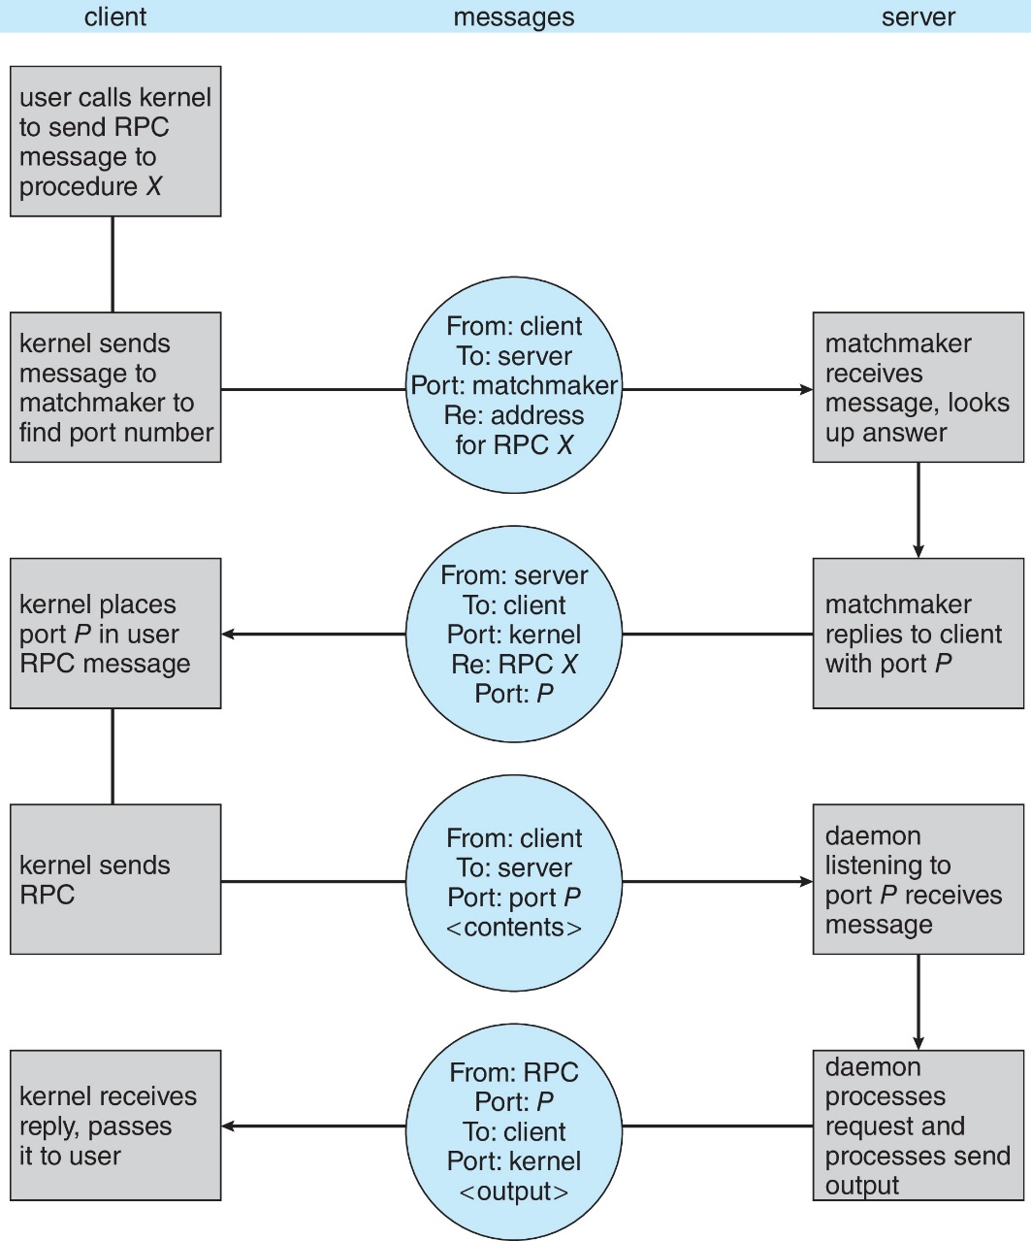

Chapter 4
Threads & Concurrency
Thread
A thread is the smallest part of a program that the CPU runs.
Each thread has:
- its own ID (name or number),
- a program counter (PC) that shows which instruction to run next,
- some registers to store temporary data,
- and a stack to keep track of function calls.
All threads inside the same process share the same code, data, and system resources (like open files or signals).
If one process has many threads, it means the program can do many things at the same time — for example, one thread can handle user input while another saves data in the background.
Single and Multithreaded Processes
Single Thread of Execution
In traditional systems, each process contains only a single thread of execution, meaning it can execute only one instruction sequence at a time. The process has one program counter that keeps track of the next instruction to be executed.
Multiple Threads of Execution
Modern operating systems allow a single process to have multiple threads of execution, also known as multithreading. In this case, a process can have multiple program counters, with each thread maintaining its own counter and execution path. This enables different parts of a program to run concurrently, improving performance and responsiveness. For example, one thread might handle user input while another performs background calculations.

Multithreaded Server Architecture
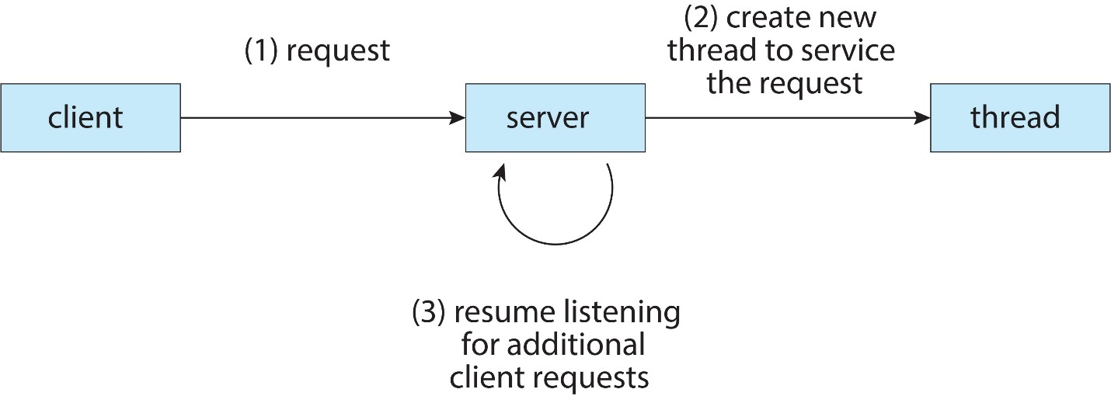
Diagram Illustration
- The Client Makes a Request: A client (e.g., your web browser) sends a request (1) to the server.
- The Server Creates a Worker: Instead of handling the request itself right away, which would make other clients wait, the server immediately creates a new thread (a tiny, independent worker) (2) specifically to handle that single request. Think of the thread as a dedicated waiter who now takes care of that customer's order from start to finish.
- The Server Gets Back to Business: Critically, as soon as the dedicated worker (thread) is created, the original server (the host) immediately goes back (3) to listening for more requests from other clients.
This process allows the server to be responsive. While the first request is being processed by its own dedicated thread, the server can accept and create threads for new requests coming in from other clients, maximizing the number of clients it can serve at once.
Benefits of Multithreading
1. Responsiveness:
If one part of the program is stuck or waiting (like loading a file), other threads can still keep running.
This makes the program feel faster and smoother — especially important in apps with user interfaces.
2. Resource Sharing:
All threads in the same process can easily share things like memory, files, or data.
This is simpler and faster than using special methods like message passing or shared memory between separate processes.
3. Economy:
Creating a new thread uses less time and memory than creating a whole new process.
Also, switching between threads is faster than switching between processes.
4. Scalability:
Threads can run at the same time on different CPU cores.
This helps programs run faster on multi-core computers.
A single-threaded program, however, can only use one core — no matter how many are available.
Multicore Programming
Computers today often have more than one CPU core — this is called a multicore or multiprocessor system.
These systems can do many things at the same time, but this also makes programming more difficult.
Some main challenges are:
- Dividing activities:
Breaking a big task into smaller parts that can run at the same time.
- Balance:
Making sure all cores get an equal amount of work so that no core stays idle.
- Data splitting:
Deciding how to divide the data so that each thread or core gets the part it needs.
- Data dependency:
Making sure that one thread does not use data that another thread hasn’t finished updating yet.
- Testing and debugging:
It’s harder to find and fix errors when multiple threads are running at once, because the order of execution can change each time.

Parallelism vs Concurrency
- Parallelism:
Means doing many tasks at the same time, like cooking and watching TV together.
- Concurrency:
Means making progress on many tasks, even if only one happens at a time — like switching between cooking and watching TV quickly.
On a single-core processor, true parallelism isn’t possible.
But the scheduler switches between tasks so quickly that it feels like multiple tasks are happening together — that’s concurrency.
Multiprogramming (Batch System)
In a simple system, a single program cannot keep both the CPU and I/O devices busy all the time.
For example, when one program is waiting for input/output, the CPU would sit idle. Multiprogramming solves this by keeping many jobs in memory at the same time. The operating system uses job scheduling to choose which job to run. If one job has to wait for input/output, the OS quickly switches to another job. In this way, the CPU is never left idle because it always has some work to do.
Concurrency vs. Parallelism
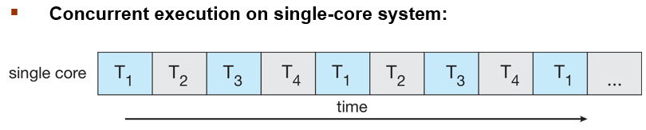

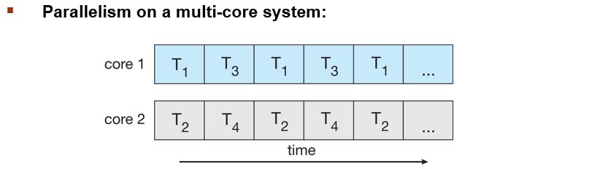
Data and Task Parallelism
1. Data Parallelism:
In this type, the same work is done on different parts of the data at the same time.
The data is divided into pieces, and each core handles a part of it.
Example
Suppose you have 1,000 students’ test scores, and you want to add 5 bonus marks to everyone’s score.
Instead of one core updating all 1,000 scores one by one,
you can split the list into 4 parts —
each core adds 5 marks to 250 scores at the same time.
2. Task Parallelism:
Here, different threads do different kinds of work at the same time.
Each thread performs its own unique task on possibly the same or different data.
Example:
In a video player:
- One thread plays the video,
- Another plays the audio,
- Another handles user controls.
All run together on different cores.
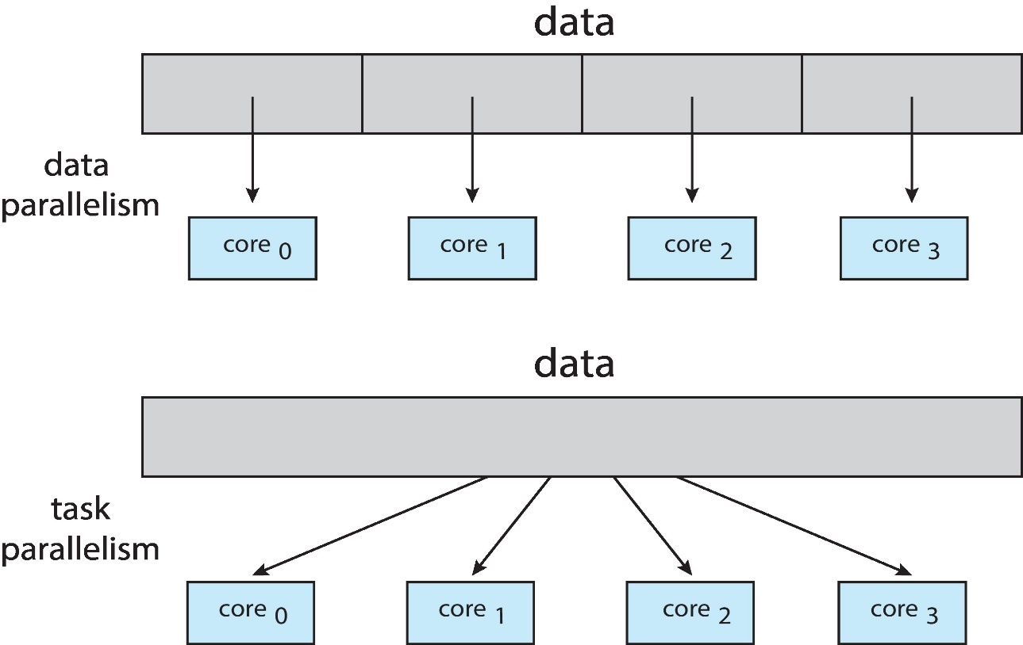
Amdahl’s Law
Amdahl’s Law helps us understand how much faster a program can run if we add more CPU cores.
Every program has two parts:
- Serial part (S): runs one step at a time — can’t be divided or sped up by more cores.
- Parallel part: can be split among multiple cores and run at the same time.

Example
If a program is:
- 75% parallel (can be divided),
- 25% serial (must run one by one),

- Then moving from 1 core → 2 cores gives about 1.6× speedup, not double. That’s because the serial part (25%) still takes the same time no matter how many cores you add.
- As you keep adding more cores (N → infinity),
the maximum possible speedup = 1 / S (1 divided by the serial portion).
So if 25% is serial → 1 / 0.25 = 4× is the best speedup possible — even with 1,000 cores.
Key Idea
The serial portion limits how much performance you can gain.
Even a small serial part can greatly reduce total speedup when adding more cores.
Does Amdahl’s Law apply to modern multicore systems?
Amdahl’s Law is useful for showing how much faster a program can get with more cores,
but it doesn’t completely fit modern computers.
Today’s multicore systems can do more work at once, handle bigger tasks, and manage tasks better,
so in real life, programs often run faster than Amdahl’s Law predicts.
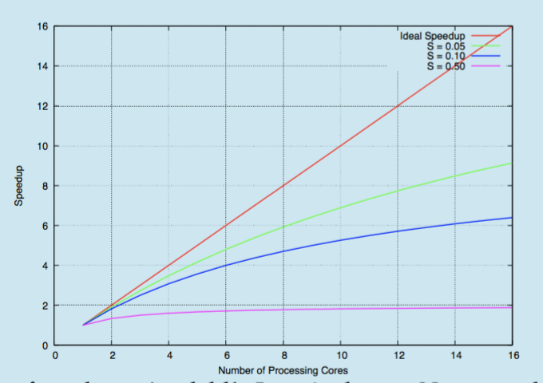
User Threads and Kernel Threads
1. User Threads:
These threads are managed by the user’s program, not by the operating system.
A special thread library helps create, run, and control them.
Common thread libraries:
- POSIX Pthreads – used mostly in UNIX or Linux systems
- Windows Threads – used in Microsoft Windows
- Java Threads – used in Java programs
Example:
A Java program making multiple threads (like one for saving data and another for updating the screen) is using user threads.
2. Kernel Threads:
These threads are managed directly by the operating system (kernel).
The kernel decides how and when each thread runs on the CPU.
Examples of systems that support kernel threads:
- Windows
- Linux
- macOS
- iOS
- Android
User and Kernel Threads
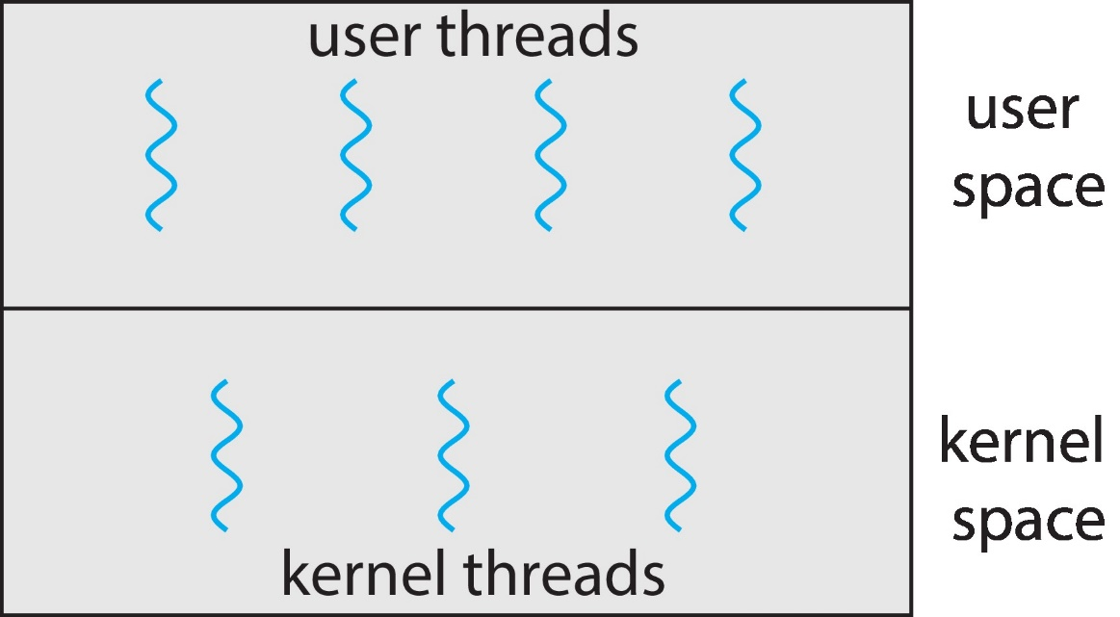
Multithreading Models
- Many-to-One
- One-to-One
- Many-to-Many
Many-to-One Model
In this model, many user threads are connected (mapped) to just one kernel thread.
What it means:
All the user threads are managed by the program itself, but the operating system sees them as one single thread.
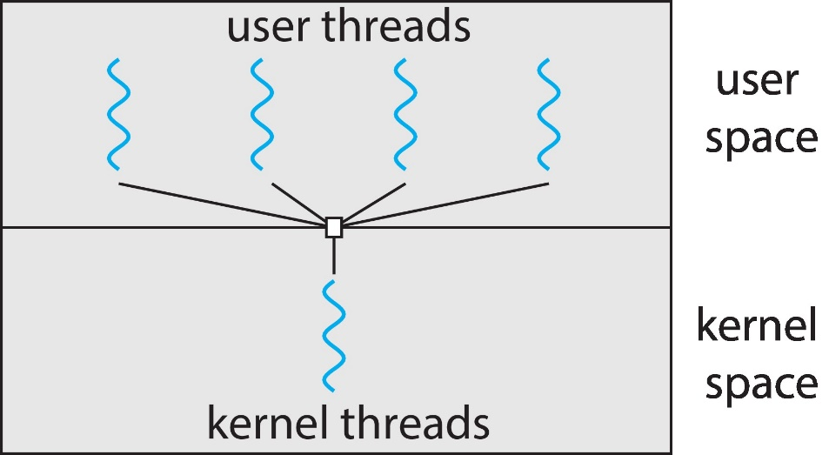
Problems
- If one thread gets blocked (for example, waiting for input or a file),
then all other threads stop too.
- Because there’s only one kernel thread, the program cannot use multiple CPU cores at the same time —
only one thread can run in the kernel at once.
Used By (Examples)
- Solaris Green Threads
- GNU Portable Threads
One-to-One Model
In this model, each user thread is connected to one kernel thread.
So, when a program creates a new user thread, the operating system also creates a matching kernel thread for it.

Features
- This allows true concurrency and parallelism — multiple threads can actually run at the same time on different CPU cores.
- But creating too many threads can cause overhead (extra work for the system),
so sometimes the number of threads a process can make is limited.
Examples of Operating Systems Using This Model
- Windows
- Linux
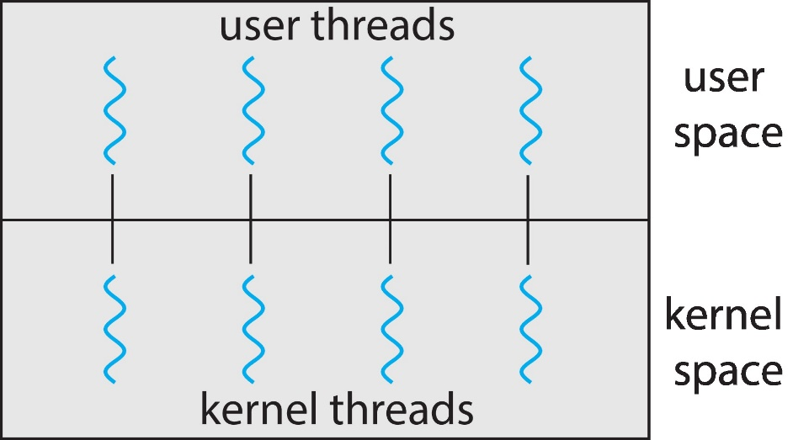
Many-to-Many Model
In this model, there are many user threads and many kernel threads,
and they are connected (mapped) to each other in a flexible way.
What It Means
- The operating system can decide how many kernel threads to create.
- It can run multiple user threads over a smaller or equal number of kernel threads.
- This gives more control and better performance — if one thread is waiting, others can still run.
Example
If your program has 100 user threads, the OS might use 10 or 20 kernel threads to run them efficiently,
depending on how powerful your system is.
For example:
- A system with 8 CPU cores may get more kernel threads
than a system with only 4 cores,
so it can make better use of its hardware.
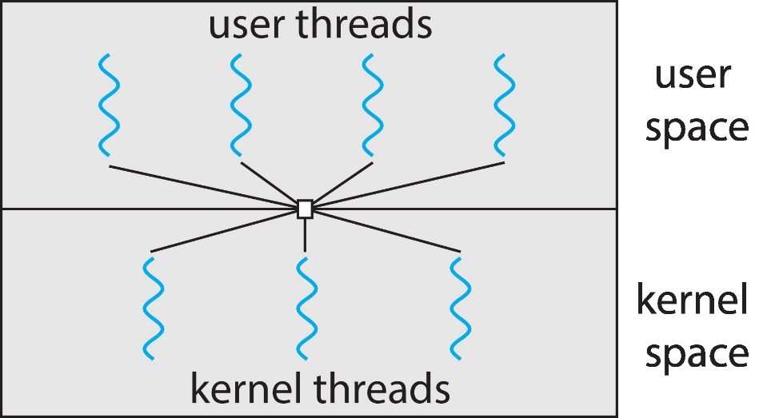
Two-Level Model
The Two-Level Model is almost the same as the Many-to-Many (M:M) model,
but with one extra feature —
it allows some user threads to be directly connected (bound) to specific kernel threads.

What It Means
Normally, in the many-to-many model, user threads are freely managed by the system —
any user thread can run on any kernel thread.
But in the two-level model, if needed,
you can bind (fix) a user thread to one particular kernel thread.
This gives that thread more control or faster performance,
especially for important or time-sensitive tasks.
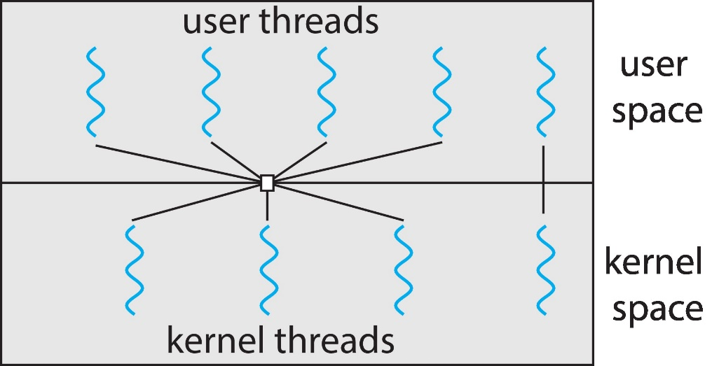
Thread Libraries
A thread library gives programmers a set of ready-made functions (API)
to create, control, and manage threads in a program.
Two Ways to Implement Thread Libraries
- User-Space Library:
The whole library works inside the program, not in the operating system.
Thread management is done by the user program itself.
It’s fast because it doesn’t need help from the OS,
but if one thread gets blocked, others may stop too.
- Kernel-Level Library:
The library is built with support from the operating system.
The OS manages and schedules threads directly.
It allows true parallelism on multicore systems,
but thread operations are slower because they involve the OS.
Pthreads (POSIX Threads)
Pthreads stands for POSIX Threads.
It is a standard set of rules (API) that explains how threads should be created and managed in a program.
Key Points
- Pthreads can be built as user-level or kernel-level threads,
depending on how the system implements them.
- It follows the POSIX standard (IEEE 1003.1c),
which defines how thread functions should behave —
like creating threads, waiting for them, or synchronizing (making them work together safely).
- It’s only a specification, not actual code.
That means POSIX tells what should happen,
but each operating system can decide how to make it happen.
Commonly used in:
Linux and macOS (Mac OS X) systems.
Fork-Join Parallelism
Fork-Join Parallelism is a way of running multiple tasks at the same time.
How it works:
- Fork: The program splits into multiple threads (tasks) that run in parallel.
- Do work: Each thread does its own part of the job.
- Join: After finishing, all threads come back together to continue as one program.
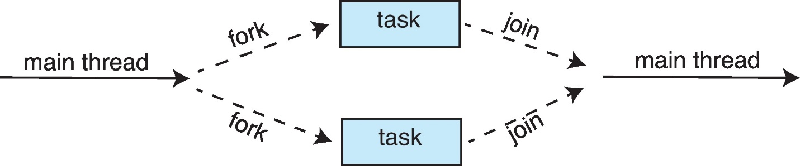
Windows Threads
Windows uses Windows API as the main way for programs to create and manage threads.
- Windows threads use the one-to-one model → each user thread has a matching kernel thread.
What Each Thread Contains
- Thread ID: A unique number to identify the thread.
- Register set: Keeps track of the CPU state for the thread.
- User and kernel stacks: Separate areas where the thread keeps information when it runs in user mode or kernel mode.
- Private data area: Used by the program’s libraries or DLLs to store data for this thread.
All of these together — registers, stacks, and private storage — are called the thread’s context.

Chapter 5
CPU Scheduling
Maximum CPU Utilization with Multiprogramming
Multiprogramming means running many processes together in memory.
The main goal is to keep the CPU busy all the time.
If one process is waiting for I/O (like reading from disk),
then another process can use the CPU.
This way, the CPU never stays idle, and its utilization becomes maximum.
What is Burst?
A burst is a short period of time when a process is actively doing something.
CPU–I/O Burst Cycle
Every process has two types of work:
- CPU Burst – when it is using the CPU to do calculations or processing.
- I/O Burst – when it is waiting for input/output, like reading a file or printing output.
So, a process keeps switching between CPU work and I/O wait again and again.
This repeating pattern is called the CPU–I/O Burst Cycle.
CPU Burst Distribution (Why It Matters)
Not all processes need the CPU for the same amount of time:
- Some processes have short CPU bursts (they mostly do I/O work).
- Some have long CPU bursts (they mostly do calculations).
The pattern or spread of these CPU bursts across all processes is called the CPU burst distribution.
It is important because:
- It helps the operating system decide how to schedule processes efficiently.
- Understanding it helps to get better CPU utilization and faster performance.
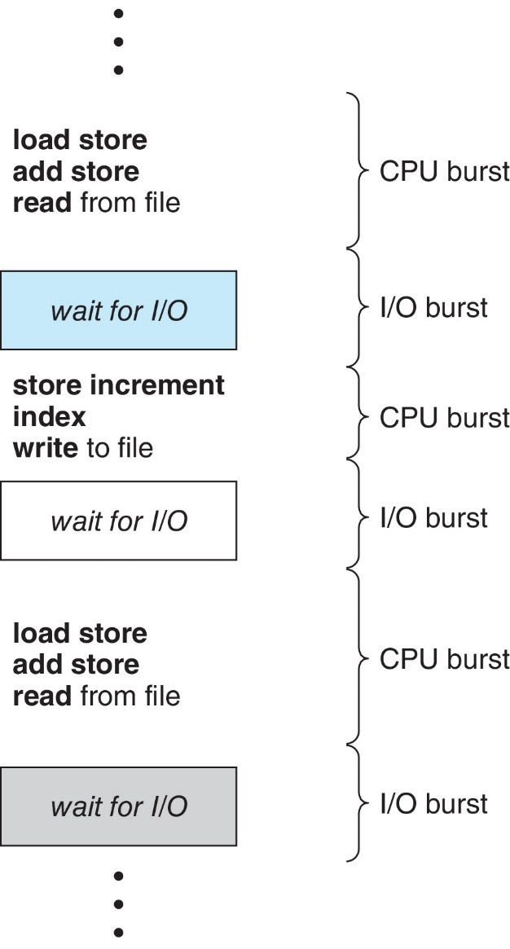

Histogram of CPU-burst Times
- CPU bursts curve: Most CPU bursts are short, a few are long, forming an exponential or hyperexponential curve.
- Short CPU bursts happen very often → most processes only need the CPU for a little time before doing I/O.
- Long CPU bursts happen rarely → only a few processes need the CPU for a long time.
- Why it’s a curve: Because short bursts happen very often and long bursts are rare, the graph drops quickly for longer burst times.
- Importance: This helps the OS decide which process to run next for efficient CPU scheduling.

Basic Concepts
- A single-core CPU can run only one process at a time; others wait.
- Multiprogramming keeps multiple processes in memory so the CPU is always busy.
- When a process waits for I/O, the OS gives the CPU to another process.
- This switching continues to maximize CPU use.
- On multicore CPUs, this idea applies to all cores, keeping them busy at the same time.
CPU Scheduler
- When the CPU becomes idle, the OS must choose a process from the ready queue to run.
- The CPU scheduler is the part of the OS that selects which process gets the CPU next.
- Think of it like a line of processes waiting their turn to use the CPU.
- Each process in the queue is represented by a Process Control Block (PCB), which stores all important info about the process.
CPU Scheduler (Cont.)
- The CPU scheduler picks one process from the ready queue and gives it the CPU core to run.
- The ready queue can be arranged in different ways (like by priority or arrival time).
When CPU Scheduling Happens
CPU scheduling decisions happen at these times:
- Running → Waiting:
When a process starts waiting for I/O or something else (like using wait()), it leaves the CPU.
- Running → Ready:
When a process is interrupted (for example, by a timer), it goes back to the ready queue.
- Waiting → Ready:
When a process finishes I/O work, it becomes ready to run again.
- Termination:
When a process finishes completely, the CPU is free for another process.
Preemptive and Non-preemptive Scheduling
Non-preemptive Scheduling
- Once a process gets the CPU, it keeps it until it finishes or starts waiting (like for I/O).
- The CPU is not taken away in the middle.
- So, the next process waits until the CPU becomes free.
Preemptive Scheduling
- The CPU can be taken away from a process before it finishes.
- This happens if a more important (higher priority) process comes or an interrupt occurs.
- It helps the system respond faster and share the CPU fairly.
- Most modern systems (Windows, Linux, MacOS) use this.
Preemptive Scheduling and Race Conditions
- In preemptive scheduling, the CPU can switch between processes anytime.
- If two processes share the same data, this can cause problems.
Example:
- Process 1 is changing some data.
- Before it finishes, the CPU switches to Process 2.
- Process 2 then reads the data while it’s still half-updated (not correct yet).
This situation is called a race condition — both processes are “racing” to use the shared data, and the result becomes wrong or inconsistent.
Dispatcher
The dispatcher is a part of the operating system that gives the CPU to the process chosen by the CPU scheduler. It basically starts the selected process running on the CPU.
Example of Dispatcher
Let’s say there are two processes in a system:
- Process A – doing some calculations
- Process B – waiting in the ready queue
- Process A is running on the CPU.
- Suddenly, an I/O request happens (A now has to wait).
- The CPU scheduler chooses Process B to run next.
- Now, the dispatcher comes in and does the following:
- Saves Process A’s current state (so it can continue later).
- Loads Process B’s saved state.
- Switches CPU to user mode.
- Starts Process B from where it left off.
The small time taken to switch from A to B is called dispatch latency.
The Dispatcher Does Three Main Things:
- Switches from one process to another (context switching).
- Changes CPU mode from system mode to user mode so the process can run.
- Jumps to the correct place in the program to continue execution.

Dispatch Latency
- The time taken by the dispatcher to stop one process and start another is called dispatch latency.
- It should be as short as possible, because this happens every time the CPU switches processes.
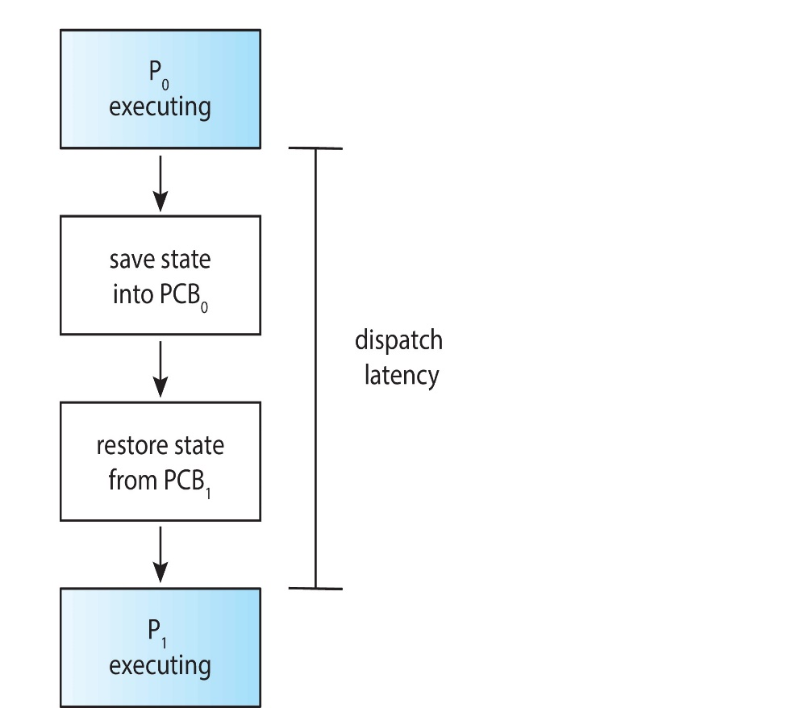
Scheduling Criteria
1. CPU Utilization:
- Try to keep the CPU working all the time — not sitting idle.
2. Throughput:
- How many programs finish in a certain time.
3. Turnaround Time:
- Total time a program takes from starting to finishing.
4. Waiting Time:
- Time a program spends waiting in the ready line before getting the CPU.
5. Response Time:
- Time between asking for something and getting the first reply (like when you click a button and it starts responding).
First Come First Serve (Non-Preemptive)
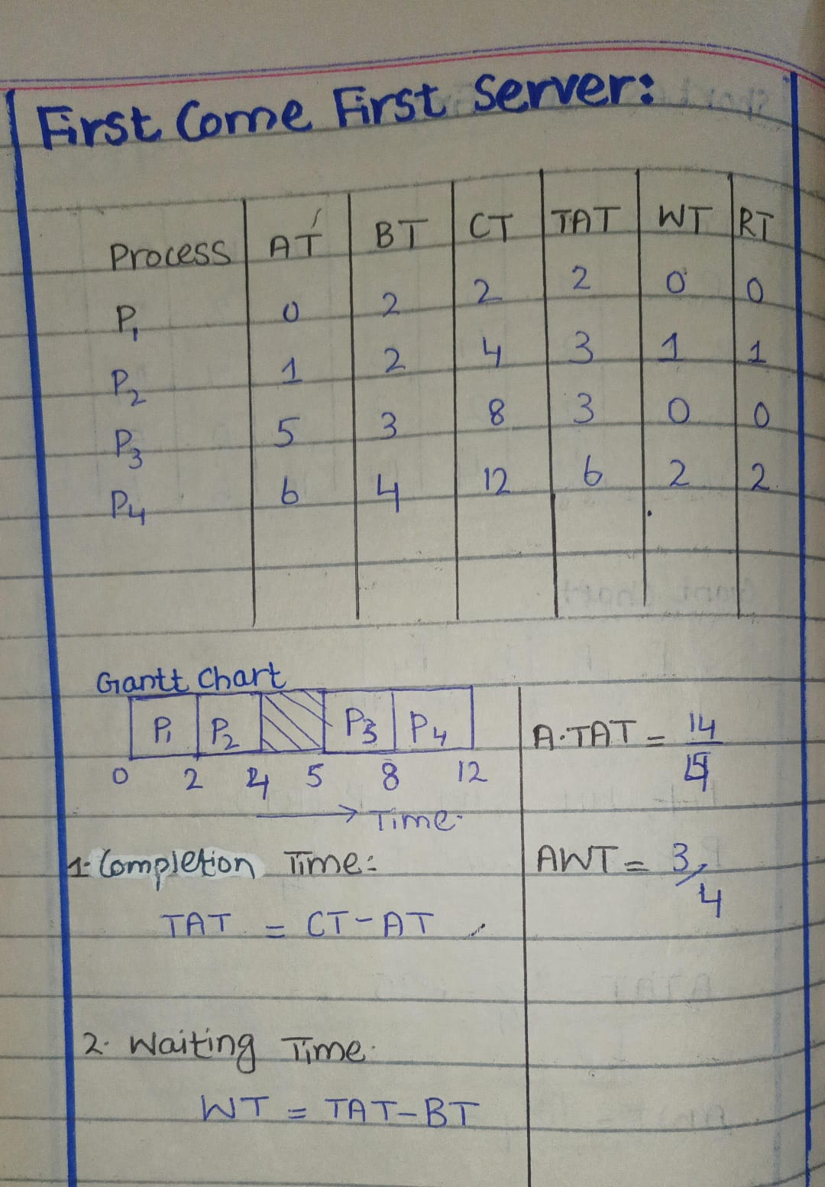
Example 2
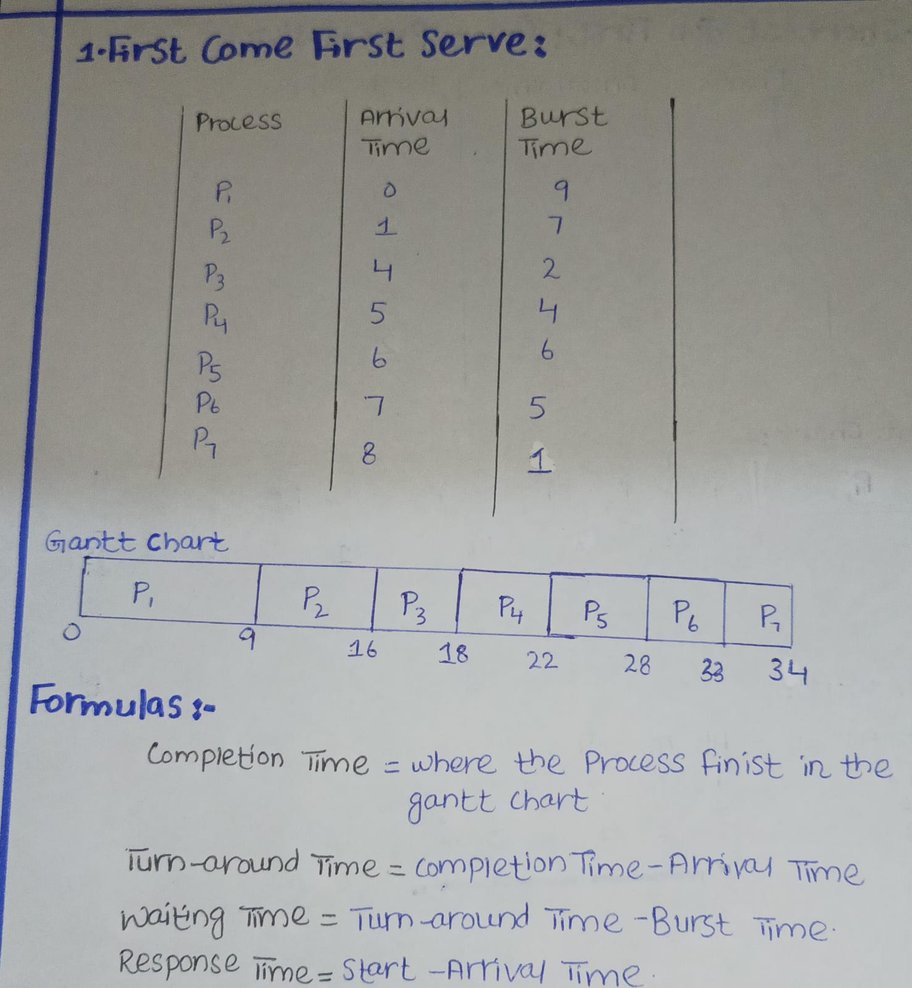

Shortest Job First Serve (Non-Preemptive)
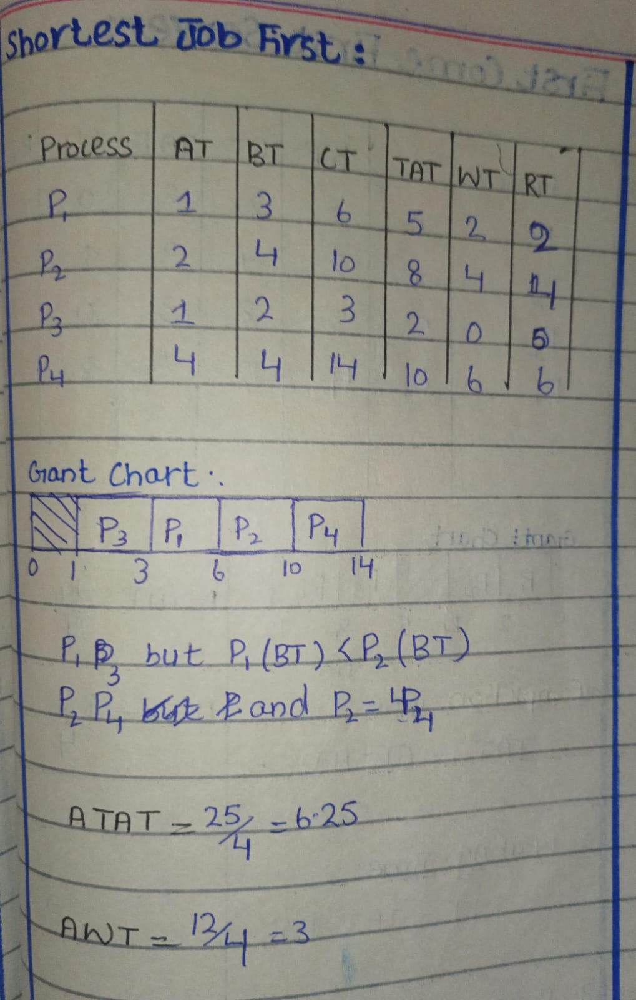

Example 2
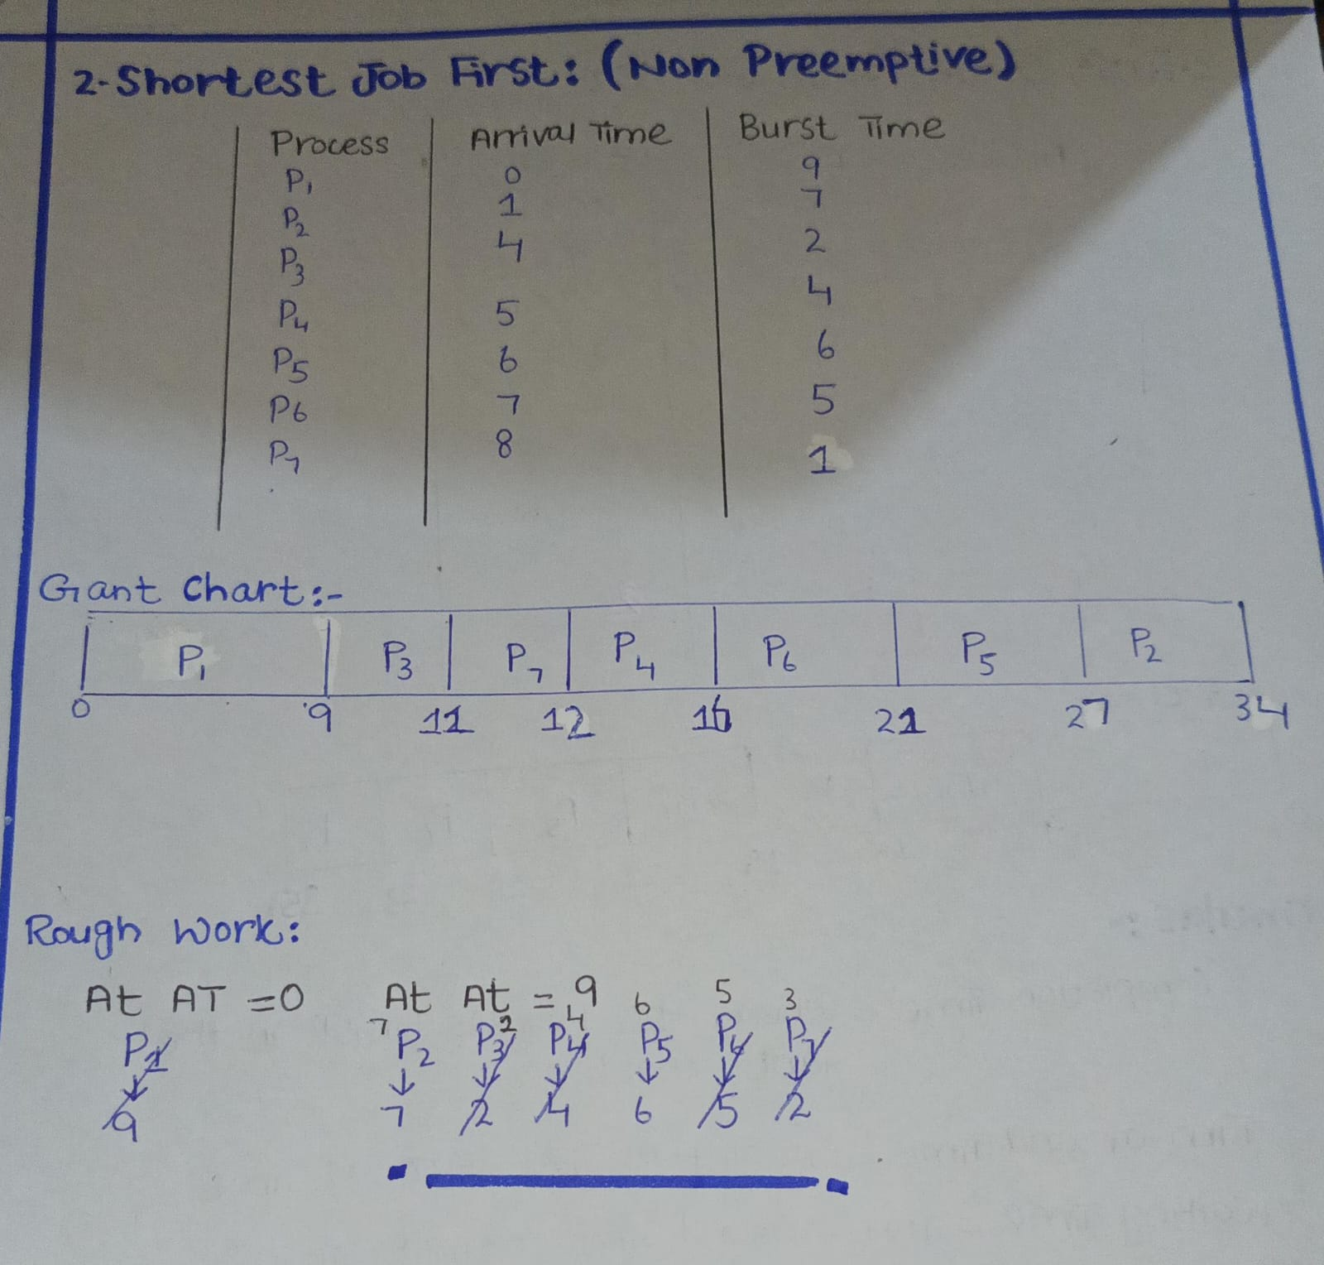

Shortest Remaining Time First (Preemptive)
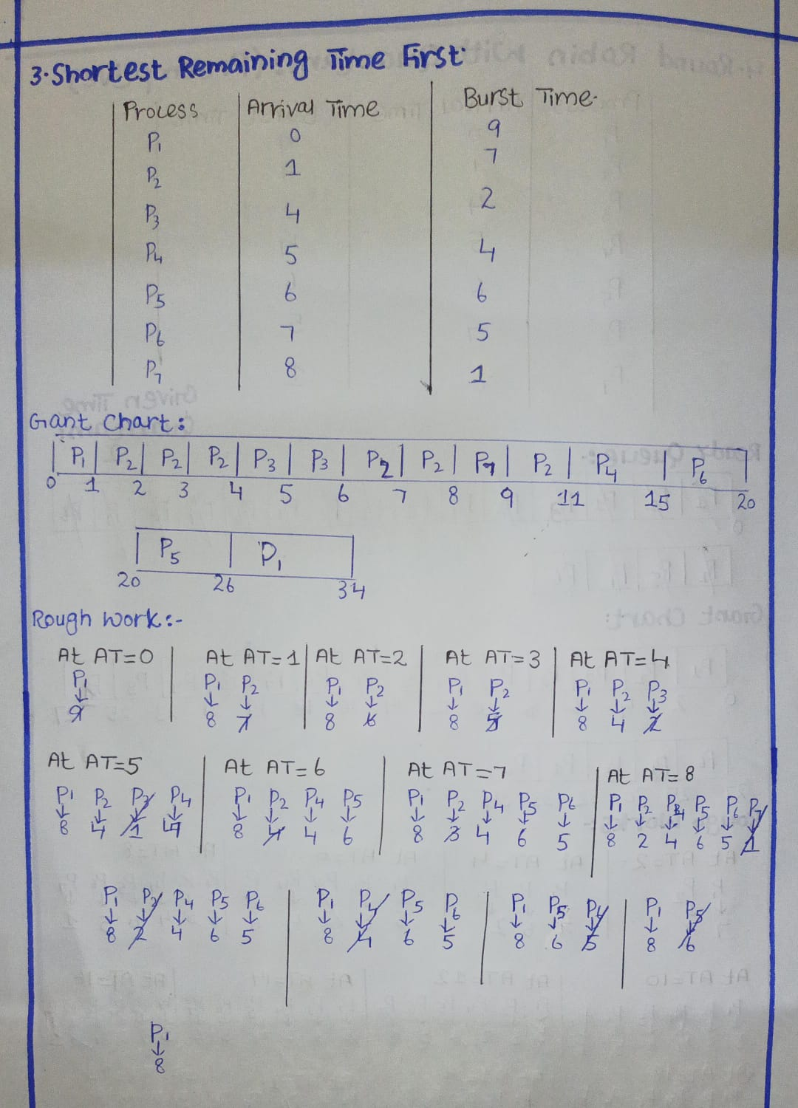
Round Robin with Time Quantum (Preemptive)
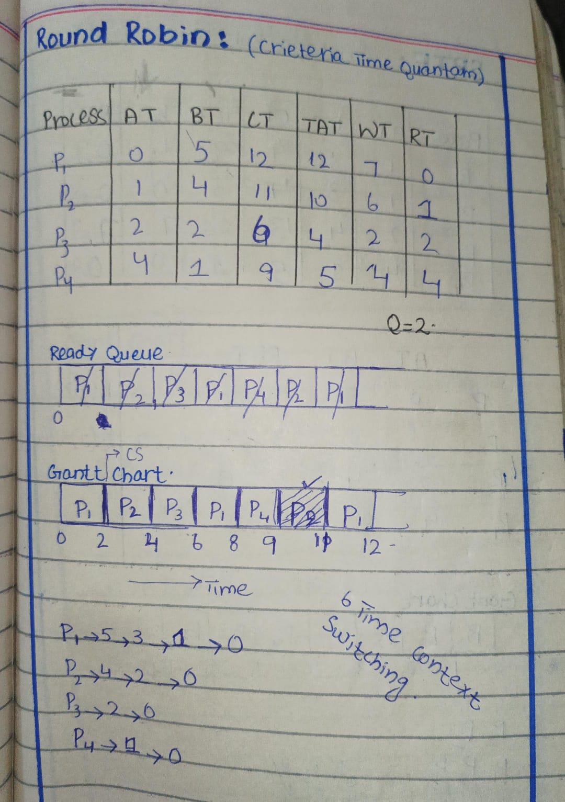

Example 2
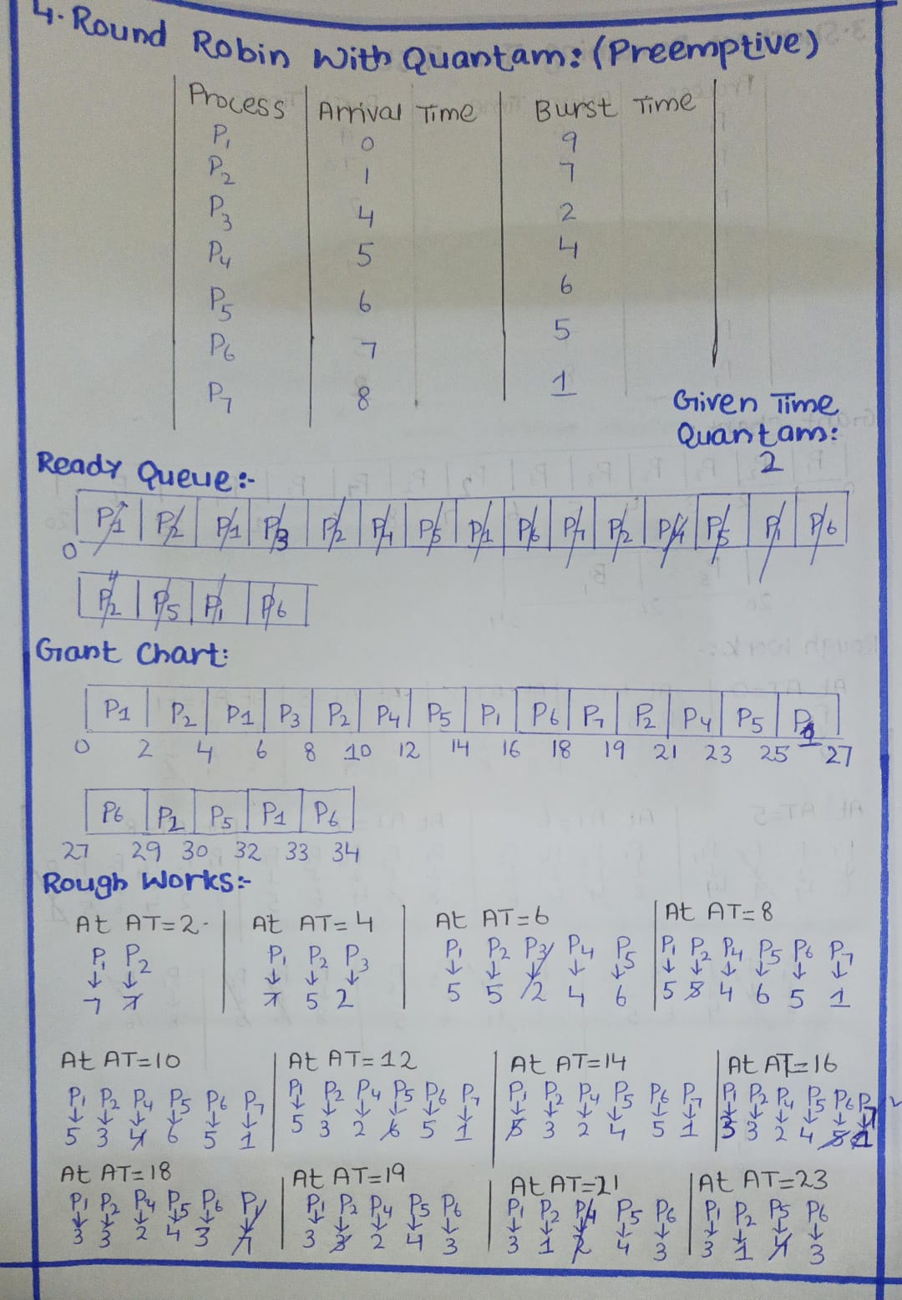


Multilevel Queue Scheduling
When many processes (programs) are ready to run, the operating system must decide which one runs first.
There are different methods for doing this, and Multilevel Queue Scheduling is one of those methods.
It is used when processes are different in nature.
In this scheduling method, the ready queue is not a single line.
Instead, it is divided into many smaller queues. Multilevel queue scheduler defined by the following parameters:
1. Number of Queues
This means how many separate queues you want to make.
Example:
- One queue for system processes
- One queue for interactive processes
- One queue for background processes
So instead of one big waiting line, you have multiple small lines.
2. Scheduling Algorithm for Each Queue
Each queue can use a different scheduling method.
Example:
- Queue 1 uses Round Robin
- Queue 2 uses FCFS
- Queue 3 uses Shortest Job First
So, every queue has its own rules for picking the next process.
3. How to Decide Which Queue a Process Goes Into
There must be a rule that decides which queue a process should enter.
Examples of rules:
- Based on process type (system, user, background)
- Based on priority level
- Based on memory or CPU needs
So, each process is put into a queue depending on what kind of process it is.
4. Scheduling Among the Queues
After choosing a queue for each process, now we decide which queue gets the CPU first.
There are two common ways:
a) Fixed Priority Scheduling
Some queues have higher priority than others.
CPU always serves the highest priority queue first.
Example:
- Queue 1 (highest priority)
- Queue 2
- Queue 3 (lowest priority)
Lower queues only get CPU when higher queues are empty.
Drawback: Starvation
If the highest-priority queue keeps getting new processes and never becomes empty,
then the lower-priority queues may never get CPU time.
This problem is called starvation (or indefinite blocking).
b) Time Slice Between Queues
Each queue gets a fixed time.
Example:
- Queue 1 → 50 ms
- Queue 2 → 30 ms
- Queue 3 → 20 ms
After its time finishes, the CPU moves to the next queue.
Two Key Terms
Starvation | Aging
If the highest-priority queue keeps getting new processes and never becomes empty,  then the lower-priority queues may never get CPU time.  This problem is called starvation (or indefinite blocking). | Aging is a technique that prevents starvation by gradually increasing the priority of a process the longer it waits, usually by adding small priority increments after fixed time intervals so that even low-priority processes eventually get CPU time.

Downgrading
Downgrading is when a process in a higher-priority queue has a CPU burst longer than its time quantum, so it is moved to a lower-priority queue with a larger quantum to allow other processes to run.
- This movement from high to low queue is specifically called downgrading.
- Aging, on the other hand, is when a low-priority process gradually moves up to prevent starvation.
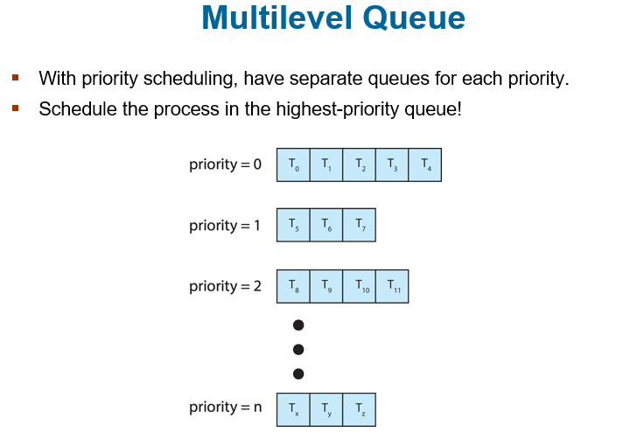

Figure Explanation
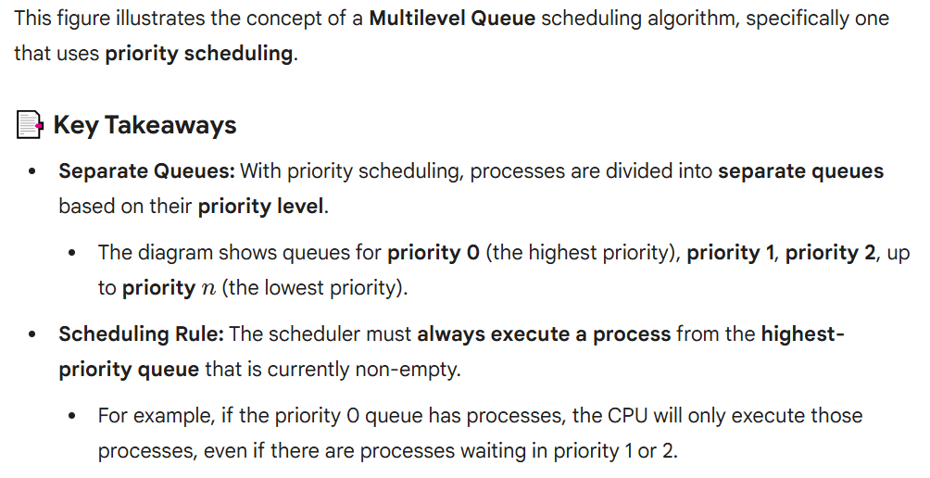

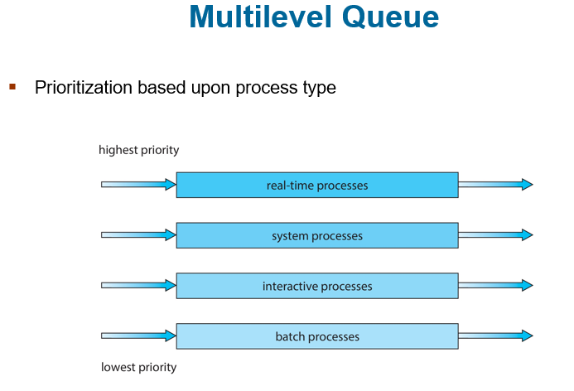
Multilevel Feedback Queue
Process Movement Between Queues
In a multilevel feedback queue, a process is allowed to move up or down between queues based on its behavior and waiting time.
What is a Multilevel Feedback Queue?
Multilevel Feedback Queue Scheduling is a CPU scheduling method that uses multiple queues with different priorities and allows processes to move between queues based on their behavior.
It helps improve performance and prevents starvation by promoting long-waiting processes (aging).
Key Parameters
1. Number of Queues
How many queues the system has (e.g., 3 queues: high, medium, low).
2. Scheduling Algorithm for Each Queue
Each queue can use a different method, like:
- Round Robin for fast tasks
- FCFS for long tasks
3. When to Upgrade a Process
Rules that decide when a process should move to a higher-priority queue
(e.g., if it has waited too long).
4. When to Demote a Process
Rules that decide when a process should move to a lower-priority queue
(e.g., if it uses too much CPU time).
5. Which Queue a New Process Enters
How the system decides where to put a process when it first arrives
(e.g., new processes may start in the highest queue).
Aging Through Multilevel Feedback Queue
Aging can be added by slowly moving long-waiting processes to higher-priority queues.
This means if a process stays in a low queue for too long, the scheduler pushes it upward, so it eventually gets CPU time and does not starve
Example of Multilevel Feedback Queue
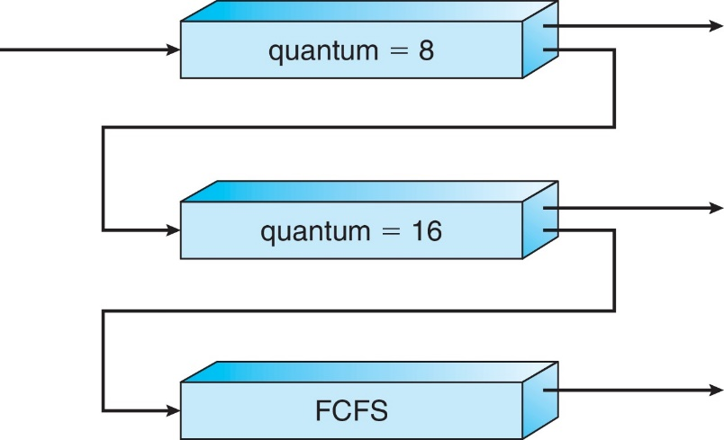
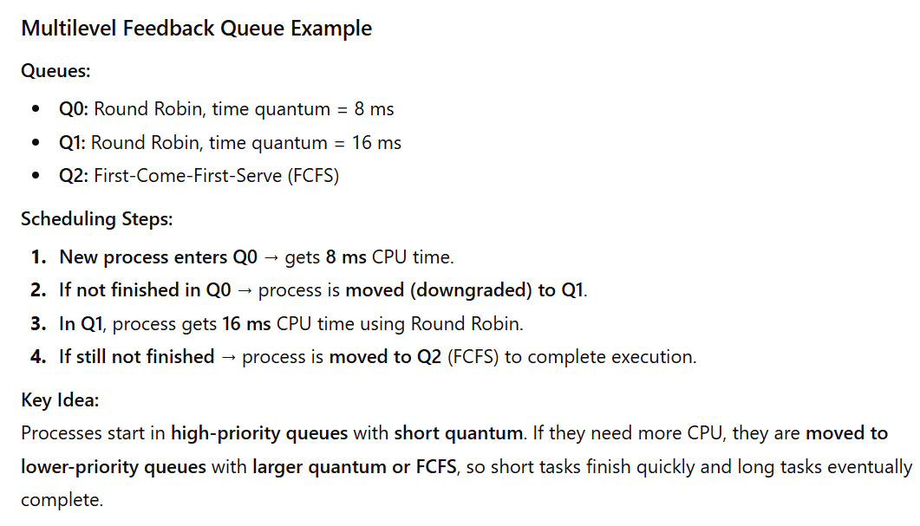
Chapter 6
Synchronization Tools
1. Processes Running Together
In an operating system, many processes can run at the same time. Since they run concurrently, any process can be paused in the middle of its work and another process may start running. This means a process may not finish its task in one go.
2. Shared Data Problems
When multiple processes try to access and change the same shared data at the same time, problems can occur. If they update the data without proper control, the final value may become wrong. This situation is called data inconsistency.
3. Need for Proper Control
To keep shared data correct, we need mechanisms that make sure processes follow an orderly and safe sequence while accessing shared data. These mechanisms prevent errors by controlling how processes cooperate with each other.
4. Example: Race Condition in the Bounded Buffer
In Chapter 4, we studied the Bounded Buffer problem. In that example, both the producer and consumer processes updated the same counter. Because these updates happened at the same time, the counter could get an incorrect value. This is known as a race condition, where the final result depends on which process runs first or overlaps with the other.

Race Condition
Race Condition with fork ()
When two processes, P0 and P1, both call the fork() system call, each of them tries to create a new child process. To do this, the operating system uses a special kernel variable called next_available_pid, which stores the next process ID that should be given to a new process.
The Problem
Race condition on kernel variable next_available_pid which represents the next available process identifier (pid)
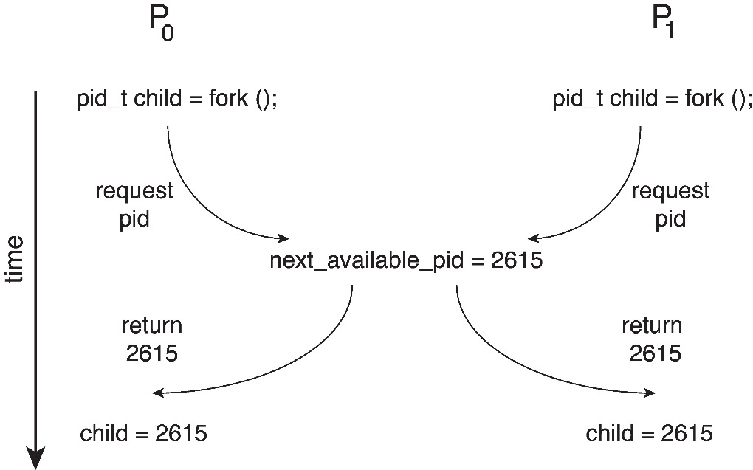
Why This Is Dangerous
Without a proper control mechanism to stop P0 and P1 from accessing the variable at the same time, both might assign the same PID to their child processes.
This is a serious error because two different processes would end up with the same process ID, which must never happen in an operating system.

Critical Section Problem
In a system, we can have many processes running at the same time, like p0, p1, … pn-1.
Each process has a part of its code where it needs to access shared resources such as:
- Common variables
- Shared tables
- Files
- Buffers
This important part of the code is called the critical section.
Why Is It a Problem?
Only one process should be inside the critical section at a time.
If two processes enter their critical sections together, they may:
- Change the same variable at the same time
- Write to the same file
- Update the same data
This can lead to errors or inconsistent data.
What Do We Need to Do?
We need a protocol (set of rules) that ensures safety.
This protocol must make sure that when one process is in its critical section, no other process can enter theirs.
How Processes Follow This Protocol
Each process follows these steps:
1. Entry Section
Before entering the critical section, the process must ask for permission.
2. Critical Section
Once permission is given, it safely accesses or updates the shared resource.
3. Exit Section
After the work is done, the process leaves the critical section and signals that others can enter.
4. Remainder Section
The rest of the program runs normally while not using shared data.
Critical Section
General structure of process P_{i}
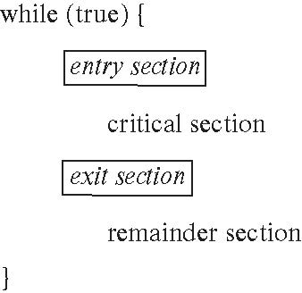
Critical-Section Problem (Cont.)
Requirements for solution to critical-section problem
- Mutual Exclusion - If process P_{i} is executing in its critical section, then no other processes can be executing in their critical sections
- Progress: If the critical section is free and some processes want to enter, then they must be able to choose the next process quickly, and no one who is not interested should affect the decision.
- Bounded Waiting: means that when a process wants to enter its critical section, it cannot wait forever. There is a limit on how many times other processes can go first, so every process will get a turn eventually.
Interrupt-based Solution
When a process enters the critical section, we temporarily turn off interrupts so no other process can stop it or run at the same time.
After it finishes, we turn interrupts back on.
On a single-core system, this actually works fine because only one CPU is running. If interrupts are disabled, nothing else can interrupt the current process.
But in a multicore system, this does NOT work well because:
- There are many CPUs running at the same time.
- Turning off interrupts on one CPU does not stop the other CPUs.
- To disable interrupts everywhere, the system must send a message to ALL processors telling them to stop interrupts.
- Sending this message takes time and slows everything down.
So even though disabling interrupts might work on one CPU, it becomes slow, inefficient, and messy on multiple CPUs.

Software Solution 1
This solution works for two processes only (say P0 and P1).
We assume that the computer’s load and store instructions cannot be interrupted — they happen completely in one step.
This is important because it prevents half-updated values.
Both processes share one variable:
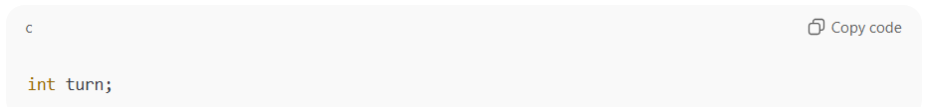
- This turn variable tells whose turn it is to go into the critical section.
- If turn = 0, then Process 0 is allowed to enter the critical section.
- If turn = 1, then Process 1 is allowed to enter the critical section.
At the start,
turn is set to i, meaning the process with ID i gets to go first.
Algorithm for Process Pi
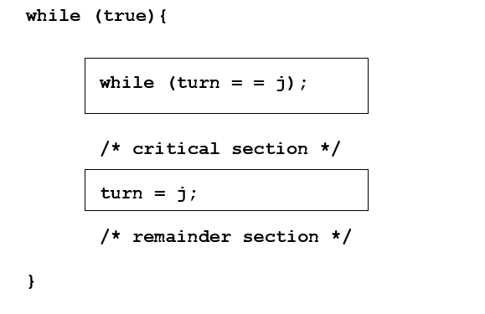
Code Dry Run


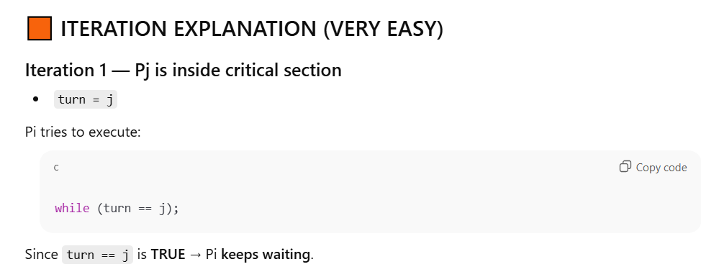
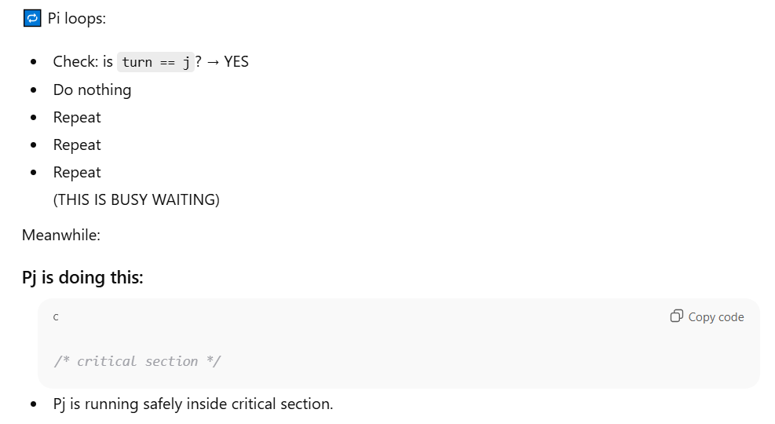
When process Pj leaves its critical section, what does it do?
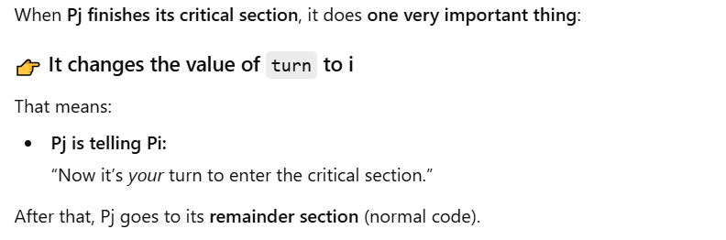
Turn change in code of J when it leaves its critical section
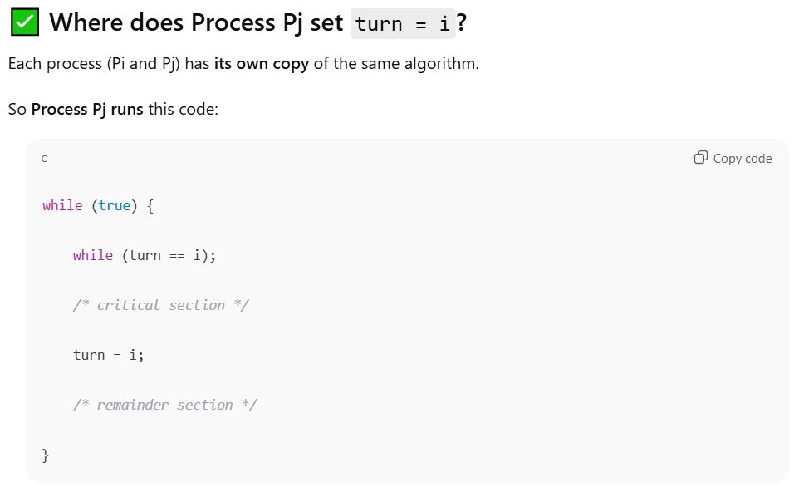

Correctness of above Software Solution
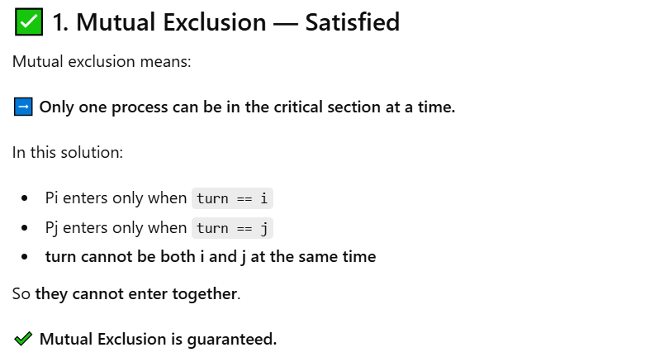
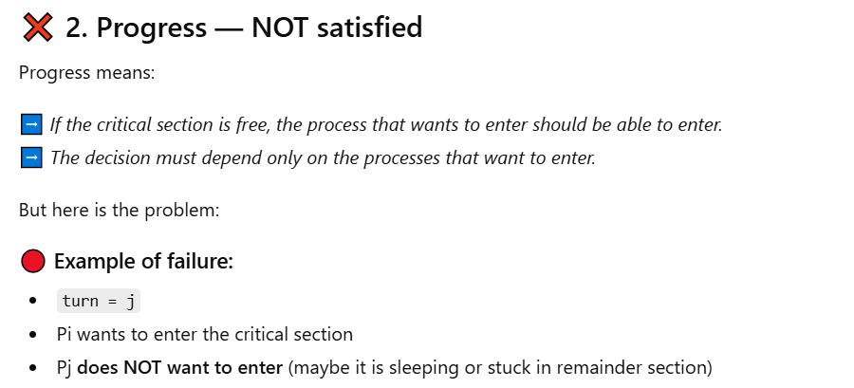
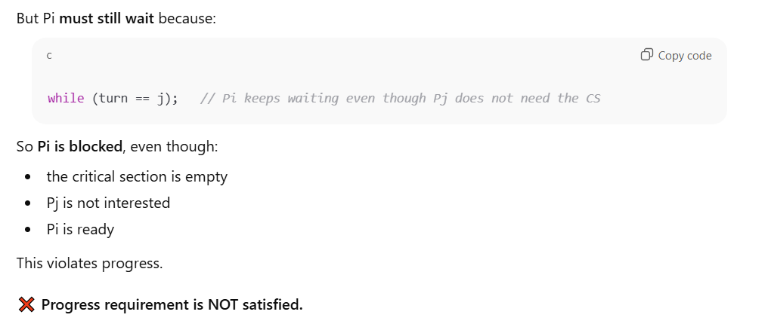
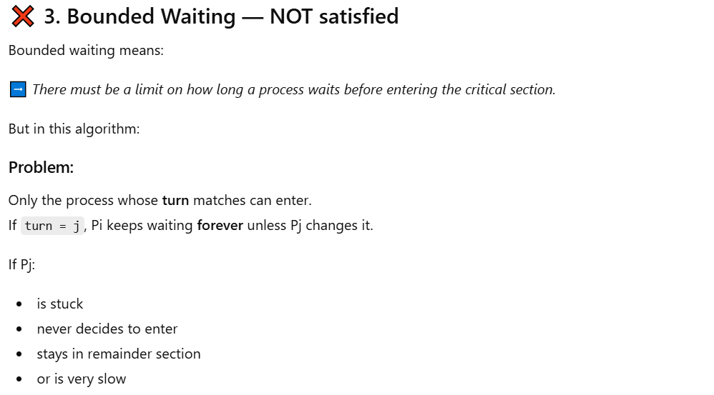


Peterson’s Solution
Peterson’s Solution is a way for two processes (Pi and Pj) to safely share a critical section without conflicts, making sure mutual exclusion, progress, and bounded waiting are satisfied.
We assume that the computer’s load and store instructions cannot be interrupted — they happen completely in one step.
How it works
The two processes use two shared variables:
- turn → Shows whose turn it is to enter the critical section.
- Flag [2] → Keeps track of whether a process wants to enter the critical section.
- Flag [i] = true → Process Pi is ready and wants to enter.
- Flag [i] = false → Process Pi is not interested right now.
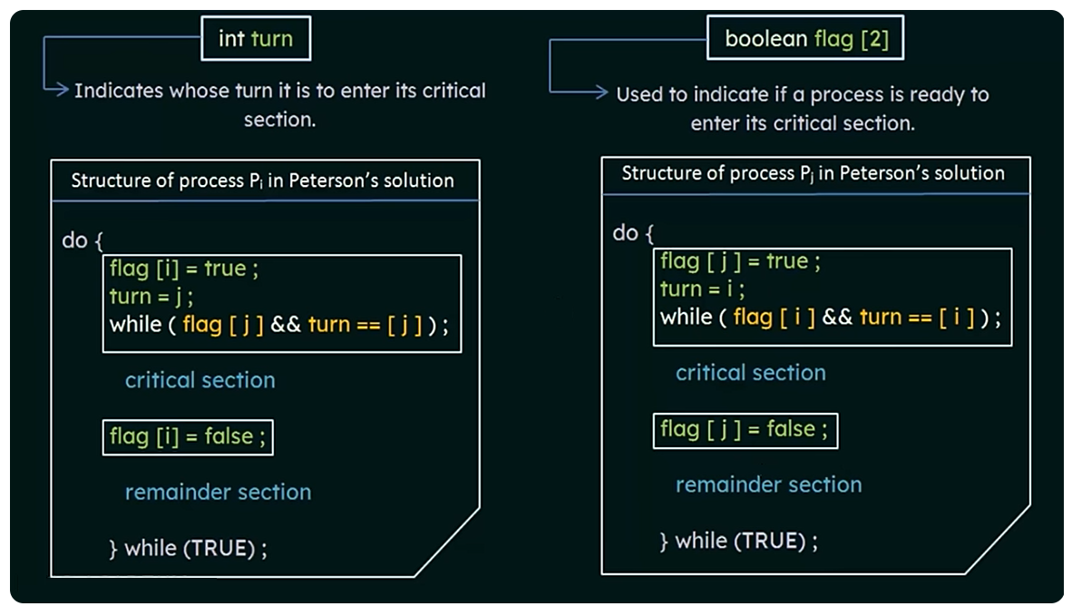

Correctness of Peterson’s Solution
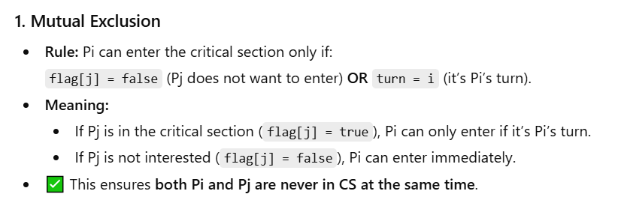
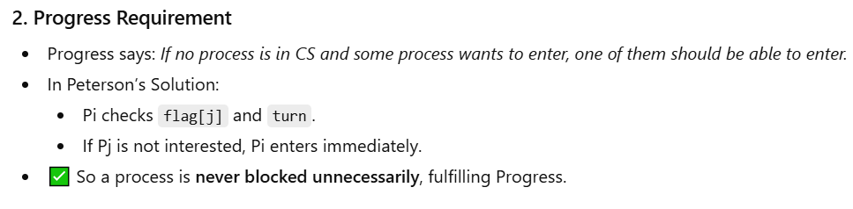
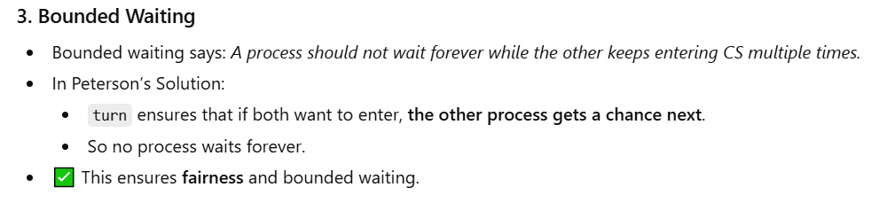
Peterson’s Solution and Modern Architecture
Peterson’s Solution is a theoretical algorithm that works perfectly on paper and in simple old computers.
But on modern CPUs, multiple cores, and modern compilers, it does NOT always work correctly.
Here’s why:

Why doesn’t it work on modern systems
1. Modern CPUs reorder instructions
Modern processors change the order of operations to run faster.
They think:
“These two instructions look independent. I can swap them to save time.”
This is fine for single-thread programs.
But in multithreading, if CPU reorders the steps of Peterson’s algorithm, both threads may get wrong values and think:
“It’s safe to enter the critical section.”
→ This can break mutual exclusion.
2. Compilers also reorder instructions
Compilers try to optimize code.
They may rearrange:
- reads
- writes
- flags
- the turn variable
But Peterson’s algorithm depends on the exact order of instructions.
If the order changes, the whole logic breaks.
3. Multi-core processors have separate caches
Each core has its own cache.
One thread may not immediately see the updated value written by another thread.
So:
- Pi may set flag[i] = true, but Pj might still see it as false.
- Pj may think:
“Pi is not interested; I can enter!”
→ Conflict!
Peterson’s solution assumes memory is instantly shared — but modern CPUs don't behave like that
Limitation — Only works for 2 threads
Peterson’s solution is designed for exactly 2 processes.
For more than 2 threads:
- The logic becomes extremely messy.
- The flags and turns don’t scale.
- It becomes slow and unreliable.
That’s why real operating systems don’t use Peterson’s solution.
Q: How does Reordering Cause Problem?
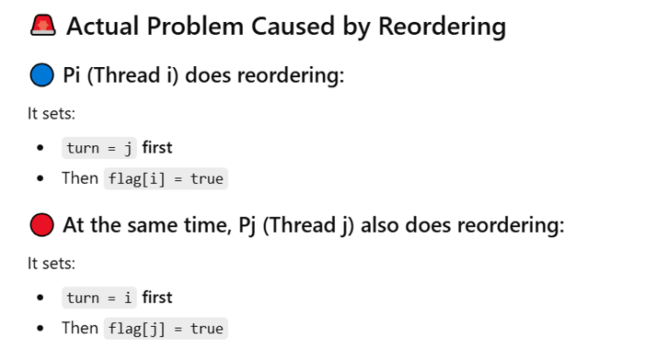


Q: How does a local cache cause a problem?
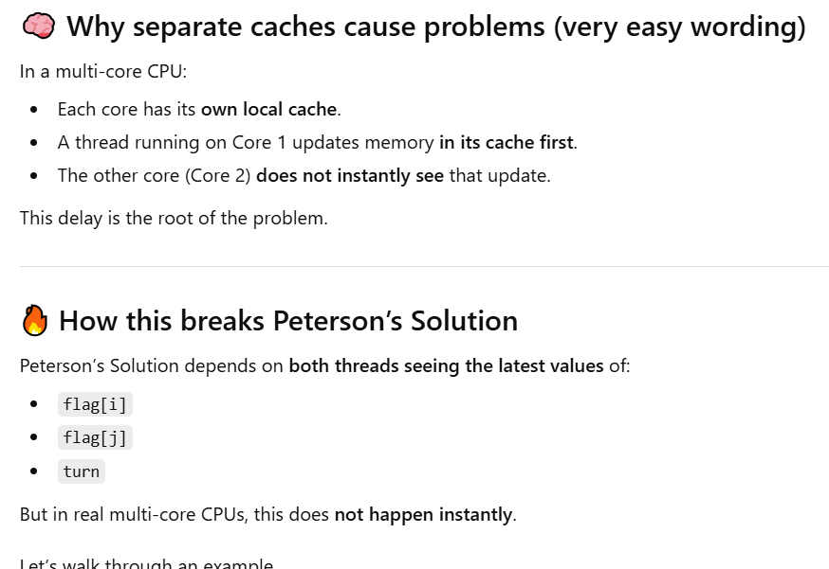
Peterson’s Solution Revisited
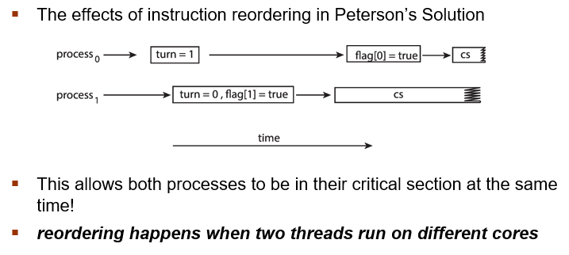
Synchronization Hardware (Hardware Solution)
Hardware Instructions (Special CPU Commands)
The CPU gives us special machine level instructions that do everything in one go, so no other process can interfere in the middle.
We call them atomic operations (cannot be interrupted).
Examples (not in detail, just idea):
- Test and Set
- Swap
- Compare and Swap
This helps us safely control critical sections.
Atomic Variables
These are variables that can be:
- read
- written
- updated
in one single, uninterruptable step, without another thread seeing half-updated values.
Why is this hardware support needed?
Old method: disabling interrupts (works only on old single-core CPUs)
On a uniprocessor system (only one CPU core), the operating system could do:
“Stop all interrupts → Run critical section → Turn interrupts back on.”
This guaranteed safety because no other code could run.
But this does not work on modern multi-core CPUs.
Even if you disable interrupts:
- Other cores are still running.
- Other threads can still modify shared memory.
- Data races still happen.
So, it is not scalable for today’s computers.
Hardware Instructions
The CPU gives us special machine level instructions that do everything in one go, so no other process can interfere in the middle.
We call them atomic operations (cannot be interrupted).
Examples (not in detail, just idea):
- Test and Set
- Swap
- Compare and Swap
This helps us safely control critical sections.

The test and set Instructions
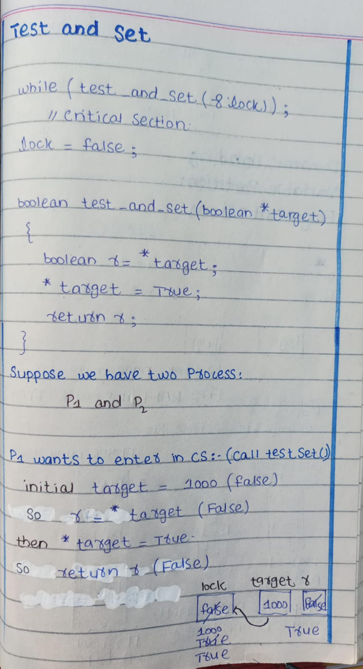
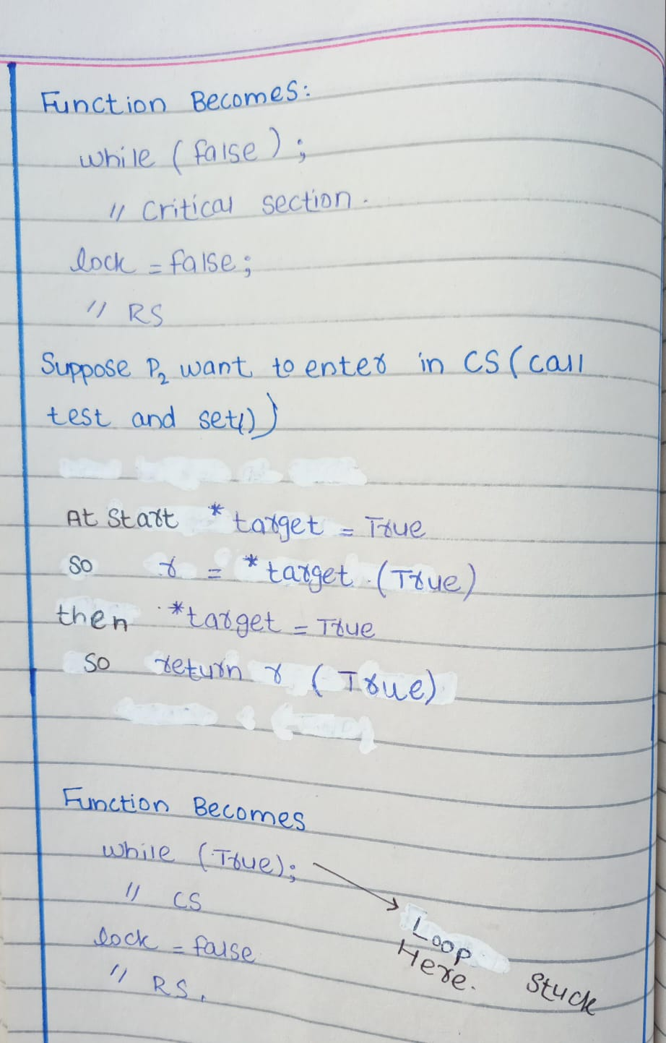
Properties
- Executed atomically.
- Returns the original value of passed parameter.
- Set the new value of passed parameter to true.
The compare and swap Instruction
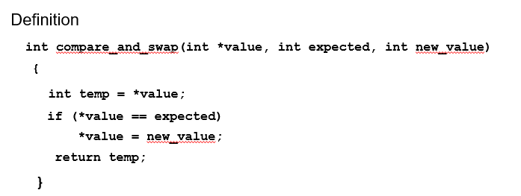
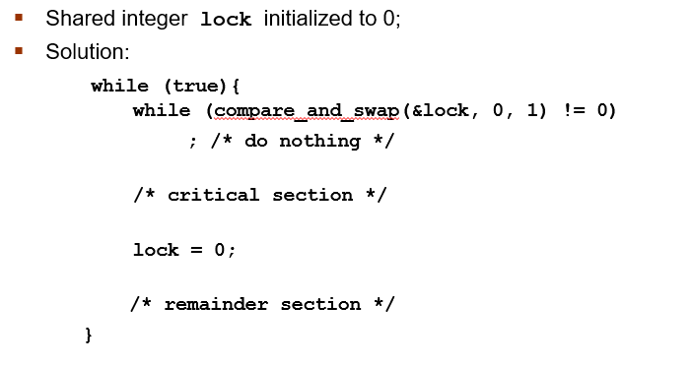
Properties
- Executed atomically
- Returns the original value of passed parameter value
- Set the variable value the value of the passed parameter new value but only if *value == expected is true. That is, the swap takes place only under this condition.
Bounded-waiting with compare-and-swap
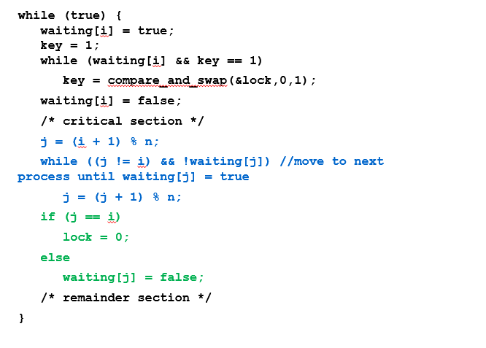
Atomic Variables
An atomic variable is a special type of variable that can be changed safely without interruption.
- “Atomic” means whole or indivisible.
- When you update it, no other thread can interfere in the middle.

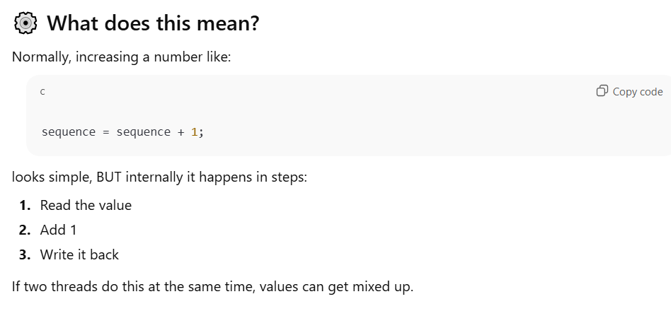
What atomic variables do
Atomic variables make sure that:
- The whole update happens as one unbreakable operation.
- No thread can interrupt or sneak between steps.
- No race conditions.
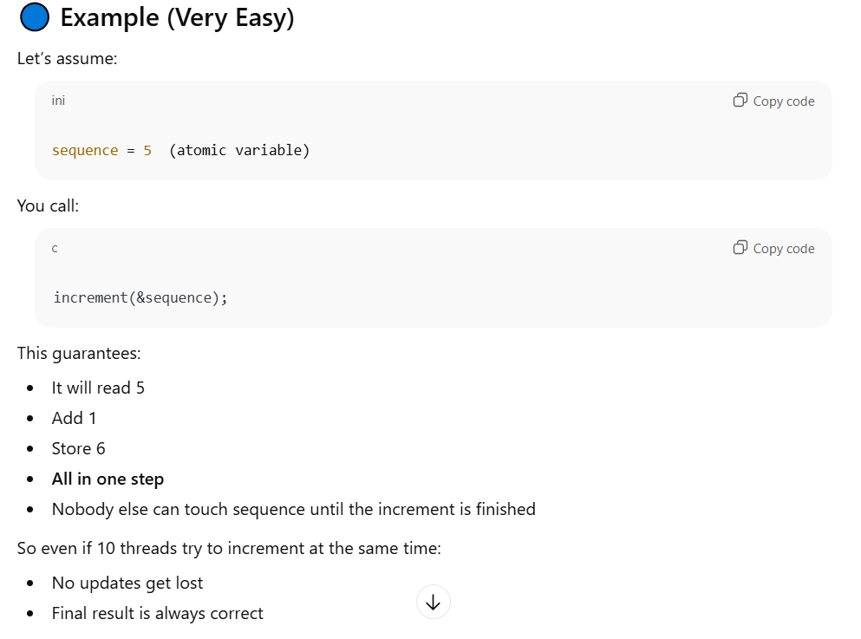
Mutex Locks
Earlier solutions of the critical section problem were too hard and not practical for normal programmers.
So, operating system designers created simple tools.
The simplest one is a mutex lock.
What is Mutex Lock?
A mutex is just a simple Boolean (true/false) lock:
- 0 (false) → lock is free
- 1 (true) → lock is busy
To enter the critical section:
- A process must acquire () the lock
- After finishing, it must release () the lock
Important Rule
Both functions:
- Acquire ()
- Release ()
must be atomic
(meaning they must happen in one unbreakable step)
How is acquire () and release () made atomic?
Using special hardware instructions like:
- compare-and-swap
- test-and-set
These are instructions from the CPU that guarantee the operation cannot be interrupted.
But there is a problem!
When a process tries to acquire the lock and fails, it keeps checking again and again:
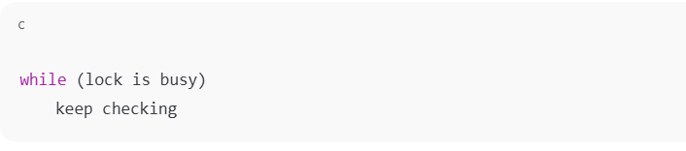
It sits in a loop doing nothing except waiting.
This is called:
Busy waiting
and the lock that uses this waiting is called:
Spinlock
because the process “spins” in a loop until the lock becomes free.
What is Busy Waiting?
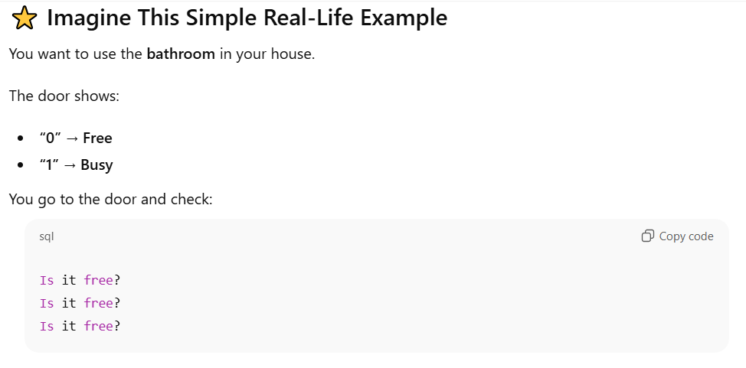
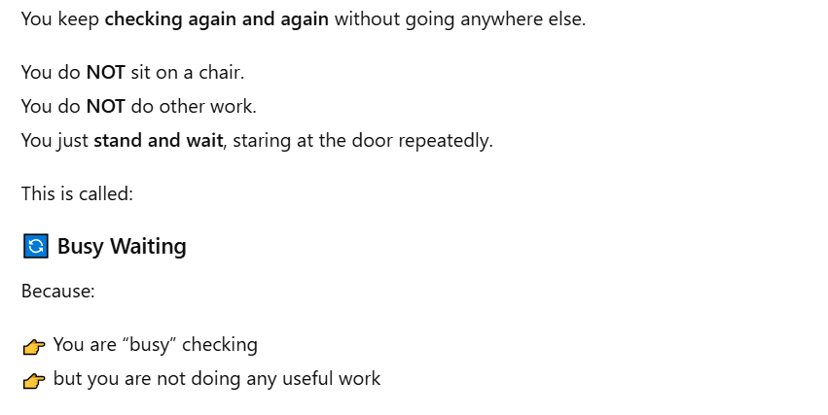
Solution to CS Problem Using Mutex Locks
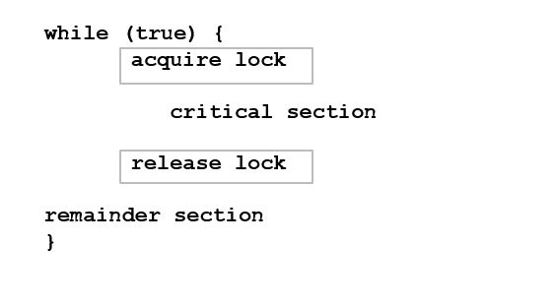
Semaphore
What is a Semaphore?
- A semaphore is a synchronization tool that helps processes coordinate better than a simple mutex lock.
- It uses an integer variable S
- The value of S tells how many processes can enter or use a resource
- Only two atomic operations can change it:
  - Wait () → try to enter (decreases S)
  - Signal () → leave (increases S)
Originally, these were called P () and V () in Dijkstra’s terminology.
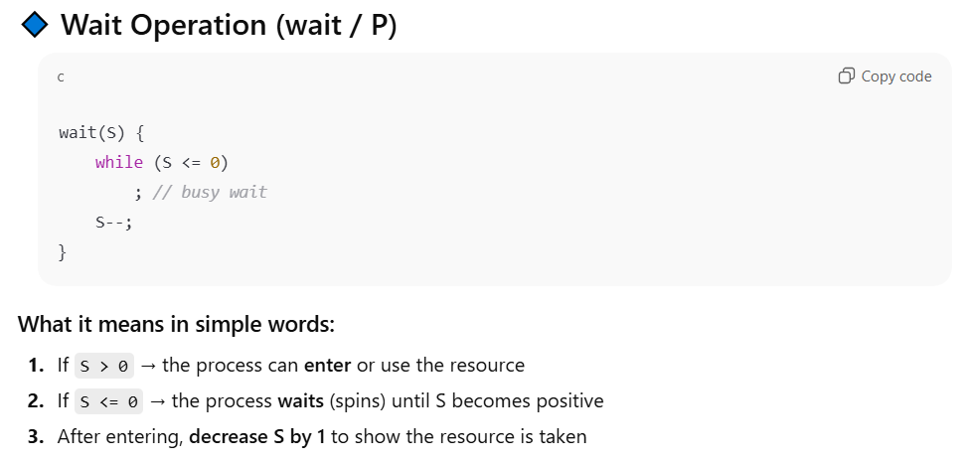
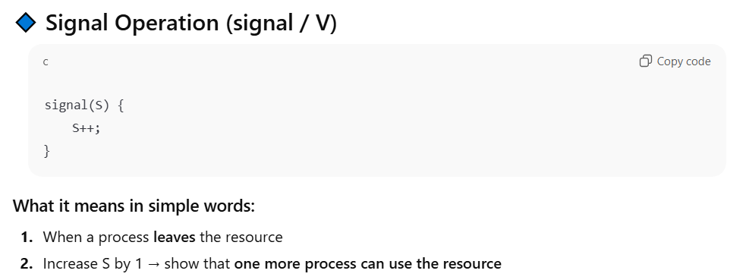
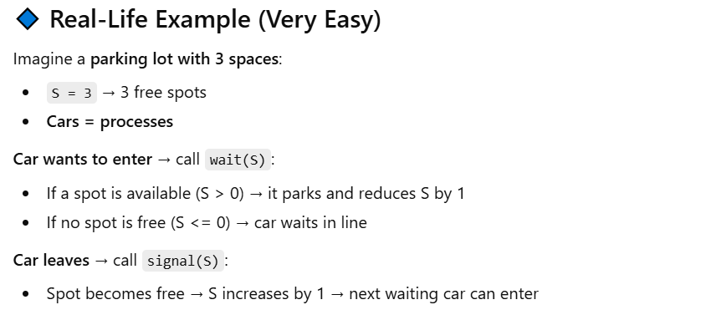
Semaphore
Types of Semaphores
Counting Semaphore
- Can take any integer value (0, 1, 2, 3…)
- Used when multiple resources are available
- Example: Parking lot with 5 spaces = 5 initially
- Each process decreases S when using a resource, increases S when leaving
Binary Semaphore
- Can take only 0 or 1
- Works exactly like a mutex lock
- Example: Single bathroom → only 1 person at a time
- 0 → locked / busy
- 1 → free

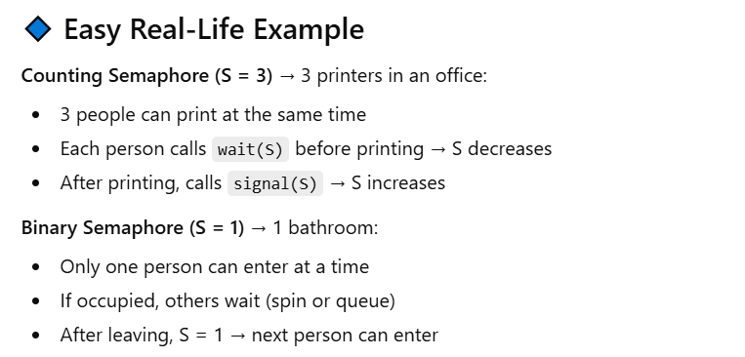
Relation to Mutex Lock
Binary semaphore = mutex lock
You can implement a counting semaphore using multiple binary semaphores (or just one atomic counter with proper wait/signal logic)
Why Semaphores Are Useful
Semaphores are more flexible than mutex locks because:
Counting semaphores let multiple processes share a limited number of resources
Binary semaphores ensure mutual exclusion like a mutex
Can solve common synchronization problems like:
- Producer-Consumer
- Readers-Writers
- Dining Philosophers

